- film analysis
- memorabilia
- production information
- trivia quiz
Foster’s Frames: The History and Mystery of D-FENS’s Glasses

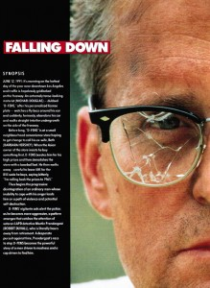
by Preston Fassel
Moreso than anything else in the film, D-Fens’s glasses have become Falling Down’s iconic image. Parodies are instantly recognizable from the combination of the frames with a short sleeve shirt and tie, and even the recent DVD release emphasizes their appearance with a loving closeup of Foster’s grimacing face framed by the battle-damaged frames. In a story that is largely about broken ideals and the loss of an idea of America, the choice of glasses couldn’t have been more appropriate.
Though the imagery may be lost on many younger viewers just coming to enjoy the film twenty years after its release, when Falling Down hit theaters in 1993, the frames were probably recognizable to a majority of middle-aged viewers. The style referred to as “browline glasses,” also known as “combination frames.” The Shuron Optica company began manufacturing them in 1947, and quickly started something of a craze. Though it’s a strange thought now, plastics being used in everyday life was something relatively new to Americans in the 1950s. Appliances and other household wares had traditionally been completely metal; the introduction of plastic casings cut down on costs and allowed the emerging post-war generation to set themselves up comfortably for a minimal investment.
The idea that this fusion of plastic and metal could carry over to eyeglasses as well struck a chord with Americans, and pretty soon half a dozen other eyeglass companies were producing their own browline frames to get in on the action. By 1960, half of all Americans wearing glasses were wearing browlines. For Americans with vision problems, browline glasses were tough, confident, and rugged; rather than suffer with poor vision, they could turn their handicap into a symbol of American ingenuity and perseverence. From a fashion standpoint, browline glasses helped to define the 1950s, right along with flattop haircuts and poodle skirts.
It was for this reason, then, that a backlash grew against browlines as the children of the 1950s grew up to become the counter-culturalists of the 1960s. Rebelling against the class-conscious, status-quo driven conformity of 1950s consumer culture, the young people of the late 1960s and early 1970s distanced themselves from anything even remotely resembling something their parents might have owned or worn. This meant that browlines had to go. The glasses had already begun to suffer a backlash in the early/mid 1960s, as literally everyone and their dad was wearing them; anytime something becomes too popular, something new and unique has to come and take its place. Rather than just slip out of fashion, though, browline glasses ended up on the receiving end of serious hate. People still wearing browlines in the 1970s weren’t just considered unfashionable: Regardless of the individual’s actual beliefs, wearing browlines post-Vietnam came to identify someone as a racist, sexist, conformist, stubbornly trying to uphold the ideals of an aging generation even as a younger, more enlightened, more savvy one was taking over the country. Sound familiar?
In many ways, Falling Down is about the last gasp of the 1950s in the face of the savagery borne of the early 1990s recession, set at that culture’s ground zero: the gang-ravaged, at-one-another’s-throat “melting pot” of Los Angeles. While proponents of 1950s social values had been given a “second chance” in the form of the Reagan 1980s, the economic collapse that came to define the early 1990s, and the resultant societal backlash, proved to be the final nails in the coffin of mid-century Americanism as an acceptable, mainstream ideal. In another era, D-Fens would have been the ideal American: A hard-working husband and father with unwavering loyalty to his job, country, and beliefs. (Amidst the climate of anti-government sentiment that defines conservative politics in 2013, it may be hard for younger readers to believe that in post-war America, loyalty to the government was synonymous with patriotism). The “lies” told to D-Fens were the standard line given to an entire generation of American men, all led to believe that getting up in the morning and going to work were all that was necessary for a lieftime of financial security and prosperity.
It’s appropriate, then, that the glasses that came to symbolize the outdatedness of the 1950s generation were chosen by Falling Down Costume Designer Marlene Stewart as Foster’s glasses. Not only do they put his character into context as a “leftover” from another era, but they are literally how he sees the world: A portal which warps his environment and leaves him perceiving of life as still existing as it did during another time. And, of course, the crack that appears in his glasses partway through the film symbolizes his own fragmented and fractured vision not only of America but indeed of his own life.
An interesting side note is that, despite browlines being a widely available style of eyeglasses, the particular brand that Foster wears remain a mystery. During the original heydey of browline glasses, the majority of frames were produced by a small number of successful manufacturers: Shuron Optical, Art-Craft Optical, Bausch and Lomb, American Optical, and Victory Optical. Many webpages claim that Foster is wearing Shuron frames; this is understandable, as Shuron optical has produced more browlines than any other company, and in fact continues to manufacture them to this day. However, this is incorrect.
Though, to casual observers, most brands probably look alike, there were subtle differences between every manufacturer’s frames, from the shape of the lens to the placement of the bridge. The easiest way to tell different brands apart, though, are the little pieces of metal in the upper corners—called “rivet covers.” In the early days of frame manufacturing, the arms of the glasses were actually riveted on; the rivet covers were a way to make the frames more decorative while also securing the rivets. Manufacturers all had their own different types of rivet covers, so to the trained eye, different brands were distinguishable with a quick glance—not much different from determining the make of a car by looking for the logo. Over time, several manufacturers started putting arms on the glasses in ways that didn’t require rivets, but they still put the metal—known instead as a “plaque” –on for decoration/identification.
Shuron Optical’s rivet cover design was the staff, a thin rectangle ending in a small bulb; Art-Craft’s were similar, but instead of the bulb, the river cover sort of slanted up, creating a kind of ramp shape; and Victory Optical had little V’s. American Optical had different types of plaques. The first, and more well known, was the stylized “wing,” as seen on Malcolm X’s American Optical Sirmonts (itself a very popular model). They also had plaques which were little “AO”s. Bausch and Lomb was unique in that they used multiple types of rivet covers. They had chunky “+” signs. They also had chunky, slanted “-“ signs that look similar to Art Craft’s river covers, except B&L’s had a much softer taper. They had shapes that looked like diamonds with one edge thicker and one edge thinner.
Of course, D-Fens has diamond shaped rivet covers. This has traditionally been the rivet cover design for Ray-Ban’s browline frame, the Clubmaster; however, because it is so basic a shape, it is also the one most found on generic, knock-off browline frames.
It is easy to tell that D-Fens is not wearing Ray-Bans by looking at the bridge, which is the most unique feature of his glasses. The bridges on virtually every manufacturer’s browlines are thick, rectangular slips of metal. D-Fens’s glasses, though, have what is called a “rolled bridge”—a thin, cylindrical piece of metal that is meant to simulate the kind of bridges found on much older styles of glasses. Having this type of bridge on a pair of browlines is almost unheard of, making D-Fens’s glasses very unique. (Though some Internet sites claim they are a “first generation” Clubmaster from the 1980s, contemporary photos show that virtually nothing has changed in the construction of the Clubmaster from the 1980s to the present).
Though there is some speculation that the costume designer simply bought a pair of cheap, knock-off glasses to use, this is unlikely for several reasons:
1) Knock-off goods are, by definition, trying to mimic something more popular. A generic brand would most likely have had the same type of bridge in order to more look like a branded frame.
2) D-Fens goes through a fair amount of physical abuse through the movie; the production team would have needed multiple pairs of glasses in order to serve as backups in the event that a pair broke or were severely damaged. Buying the glasses as cheap knock-offs could have meant not being able to get their hands on any more in the event that all of the glasses were damaged/broken. (This also raises the possibility that the frames were made by a company that was still manufacturing them in the 1990s).
3) Most tellingly: Recently, a character on the CBS show Vegas has shown up wearing identical frames, down to the diamond rivet covers and rolled bridge. It is unlikely that a line of cheaply produced, knockoff frames with such a unique identifying feature would still be in production over twenty-years later, and that those frames would also be chosen by another large-budget production.
The mystery remains, then: who manufactured these iconic glasses? If you know, contact us through this web site!
Preston Fassel is an optician in Houston.
Share:
- Facebook16
- Email
- Google
- Twitter2

1 Response »
“I’m Going Home”: Home and Place in Falling Down

The first words that Bill Foster says in Falling Down are “I’m going home.”
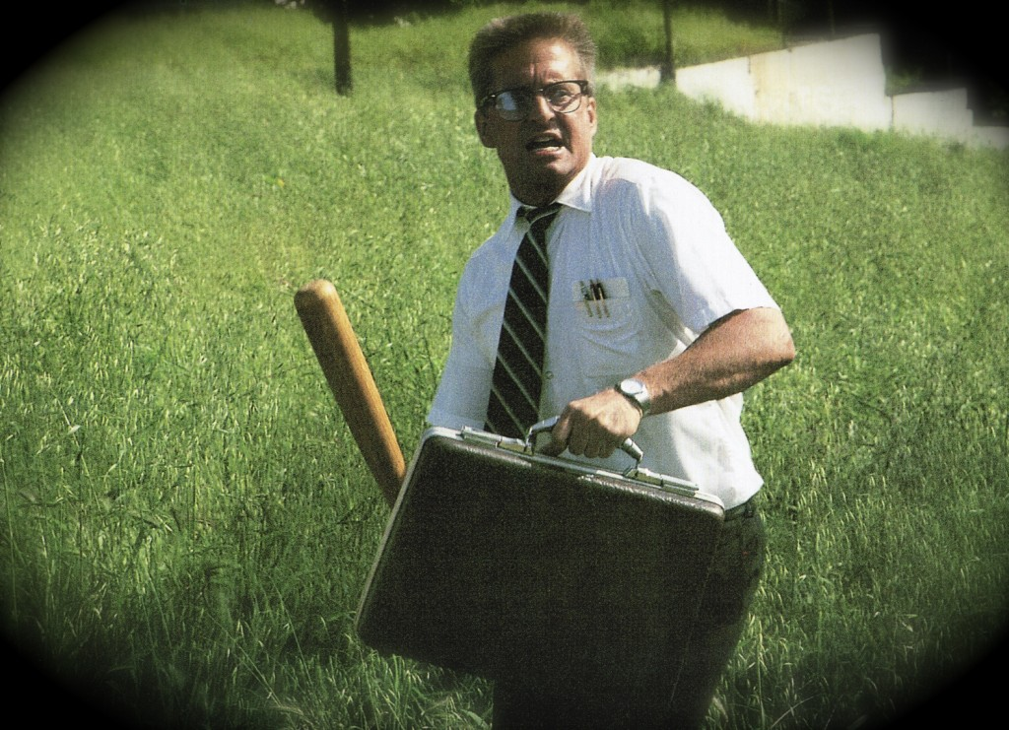
"I'm going home! Clear a path, you motherfuckers! I'm going home!"
This theme of a man searching for his home comes up throughout the film. It is of course a basic, understandable, and noble desire: to find a place where we can be accepted and secure. Foster’s goal is not to hurt anyone, it is merely to go home—in this case home being with his ex-wife Beth and their daughter Adele, for her birthday. He wants to reunite his family despite the fact that he and his wife are divorced. As he journeys across Los Angeles from one home to another (his current unhappy home with his mother in Pasadena to his idealized former home with Beth in Venice), Foster crosses into other people’s homes, territories, and privatized spaces.
Over and over Foster encounters people who tell him where he can and cannot go, that he is in a place he has no right to be. He’s told at Mr. Lee’s shop that he is not welcome to stay unless he pays 85 cents for a can of Coke (“You pay—or go,” Mr. Lee snarls, with a dismissive wave of his hand). Next he’s confronted while resting in a vacant lot by two gang members who tell him that he’s trespassing on their private property; later two street utility workers tell him he can’t use the sidewalk in front of him. As Foster walks through a public park he’s told by a seedy guy to give him some money because Foster is encroaching on his territory: “This is my park!” the man yells. Soon Foster is walking across a golf course, where he is once again berated and told to leave by a golfer irate at his presence: “Get off my hole…. This is my golf course!” Foster leaves, climbing a fence into yet another place he’s not welcome: the posh back yard of a plastic surgeon’s home. The one place where Foster is welcomed is an army surplus store—and only because the racist owner, Nick, mistakes him for a racist vigilante like himself. Foster is only welcome there as long as he hides his true self; as soon as he asserts his real feelings and beliefs he is rejected and attacked. (For more on this, see Drew Whitelegg’s article “’Keeping them peeled’: Falling Down, Vision, and Experience in the Modern City.”)
Foster’s search for home, validation, and acceptance are thwarted at nearly every step. He is in a futile search for a meaning or reason for his existence. This theme echoes the struggle of the main character in Ayn Rand’s novel Anthem in which he (unlike Foster) finally realizes, “I am the meaning. I wished to find a warrant for being. I need no warrant for being, and no word of sanction upon my being. I am the warrant and the sanction.”
Foster’s journey is both geographical and emotional; home is not merely a location, it is a nostalgic state of mind. He wants to return to the days when he was happy and employed and married—before economic uncertainly and emotional instability tore his life apart. That nostalgia is shared by Foster’s nemesis Det. Prendergast as well; during the confrontation at the end of the film the two agree that the world is in decay, reminiscing about the good old days before water pollution contaminated the fish. The scene takes place at the end of the Venice Pier—literally and metaphorically the end of the line; there is nowhere else for Foster to go.
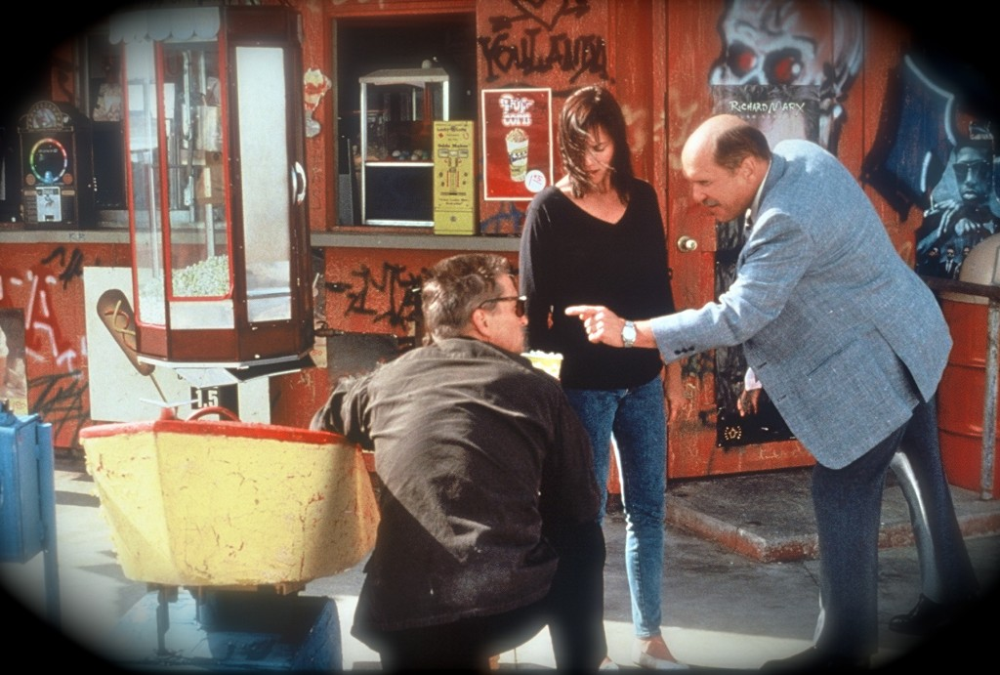
Prendergast confronts Foster and Beth at the Venice Pier.
At the end of the film Foster realizes that he will not be going home after all. He finally made it home, only to find that there was no home. The home he so desired and spent his day (indeed his life) searching for didn’t exist except as a phantom product of false nostalgia. Beth would not be reuniting with him; his daughter Adele, though happy to see her father, would not be close to him. He was not welcome anywhere else in the city or in the world, and he finally realized that he was not welcome with Beth and Adele either. Home was a mirage, a false promise inherent in the larger lie of the American dream.
"I'm not your wife anymore..."
Foster is incredulous as he realizes that he somehow transformed from victim to victimizer. “I’m the bad guy?” he asks. “How did that happen? I did everything they told me to… They lied to me.” In response Prendergast asks, “Is that what this is about? You’re mad because you got lied to? Listen pal, they lie to everybody. They lie to the fish.” The irony is that in his confrontation with Prendergast—a man with a gun trained on him who will shortly kill him—Foster for the first time in the entire film finds someone who understands him (or at least his perspective).
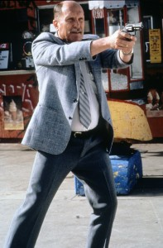
"Is that what this is about? You got lied to?"
In an article titled “Definitely Falling Down: 8-1/2, Falling Down, and the Death of Fantasy” in the Journal of Popular Film and Television, J.P. Telotte notes that unlike Foster, Prendergast “retains the ability to move between the hard, cynical world of the police and the dangerous fantasies and psychoses of the people on the street. He can soothe his wife’s imaginings about a prowler over the telephone, sort out the Korean grocer’s exaggerated account, persuade the Chicana girl Angie to talk about her gang’s guns and describe Bill, prod Bill’s mother to talk about her son as if he were one of her fragile glass figurines, and even draw Bill into a conversation in order to save Bill’s family from his [potentially] homicidal plans. Prendergast is, quite simply, able to understand and deal with the various sorts of fantasies that have become endemic in the world…”
Prendergast validates (and indeed shares) Foster’s understanding about what happened to him, about the unfairness of the economy and life in general. But he appeals to Foster to rise above his disappointment and disillusionment and realize that he’s not the only one: everyone’s hopes and dreams fall short.
Indeed Foster does recognize that he’s not the only victim of the economy and social pathology—others have been hurt too, including the Black protestor at the Savings and Loan, whose phrase Foster repeats as he explains his situation to Prendergast: “I’m not economically viable.” (The “economically viable” phrase is, of course, a dehumanizing corporate banker euphemism for “poor.”) His job has been lost, his self-respect has been taken, and his status as a husband and father have been stripped. In a final, resigned realization Foster recognizes that his only value lies in his own death. Through his life insurance policy he can offer his wife and child the economic viability that he could not provide in life. He has nothing left to offer, so he sacrifices himself by forcing Prendergast to kill him. If Falling Down is the story of an ordinary man at war, the everyday world won and Bill Foster—just like the rest of us—is only one victim.
Share:
- Facebook1
- Email
- Google
- Twitter

Comments Off
Unauthorized and Fan-Inspired Items

Perhaps one of the most interesting things about Falling Down is the audience response. Of course many films have developed cult followings; there’s nothing odd about that. But Falling Down is different, for several reasons. For one thing, most films that have enduring, cult, or even widespread audience resonance are genre films such as horror, action, or science fiction. By contrast, Falling Down is a mainstream drama / thriller / satire that doesn’t even have a clear hero (or anti-hero). Its message and moral is murky and nuanced—hardly the stuff of mainstream success.
Furthermore most films with a strong audience or cult reaction have been carefully cultivated, commercialized, merchandised, and licensed by the movie studios as part of their marketing campaigns (there’s no shortage of Batman or Freddy Krueger figurines and memorabilia, for example). Fans of those films are no less genuine, of course, but Falling Down enjoys a strong, multi-cultural, and truly grassroots resonance. The film was never intended to launch sequels (nor a video game franchise), nor sell toys and T-shirts. Because there was no effort by Warner Bros. to create a money-generating fan base, people who loved the film were inspired to create their own artwork and expressions of devotion. Here are some examples of fan-created art from Falling Down.
One t-shirt is explicit about the creator’s view of the D-Fens character: he’s an “American Hero.”
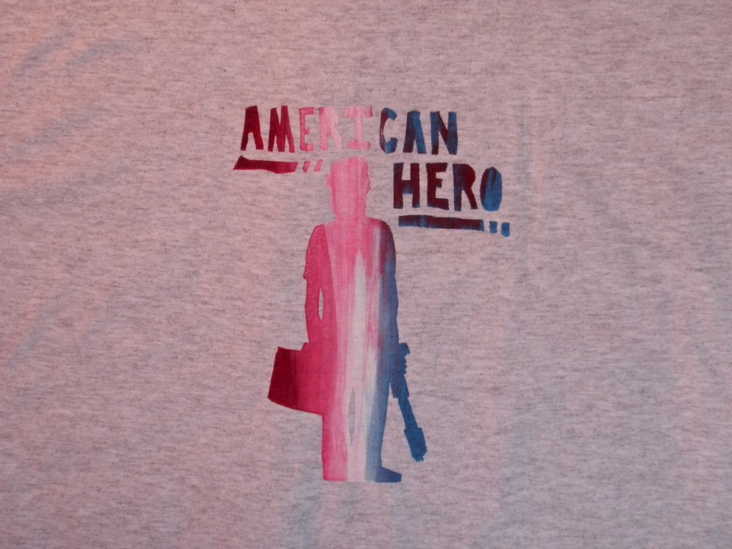
Another shirt design offers a more ambiguous phrase that emphasizes the character’s power and might: “An Army of One”:
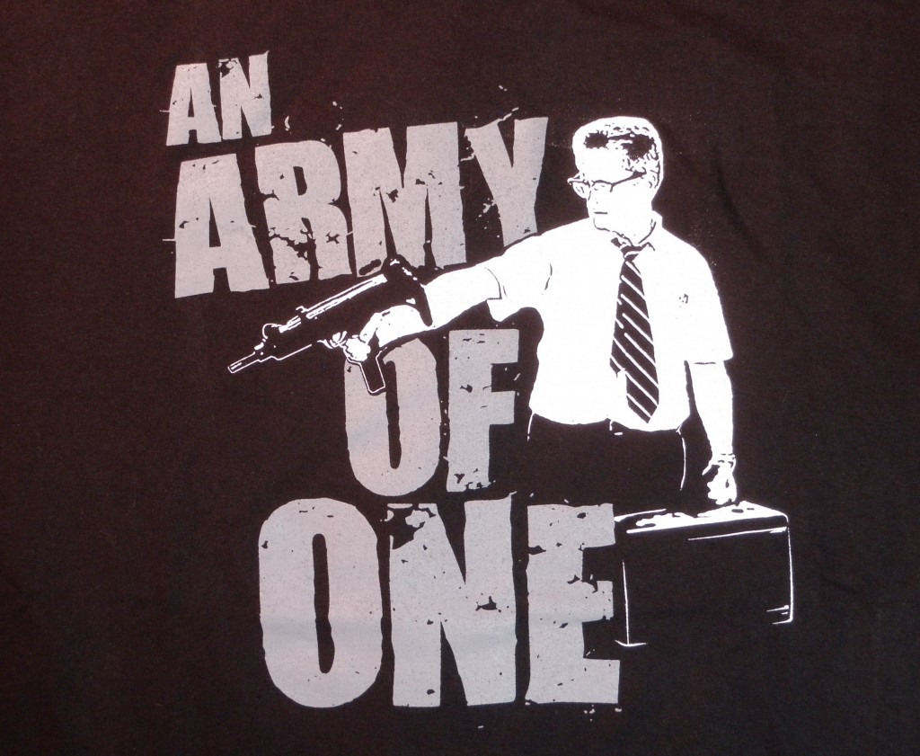
This was actually a well-known recruiting slogan used by the United States Army between 2001 and 2006. Other shirts merely used an image from the film or poster.
One artist who goes by the name Gigantic created a series of spray-painted LP records, including one featuring a black-and-white semi-silhouette of D-Fens on the film poster, with blood-red spatters:
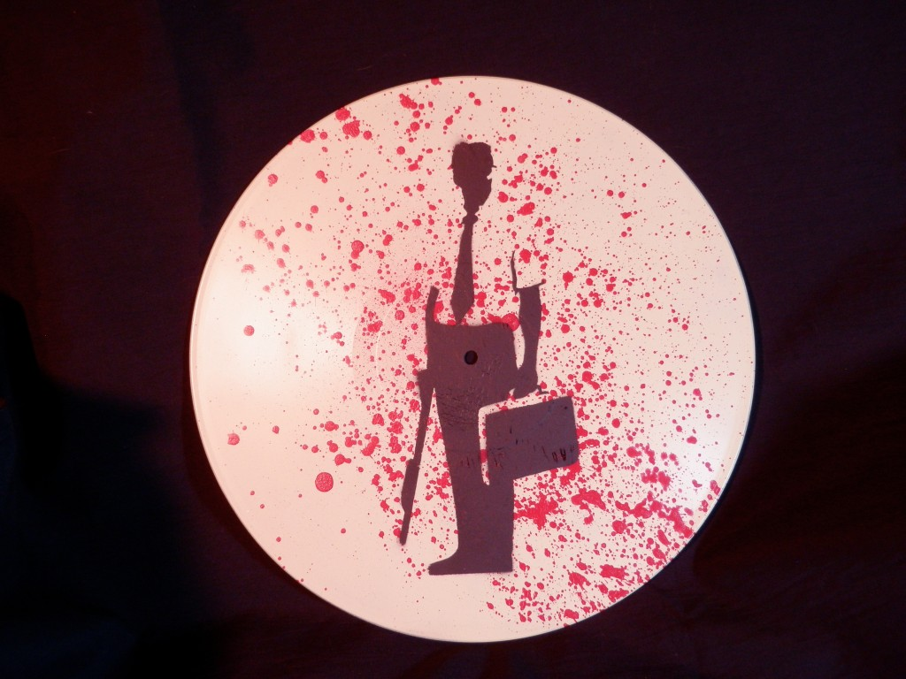
Then there are the figures and models. One is a simple arm-articulated action figure that has been modified and painted to look like Bill Foster:
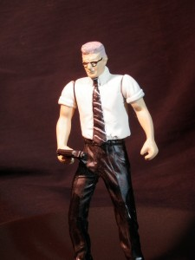
Though the likeness (with the tie, buzz cut, and glasses) is crude, it’s still a remarkable achievement for what is essentially a custom-created piece.
The most impressive piece by far is the D-Fens figure created by sculptor Joe Bailey for the U.K.–based company Killer Kits, standing 12 inches tall including the base.
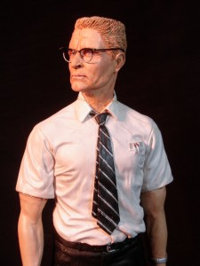
All the pieces were custom sculpted and created, including the wire-rimmed glasses, the briefcase, and gun. The base has an inscription on the front reading, “I’m not economically viable,” and a Monopoly board theme on the top, with small relief depictions of various items seen in the film, including the D-FENS license plate, the gangster’s butterfly knife, a gun, and a golf ball and club.
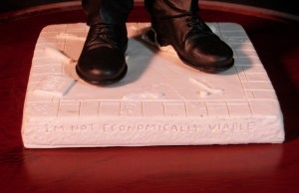
It’s a very clever piece, combining the risk-taking, money-losing theme of the Monopoly game with the main character’s journey—not only through Los Angeles on the day the film takes place but also through life.
Share:
- Facebook3
- Email
- Google
- Twitter

Comments Off
Falling Down Poster Analysis

Film posters are crucial for communicating—often in a single image—what an entire film is about. It is the most important part of movie marketing, because millions of people will see the poster but only a tiny fraction of them will buy tickets to see the film.
The poster for Falling Down shows Michael Douglas’s character D-Fens / Bill Foster standing atop a graffiti-covered, crumbling concrete slab with steps leading up to it. The scene is an empty, abandoned field, though the urban skyline in the background signifies that it’s an urban story. (More skyline buildings were added in one horizontal version of the British poster.)
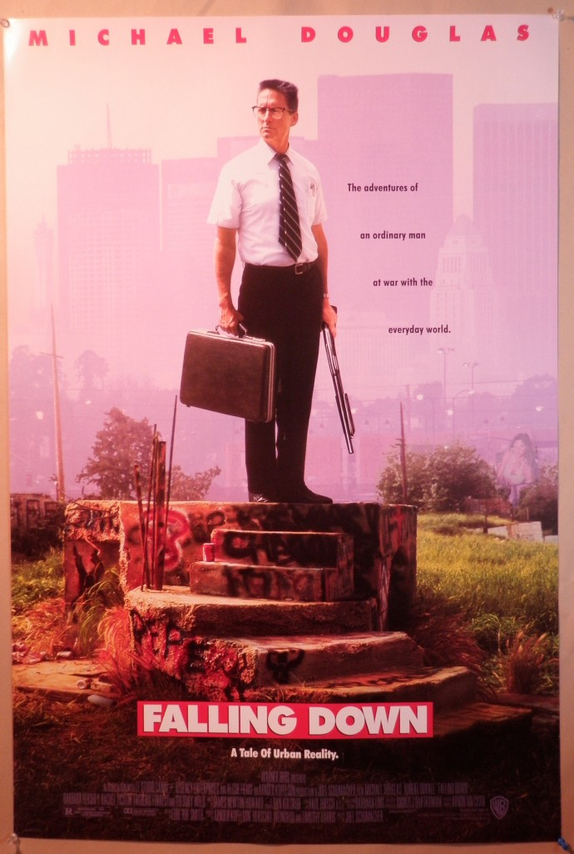
Atop this piece of steel and spraypaint-riddled cement platform is a middle-aged man in a white short-sleeved shirt, black pants, and a tie. Part of the character’s appeal is of course the inherent contradiction of an office drone (or nerd) with a briefcase, white shirt, and tie carrying a rifle. People associate guns and rifles with specific uniforms (such as military fatigues, law enforcement, or hunting outfits), not standard office worker uniforms.
The tagline to the right of the man (in the American poster, at least—the poster design varies slightly by country) reads, “The adventures of an ordinary man at war with the everyday world” against a smoggy sky. Below the steps is a bold, white-on-red film logo with the title, and below that is the line “A Tale of Urban Reality.” The words and phrases chosen in these taglines (ordinary man, everyday world, urban reality) evoke a populist sentiment, juxtaposed with the idea of a battle or struggle.
The poster image is fairly straightforward, but upon closer inspection we can find a few hidden symbols and meanings in the image—specifically in the concrete steps D-Fens is standing on. Much of the slab is covered with random graffiti, including the name “Pepe” written in black spray paint on the bottom left hand corner. There are also at least two skulls, one in red paint under D-Fens’s briefcase (and to the left of the Coke can), partially obscured by sprouted rebar; and a smaller one in black paint on the third step, directly above the ‘G’ in Falling Down.
However there are also two identical silhouetted symbols of falling human figures in the image. The largest and most prominent one can be found on the far left facing side of concrete, to the left of the rebar and partly obscured by weeds. The second and smaller one can be seen directly above the ‘I’ in Falling Down. In the first instance the figure is falling headfirst (you can clearly see the outlines of the figure’s shoes), and in the second his head is facing up, perhaps falling up (or crawling) up.
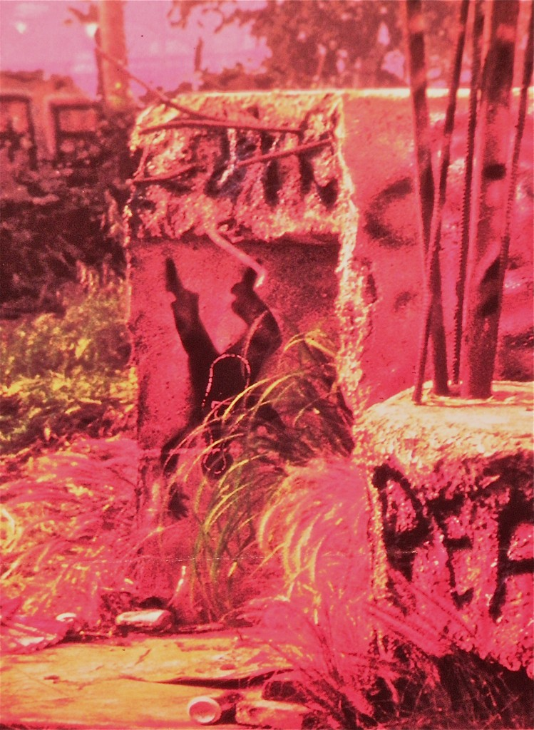
"Pin man" figure in the Falling Down poster
Indeed, this falling figure was the original iconic image associated with the film. We know this because it appears on the hats and jackets given to the cast and crew during filming (see photos). The film’s poster image (including the falling figure) was not designed until after the film wrapped up shooting, and was likely completed in the marketing phase during post-production. In fact by comparing a cropped still image from that scene in the film with a cropped image from the poster we can see that both of the falling figures were not present at the time of shooting but were later added photographically in the poster art production (see images). The public would have no way of knowing what the original art was, but it remains as a hidden remnant in the final poster.
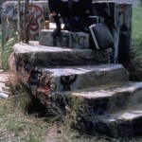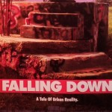
(click each image to enlarge)
Those are curious enough, but there’s an even more hidden symbol within the falling figures themselves. If you look closely you’ll see an outline of what looks like a bowling pin in white inside the figure’s torso. This also fits the film’s theme as well: people bowled over by a bowling ball of society and circumstance. You can, of course, take this metaphor as far as you like: the identical upright (and, perhaps coincidentally, white) figures standing in dutiful, orderly rigidity like office drones just waiting to be knocked down by an unstoppable force bigger than themselves. Like D-Fens and others like him, their purpose in this context is to stand there and passively accept the abuse against them; that is their role in society.
There’s yet another hidden symbol within the bowling pin image within the falling man silhouette. It is not clear enough to be seen in the film poster, but is easily seen in a close-up examination of the Falling Down crew hat and jacket:
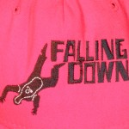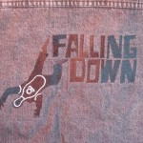
(click each image to enlarge)
It is a circle with a short vertical line connected to (and centered over) a longer horizontal line, with a short line stroking up at the end:

At first glance it looks like it might be a symbol for a planet, but it is not; in fact I was unable to match it with any known symbols. In the end, it is probably exactly what it appears to be: the top half of a stick figure holding up his hands in surrender—another element echoing the film’s themes.
Share:
- Facebook
- Email
- Google
- Twitter

Comments Off
Violence and Racism in Falling Down

Much has been made of the violence in the film, particularly as it relates to minorities. A common complaint was that D-Fens / Bill Foster was simply espousing racist, White male paranoia. More than one reviewer hinted that Falling Down has xenophobic fantasy elements to it. Let’s examine the violence in the film, organized by action, victim, provocation, and perpetrator:
Scene | Violence | Victim | Result | Perpetrator
Lee’s grocery* | Grocery abuse | Bread, chips | Squashed sundries | Foster
Gangster hill | Threat by knife | Foster | None | Gang thugs
Gangster hill* | Bat attack | Gang thug | Shoulder injury | Foster
Market street | Drive-by shooting | Intended: Foster; actual: innocent bystanders | At least two people shot | Gang thugs
Car crash | Shooting | Gang thugs | Bullet in leg | Foster
Surplus store | Threat by knife | Foster | None | Nick
Surplus store* | Knife | Nick | Shoulder stab | Foster
Surplus store | Gun | Nick | Shot in chest | Foster
Beth’s house | Gun | Sandra | Hip wound | Foster
Pier | Gun | Foster | Shot in chest | Prendergas

I have put an asterisk next to the violent actions that were immediately preceded by a violent provocation. I make the distinction because a violent act following a rude comment should be judged differently than one following a physical threat or violence. Of the ten violent acts listed above, only 60% were committed by Foster, and in half of those cases, he was threatened, so the act could justifiably be seen as self-defense. Discounting his attack on Mr. Lee’s overpriced inventory (and note that Mr. Lee introduced the bat as a weapon), that leaves only two instances in the entire film where Foster showed unjustified violence, once against someone who had just tried to kill him, and the other, more seriously, against a police officer trying to arrest him.
Compared to the body count in many films, Foster’s crimes are minor. All he did was wound a police officer; the cholo thugs killed several people, and Prendergast killed Foster. So why was he portrayed by some critics as a racist killing machine? Apparently a New York screening led to Korean and Hispanic protests outside the theaters. I have been unable to find original news reports of the specific grievances, but they centered around minorities’ portrayals. So let’s examine that.
Portrayal of Minorities in Falling Down
Much has been made of the role of minorities in the film, usually contending that they are portrayed negatively. This would include not only Foster’s view of them, but also the overall tone of the film. Aside from how the main character views minorities, how does the filmmaker (and, by extension, the audience) feel toward them? Is Foster’s rampage an exercise in ethnic cleansing and minority-bashing?
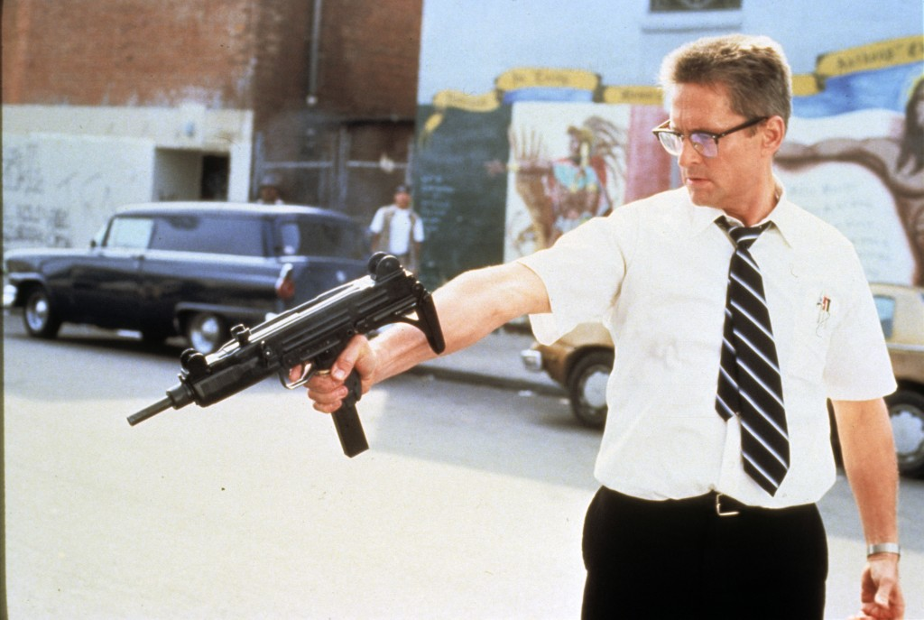
D-FENS takes aim at claims of racism
Here’s the list of minorities portrayed in the film, followed by the Caucasians, and how they are seen:
Mr. Lee, shopkeeper (Korean): negative Brian, police officer (Japanese): neutral or positive Detective Sanchez (Hispanic): positive Officer Sandra Torrez (Hispanic): positive Not Economically Viable man (Black): positive Unnamed shopkeeper (East Indian): neutral or positive Gang Thugs (Hispanic): negative Two Gays (Gay): positive Kid on Street on bike (Black): positive
Construction guy (White): negative Seedy Guy in Park (White): negative Rick, Whammyburger (White): negative Man at Phone Booth (White): negative Street Worker (White): negative Construction Worker (White): negative Nick, racist surplus owner (White): negative Frank, golfer (White): negative
Of the eleven minority characters, only three are portrayed negatively, the two gangster thugs and the Korean shopkeeper, Mr. Lee. The rest are shown either neutrally or positively. I have included sympathetic treatments (such as for the gay men and the Not Economically Viable Man) in the Positive category. When you consider the racial breakdown of Foster’s antagonists, the claim of minority bashing becomes even more clearly inaccurate. Along with the total of three minority antagonists, we have another seven White males who abuse Foster. In fact, there is not a single White male that he meets that day who does not abuse or irritate him in some way. By contrast, there are several minorities he talks and jokes with. And if you view the minorities quantitatively—i.e. the two Hispanic police (positive portrayals) “cancel out” the two thugs (negative portrayals)—then we are left with only one “unanswered” negative minority character in the whole film.
I would not go to such lengths to make this point were it not for many people’s mistaken view that Falling Down is in some way a racist revenge fantasy. Aside from the protesters, at least four reviews termed it “racist.” This perception probably comes from the scene in Mr. Lee’s shop where Foster mocks Mr. Lee’s accent by asking “Don’t you have V’s in China?” The conversation that follows has tinges of racism, but nothing else of that sort is seen in the rest of the film; he certainly does not spend the next ten hours shooting minorities.
While Foster’s comment about Lee’s accent could be interpreted as racist, a closer look reveals that it is actually less about Lee’s race than his language abilities; in fact Foster states this explicitly by pointing out that minorities like Lee don’t “even have the grace” to learn English. The same issues are heard today in some areas where critics complain about immigrants (sometimes even third-and fourth-generation American citizen immigrants) who don’t speak English (or don’t speak it very well). They believe that it is respectful and courteous to adopt the dominant language of a person’s adopted country. (I’m not offering an opinion about the validity of the argument, simply pointing out that it’s a common topic subject to legitimate debate.)
In fact Foster’s complaint about Mr. Lee’s accent (and indeed not being able to understand what he says) is symbolic of the film’s larger themes of alienation and miscommunication. Note that another miscommunication occurs soon after the encounter with Mr. Lee, when Foster pauses on a concrete slab, and two thugs point to what they see as a posted warning:
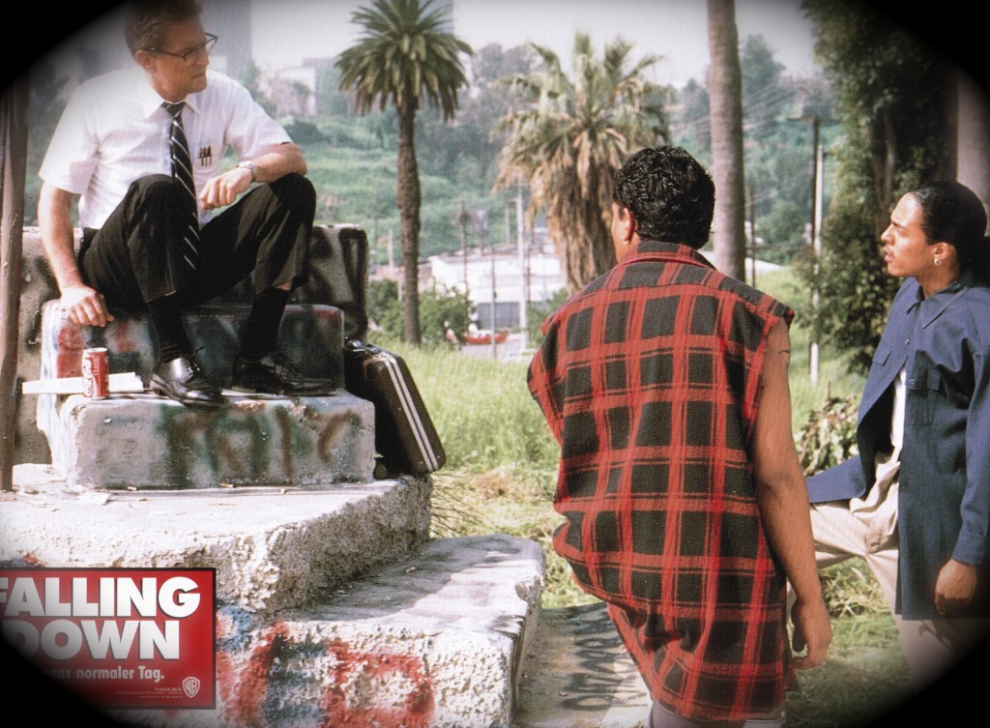
"You're trespassing on private property."
Gang Member: “You’re trespassing on private property.”
Bill Foster: “Trespassing?”
Gang Member #2: “You’re loitering too, man.”
Gang Member #1: “That’s right, you’re loitering too.”
Bill Foster: “I didn’t see any signs.”
Gang Member #1: [points at a graffiti skull] “What you call that?”
Bill Foster: “Graffiti?”
Gang Member #1: “No man, that’s not fucking graffiti. That’s a sign….I’ll read it for you. It says ‘This is fucking private property. No fucking trespassing. This means fucking you.’
Bill Foster: “It says all that?”
Gang Member #1: “Yeah.”
Bill Foster: “Well, maybe if you wrote it in fucking English, I could fucking understand it.”
This exchange shows people from different worldviews and cultures not speaking the same language. What one person sees as meaningless graffiti, another person sees as a clear sign or message. What one person takes for granted is lost on another; the thugs think it should have been obvious to the out-of-place nerdy office worker that he shouldn’t be there; Foster was looking for something clear and obvious that he’d recognize—something in “fucking English” so he “could fucking understand it.” (The class and race hositilities cut both ways: the thugs don’t want him there, and as Foster quaintly admits, “I wouldn’t want you people in my back yard either.”)
Of course the dialogue is exaggerated a bit for effect, but the meaning is clear and direct and true to life; often graffiti tags and gang signs mean little or nothing to the average person of a particular social class, but may convey a lot of information to those who know how to decipher the signs and symbols (for example a gang member or a police detective working the gang squad could identify the tagger, his gang affiliation, areas of drug sale control, and so on).
In his walking journey Foster meets Angelino characters he’d rarely or never encounter in everyday life, from Mr. Lee to the gangster thugs to cranky golfers. Each have their different ways of communicating, and that’s partly what the film is about: miscommunication and misunderstanding.
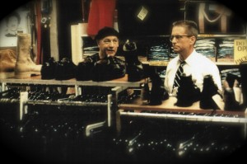
"We're the same, you and me... we're the same!"
Mr. Lee misunderstands Foster, thinking he’s a thief. Foster misunderstands Mr. Lee, at times literally not understanding what he’s saying. Nick the racist surplus store owner misunderstands Foster, believing him to be a racist vigilante. Det. Prendergast’s captain and police co-workers misunderstand why he retired from street duty, thinking it was because he was injured instead of because of his wife’s mental instability. Foster’s mother misunderstands where her son goes every morning, believing him to be employed. The family vacationing at the plastic surgeon’s house misunderstand Foster’s intentions, thinking he wants to take them hostage. And so on. Other misunderstandings are less clear: Does Prendergast truly understand Foster’s motives? Does Beth really understand her ex-husband’s intentions?
Share:
- Facebook8
- Email
- Google
- Twitter

Comments Off
Falling Down Notes and Trivia

The screenwriter, Ebbe Roe Smith, appears in the film as the driver who helps push D-FENS’s car off the freeway. Smith is an actor who has appeared in several other films, including Brubaker and as John Goodman’s partner in The Big Easy. He wrote Falling Down in ten weeks after being inspired by an article in the newspaper about a truck driver who began ramming cars in front of him on a freeway.
The ending song is titled, “I Didn’t Slip, I Wasn’t Pushed, I Fell.”
Falling Down takes place on Wednesday, June 12, 1991.
At one point, Foster says to Beth (Barbara Hershey), “’Till death do us part? Does that ring a bell?” A virtually identical line was said to her by her husband in another film, Paris Trout; Dennis Hopper played her husband.
The mural on the wall of the Army surplus store has a picture of military men in a rubber raft. The most prominent face appears to be that of Nick (Frederic Forrest), inside the store.
The scene where the Hispanic gangsters drive by to shoot Foster has a slight parallel to the Los Angeles riots. In both cases, the minority tries to get back at the White, but ends up killing and destroying their own neighborhoods. Virtually all the victims of the drive-by, including a three-year old girl, were Hispanic.
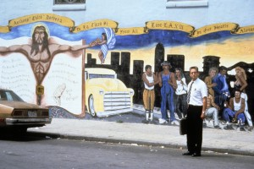
D-FENS near a mural near the drive-by shooting.
Michael Douglas has a small cold sore that seems to come and go, depending on the scene.
The poster for the film shows Foster on top of the cement block, with the city in the background. Foster is shown much bigger than life, standing on the concrete block. On two places, silhouettes of falling figures can be seen; the larger of the two is on the far left side of the block. Also, the Coke can is slightly smaller but still recognizable. And, the scene is a bit inaccurate, because at the time he was on the hill, he did not have the gun, only the baseball bat.
Several reviews (including Roger Ebert’s) said that the character was known only as D-FENS. This is, of course, inaccurate. His name is William (Bill—“He likes Bill”) Foster.
Falling Down was first screened in Albuquerque, New Mexico, on May 8, 1993. I went to see it on the last day of final exams at UNM. I saw it again one week later, the day I received my bachelor’s degree. Clint Eastwood’s Western Unforgiven opened two weeks later.
In an interview published in Playboy, Kirk Douglas, Michael’s father, said he considers Falling Down to be Michael’s best work. In the director’s commentary on the Falling Down DVD, Michael Douglas said he believes his work in the film was his best since Wall Street (1987).
Foster was featured on the cover of the March 29, 1993 issue of Newsweek. The headline was “White Male Paranoia: Are They The Newest Victims—or Just Bad Sports?”

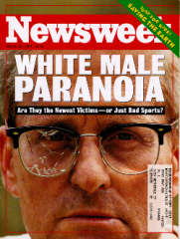

Dedee Pfeiffer, Michelle Pfeiffer’s younger sister who plays Whammyburger clerk Sheila (“You can call me Miss Folsom if you like…”), appeared in the February 2002 issue of Playboy magazine.
Falling Down was parodied in The Foo Fighters’ music video for their song “Walk.”

Share:
- Facebook2
- Email
- Google
- Twitter

Comments Off
Falling Down Reviews

“Often vulgar and exploitative . . . a dangerous and morally stupid movie.” –Richard Schickel, Time magazine, March 1, 1993 “ . . . explosive drama with whiplash intensity . . . D-FENS is no vigilante hero in the Charles Bronson tradition. He’s a man losing his moral balance, and he is not alone . . . The timely, gripping Falling Down puts a human face on a cold statistic and then dares us to look away.” –Peter Travers, Rolling Stone magazine, March 4, 1993 “darkly comic . . . the first half keeps you off balance with its discomforting mixture of humor and violence.” –Lisa Henricksson, GQ magazine, March 1993
“Tough, honest, uncompromising, putrid . . . A transparently racist attempt to create a fantasy world in which goofy White people get to beat the shit out of muscular ethnics.” –Joe Queenan, Movieline magazine, September 1994
“A brutally manipulative revenge fantasy, a piece of comic-strip demagoguery that teeters uneasily on the brink of satire…. This is a movie that thinks it’s scoring points by turning everyone into jerks and then saying we live in a jerky world. Falling Down is too cartoonish and blunt-witted to take seriously, yet there’s a disturbing fascist element at its core… Falling Down seems to have taken its tone from the glib, rabble-rousing self-righteousness of talk radio. Instead of a coherent point of view, it offers gripes…. Demagogic shallowness has its appeal, and Falling Down could turn out to be the Network of the 1990s. –Owen Gleiberman, Entertainment Weekly, February 26, 1993
“A slick, deeply confused exploitation movie . . . (director) Schumacher veers recklessly between social satire, kick-ass fantasy, and damsel-in-distress melodrama, playing the game for opportunistic cheap thrills . . . It would be easy to dismiss this as a simply dumb junk movie . . . but its pretensions render it pernicious.” –David Ansen, Newsweek magazine, March 1, 1993
“ . . . proponents of political correctness will be appalled by the message implicit in this film. Viewers with a modicum of common sense will love it.” –Arnott Weber, Alberta Report magazine, September 6, 1993
“ . . . finally, at the end, it doesn’t click—not because the ending is prettified—it isn’t—but because on the way to the ending, it exaggerates . . . and because the mechanics of the screenplay don’t help Douglas’s credibility and neither does his thin talent.” –Stan Kaufman, New Republic magazine, March 22, 1993
“2-1/2 stars: Dead-on portrait of a disenfranchised, modern-day American who goes off the deep end and turns into a gun-blazing powderkeg swearing revenge on “the system.” It’s vivid, it’s credible, it’s extremely well acted . . . but what exactly is the point?” –Leonard Maltin, 1997 Movie Guide
“Falling Down turns one man’s slide toward madness into a wickedly mischievous, entertaining suspense thriller…. a movie that couldn’t possibly have been made anywhere else in the world today. It exemplifies a quintessentially American kind of pop movie making that, with skill and wit, sends up stereotypical attitudes while also exploiting them with insidious effect. Falling Down is not meant to be seen as the anatomy of a madman, but as a spectacle of civil despair in which some people give in to galvanizing self-pity and others cope as best they can.” –Vincent Canby, New York Times, February 26, 1993
“3 stars: Falling Down does a good job of representing a real feeling in our society today. It would be a shame if it is seen only on a superficial level.” –Roger Ebert, 1996 Movie Guide
“This at first comes across like a mean-spirited black comedy and then snowballs into a reasonably powerful portrait of social alienation. The tone is unremittingly dour, however.” –Variety, December 31, 1992
Share:
- Facebook
- Email
- Google
- Twitter

Comments Off
Family and Alienation in Falling Down

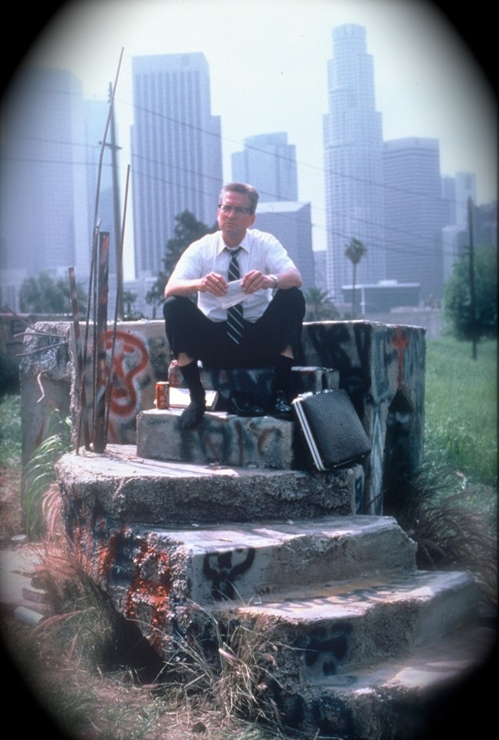
Alone, divorced, and unemployed, Bill Foster abandons his car and sees Los Angeles.
Falling Down was very much a product of its time. It was set in the early 1990s when America was in the midst of social, economic, and political uncertainty. Jobs were being lost to factories overseas. Racial tensions were in the news (and in fact erupted into the worst riots Los Angeles had ever seen, just days after filming stopped). People who worked hard to achieve the American Dream were realizing that they had been disenfranchised. The rich were getting richer, and everyone else felt left behind.
Many things have changed in the 20 years since the film was released; and many things are exactly the same. The economic uncertainty, fear and insecurity are still very much with us. Corporations got bailed out by the billions while average hardworking people work harder and harder for less and less. Americans are disillusioned and angry. Class tensions are still very much with us; the recent Occupy Wall Street movement (whose slogan is “We Are The 99%”) is only one sign of this outrage. Racial tensions, also, are still part of the daily social fabric, as the current (May 2012) Trayvon Martin shooting case in Florida clearly shows. In that case a common slogan is “We Are All Trayvon Martin”—the clear message is that the majority of people symbolically reflect the (real or perceived) social and economic abuses visited upon the few.
Many of D-FENS’s actions are reactions to a hostile, urban, modern life. Granted, the depiction is overdramatized to make a point, but the cinematic license isn’t drawn too broadly. Such everyday irritations depicted include high prices; road work and seemingly unnecessary construction; traffic congestion; flies; heat; smog and pollution; crime and assault; unemployment; scamming bums, dishonest advertising, and rudeness. We all encounter these annoyances frequently but usually we can avoid letting these things get to us. But just how far off base is D-FENS? Is it only the deranged among our urban masses who react to the daily barrage? At one point, D-FENS says “You want to see sick? Take a walk around this town. That’s sick.” And there is truth in his words. The profound pathologies of our cities and culture is there for all to see. The public’s fascination with sleaze, flashy, meaningless images, and pat, feel-good solutions to complex problems is sick. Evidence of cultural and social decay is all around us. Broken homes. Crack babies. Talk shows. Pauly Shore movies.
Do we accept parts of our culture that we find to be unsavory, or do we react against it, as D-FENS did? I believe that many of us harbor the fantasy of doing just what he did. In traffic jams, I have certainly entertained the thought of bashing my way out, simply smashing the vehicles on all sides until I can get off the freeway.
To understand the D-FENS character we must look at his motivation, what he wants. And what he wants the most basic thing everyone wants: a family. When we first meet D-FENS, he is on his way to his daughter’s birthday party. He does not want to be a vigilante (he states this explicitly), he does not want to avenge anyone; he simply wants to be with his family again. Because of the divorce, and a restraining order against him (although he has never hurt his ex-wife or his daughter), he cannot see Adele on her birthday. It is fitting that the first words D-FENS speaks are, “I’m going home.” These are not the words of a social misfit about to turn psychopath; these are the word of a frustrated, lonely man disenfranchised from his family, his career, and his life.
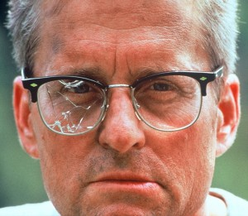
Bill Foster: An ordinary man at war with the everyday world.
Over and over, during his cross-city trip from Pasadena to Venice, the same theme recurs. “There should be children playing here. You should have families having picnics,” he berates the golfers on the golf course. D-FENS’s frustration is understandable. His goal is touching, and his idealism honorable. Yet he blithely avoids the harsh reality that he is divorced; he no longer has a family. When he finally accepts that his family will never reunite, at the very end, he is lost.
America and its ideals play a significant role in the film. In several places in the film, the American flag is shown. One of the first things to break in Mr. Lee’s shop is a glass bowl of small plastic flags, which scatter onto the floor. The setting—urban decay in Los Angeles—is a metaphor for the crumbling of the American Dream, the disillusionment that comes from realizing how deep and wide the gulf is between the glossy promises and mundane realities of American life. In his journey, D-FENS goes from the worst neighborhoods to the best, from a small wooden shack across from where gangsters meet him, to a plastic surgeon’s posh mansion. The audience is shown the hypocrisy embedded in a country whose founding principles include the idealistic phrase “All men are created equal.”
As for D-FENS himself, he certainly has bought into the American Dream. His father was awarded a Purple Heart for military service (in Korea, recalling the confrontation with Korean grocer Mr. Lee). He obviously went to college and got a job serving his country making missiles. He does not smoke, drink, or do drugs. Everything about him is conventional, from his haircut to his clothes to his car. Although we are given hints of a possibly stormy marriage, we are told explicitly that he never abused his family. He looks at himself and sees a failure, yet he is at a loss to understand why. What did he do wrong? How can he fix things? The problem is that he is fighting phantoms. His layoff was not due to poor performance or absenteeism. Budget cuts in the late 1980s and early 1990s probably led to his layoff. A family is, among other things, an intrapersonal arrangement, and, of course, it takes two to keep it together. There is no evidence that he is entirely to blame for the failure of the marriage, although we do hear that D-FENS was unreliable about custody after the divorce. D-FENS blames his mother, in fact, for the failure of his marriage. The audience is not given evidence to support or refute this, although the claim seems unlikely.
He has lost his family, and now he has lost his job. He is let go for being “overeducated, underskilled,” or the reverse. In the end, it really doesn’t matter what the details are: He is unemployed. “I am obsolete,” he says sadly and bitterly, “‘Not economically viable.’” In our society, men are closely identified with the type of job they do. It’s one of the first things brought up in a conversation: ’What do you do?’. A job means not only an income, but some degree of prestige and status, not to mention sex appeal. Women tend to be attracted to men with wealth, resources, and status; he has none of those. After seven and a half years at the defense plant, making missiles, he still calls his boss “Mister,” indicating a very formal relationship. No friends, close or otherwise, are mentioned at all in the film. Although we are told that D-FENS could be “possibly violent,” Beth is vague about the nature of his threats. She says he has never hit either of them, but “thinks he could.” It is hard to tell whether or not she overreacts to him, though he certainly becomes menacing in some of his conversations. At any rate, by the time D-FENS walks off the freeway, he is unusually vulnerable to the city’s harms and annoyances. Due to circumstances mostly beyond his control, he has been stripped of his prestige, his power, and his family.
As for the police officer pursuing him, Detective Prendergast experiences many of the same feelings and losses. We do not see as many daily frustrations he encounters, but we can certainly see his problems and pressures. His unstable wife calls continuously to bother him at work, her calls obviously more a demand for attention than anything else. Although he loves her, there is a fair amount of guilt between them; she lost her figure for him (and their child); he gave up being a street cop because she couldn’t handle it. Their one child died from a known but unexplained cause, SIDS. And now he is retiring early for his wife.
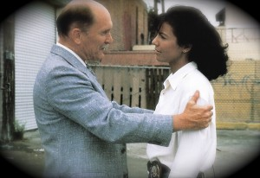
Det. Prendergast with his one friend on the police force.
His alienation isn’t as bad as it is for D-FENS, but then again he is still employed. But his job has a dark, impersonal side, as seen in his interaction with Captain Yardley. Like D-FENS, Prendergast’s superior barely knows his name, and nothing about him personally. All he knows, or wants to know, is what’s in his personnel file. Here is the exchange with Prendergast in the captain’s office:
Yardley: “Will you stick with the team?” Prendergast: “No, Captain, I don’t think I will.” Yardley: “Well, like I said, they make me ask, you understand . . . how are the kids, by the way?” Prendergast: “I don’t have any.” Yardley: “I’d like to take my stick to some of these clerks—the file says—” Prendergast: “We lost a child.” Yardley: “Lost it?” Prendergast: “Her. Lost her.” Yardley: “Yes, of course. It’s rough.” Prendergast: “Well, it can be . . . ” (silence) Yardley: “Still married, right?” Prendergast: “Yes, sir, I am.” (silence) Yardley: “Well, that’s good . . . that’s good.” Prendergast: “Yes…”
At the end of this exchange, director Joel Schumacher adds a brilliant touch: a lingering, painful, unnecessary extra few moments. This is the first of two (the other is of Barbara Hershey at the end of explaining her ex-husband’s potential for violence). Duvall is given extra screen time to show his discomfort and alienation. He sits more or less motionless, using just his facial expression and eyes to reveal his alienation and discomfort.
Captain Yardley feels that Prendergast is a disgrace to the police force, because he took a desk job after being wounded. A big, bad, tough cop, we first see him working over his punching bag in his office. He tells Prendergast to “get back behind the desk where you belong” and tells him not to pretend he’s “a cop.” He also states that he doesn’t trust Prendergast because he doesn’t swear. “A real man swears,” he says, getting in his face. Prendergast takes the abuse quietly and passively. At the end of the film, though, he tells the captain, in front of a television camera crew, “Fuck you, Captain. Fuck you very much.”
Both D-FENS and Prendergast are among the walking wounded. They both have family on their minds, and, at the very end, all each of them wants to do is get back to their families. Both have to live in the same city and deal with unstable people close to them. Both men are at a crossroads in their lives; D-FENS faces his second month out of work and his daughter’s first birthday without him. Prendergast is about to reluctantly “watch the cactus grow” in retirement in Lake Havasu, Arizona. Both have noble intentions but are misunderstood by those around them. D-FENS is thought variously to be a thief, a racist vigilante, and a hostage taker. Prendergast must deal with his coworkers and captain, who think he is at his desk job because he was wounded in action, when in fact he did it for his wife’s mental stability.
Share:
- Facebook
- Email
- Google
- Twitter

Comments Off
Falling Down Mistakes and Continuity Errors

The following list of film errors and mistakes was adapted from the Internet Movie Database (IMDb.com).
1) When Prendergast is asked for his signature to turn in his gun, he’s asked to “Put your John Doe right here,” though the usual reference is to John Hancock (the most prominent signer of the Declaration of Independence).
2) When Foster shoots out the phone booth with a machine gun, a man in the background jumps off his bicycle twice, once at the end of one shot and again a second later at the beginning of another shot.
3) When Foster tells the employees to turn around and look at the picture of the burger on the Whammyburger sign, the boom microphone’s reflection can be seen.
4) At the drive-by shooting, the driver turns the wheel to the left to avoid crashing into another car, but the car careens to the right.
5) When Foster is confronted by the two Hispanic thugs, his socks are black. Earlier in the film when he is walking into Mr. Lee’s store they are white.
6) An old man who tries to escape during the Whammyburger scene can be seen dressed differently in the Mexican restaurant where Sandra and Prendergast are eating.
7) The first time Foster’s license plate is seen, it reads “D-FENS,” though when Prendergast bumps the police motorcycle the hyphen is absent.
8) Foster is first seen is wearing his seat belt, though in later scenes the seat belt is off (that’s why he’s able to chase the fly around his car).

