All made up: Scene
Eric returns to apartment where the murder took place one year ago- after the mystical power of the Crow has resurrected him from the grave
Very good sequence for :
Camera work:
Mise en Scene and visual composition- ( look at the contrast in settings- lighting-) from flashback scenes of Shelley- to flash forward scenes of Eric alone in the darkened decayed loft
Sound – Music- Note style of music by The Cure and Lyrics
Editing- rapid tempo of editing from flashback to flashforward
Also good scene for
Story elements
Settings
Cause and effect
Character development
Motifs- mannequin mask
Medium low angle shot- cockroach scampering along floor – note metaphor here
Cut to medium shot of crow landing in loft room
Diegetic sound of crow squaking
Camera tracks forward along floor of room
Music Non Diegetic bass roll-
Sound diegetic Heavy breathing
Diegetic sound of rain
Medium shot of Eric sitting on stool
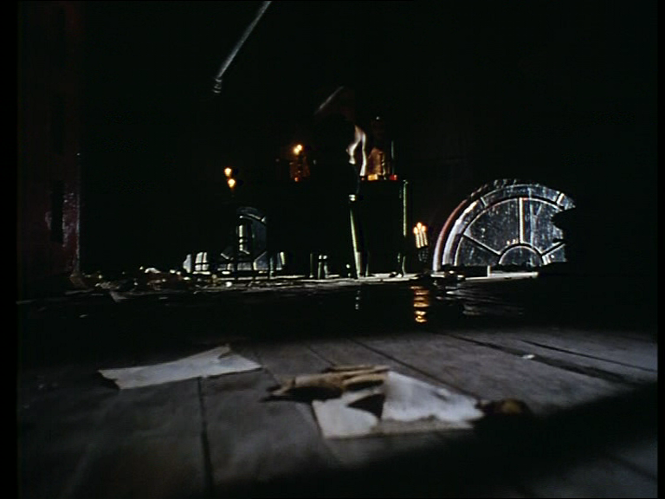
Close up of crow observing
Mystical non diegetic celtic music –mystical and melancholy (sad in tone)
Close up theatre mask on mirror- Eric’s hand reaches and touches it

1.
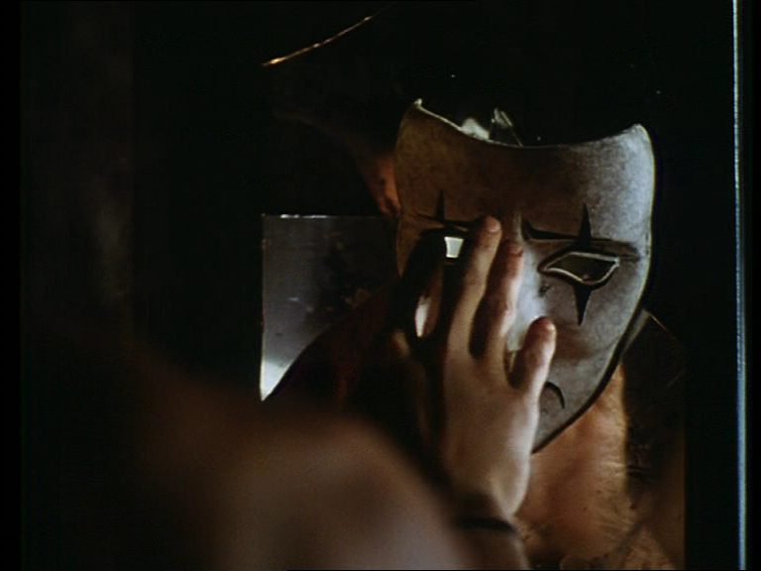
Cut to flashback of Eric wearing mask
2
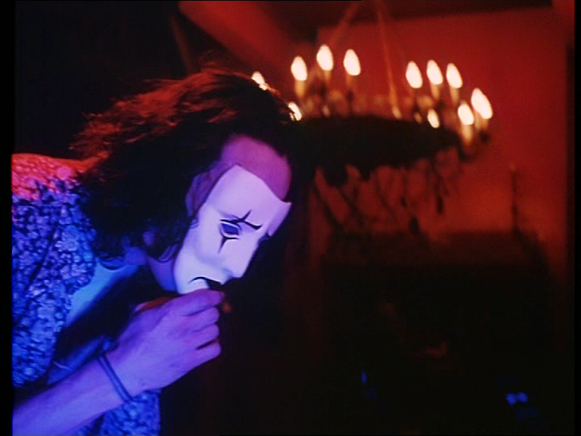
medium shot of Shelley lying down asleep –awoken by Eric in mask –he says “boo” Shelley laughs
Compare these 2 shots- mise en scene-
- Lighting under lighting and side light- create dense lighting- brown shadowed tones of Eric without shirt - and the mask is pale white
- location-/set - in front of cracked mirror in the loft- tight medium shot of Eric looking at mask
- composition- mask is in the centre of frame –conceals Eric’s reflection Eric to the left
- movement- Eric’s had draws audience to the significance of the mask.
- Effect- tension – sadness- hopelessness
Shot 2 – Flashback-
- Lighting- key light –side light- top lighting gives bright illumination to Eric highlights colours- blue Soft red light in background –
- location- in loft lounge room - camera pans across room following Eric’s action – reveals Shelley lying on couch as Eric says- “Boo”
- composition – Eric left of frame – moves into centre of frame- in rythym to camera pan
- movement- Eric left of frame – moves into centre of frame- romantic chandeliers in background
- Effect- Happiness- Love-

Flash back continues- Medium shot as Eric sits back laughing
Cut to present- Close of Eric and mask in the loft
Eric shivers
Close up of Shelleys photograph
Flash back- to Shelley holding Eric and she exclaims- I Love You= Eric replies “say that again- Shelley replies ‘I love you’
Cut to another flashback of Eric running into the kitchen to put out a fire from a cooking pot- both laugh – Eric holds Shelley and says – Restaurant
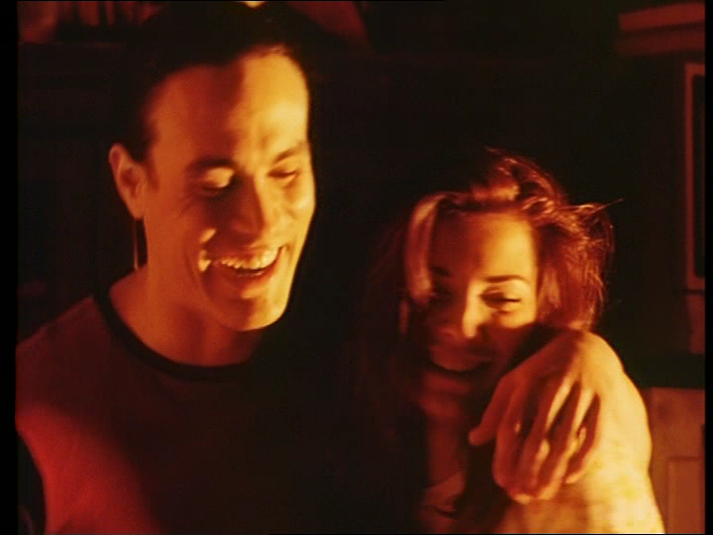
High angle shot of Eric( present time) shot
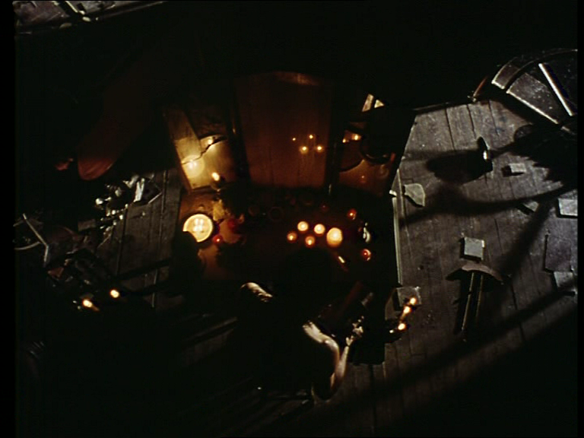
Cut back to flashback –medium shot Eric entering room without shirt smiling
Medium shot as he approaches and leans forward on couch as Shelley reads
Close up Shelley smiles
Close up of Spring Bride book

Medium shot Shelley trying on wedding dress – in front of Sarah

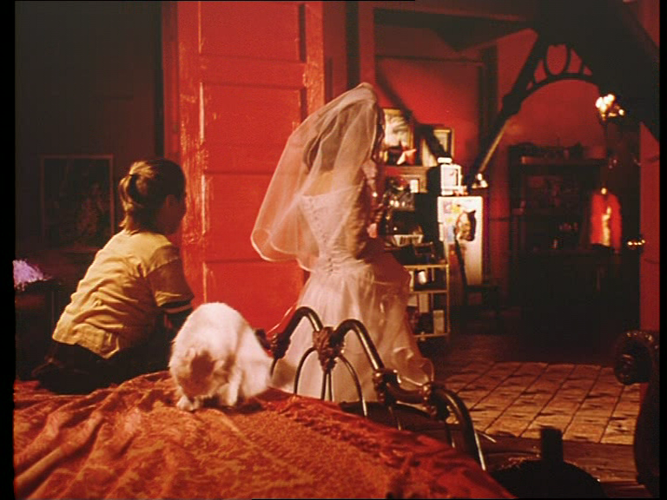

Close up of Sarah sitting on the bed smelling a red rose
Tracking shot as Sarah chases Shelley onto bed and they have playfull pillow fight
Flashback to
Cut to Medium shot of Eric as he squirts Shelley with vanilla topping- both laughing
Flash forward to Eric holding a photo of him and Shelley embracing
Eric shivering
Flashback to Eric and Shelley in romantic embrace
Flash forward to Eric holding Shelleys earings
Flashback to Eric and Shelley kissing
Flash forward to High angle medium shot of Eric sitting in front of mirror alone
Fashback Eric and Shelley making love
Music tempo accelerates ( music becomes faster)
Flash forward High angle medium shot of Eric who punches mirror
Close up of Eric’s reflection in broken mirror- as he cries out
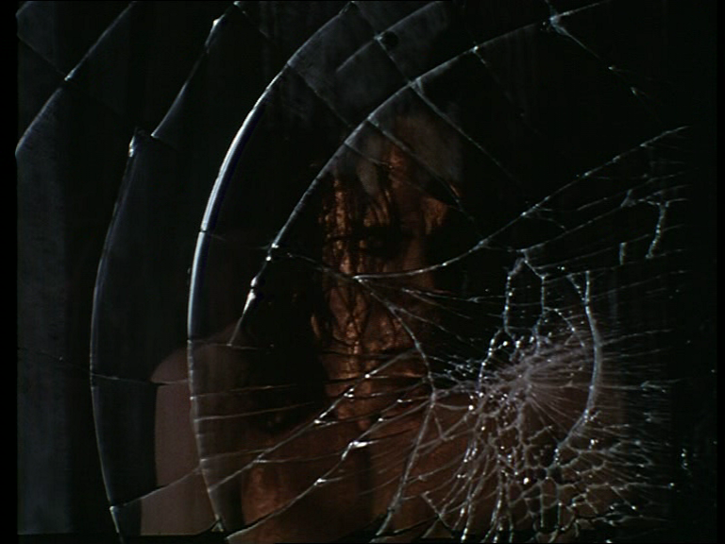
High angle medium shot as Eric falls forward onto table pushing things off tale
Close up of the crow
Close up of mannequin theatre mask
Music- tempo rapid
Close up of Eric’s fingers in make up cache
Medium shot applying makeup to shot
Medium shot of wall refelecting eric
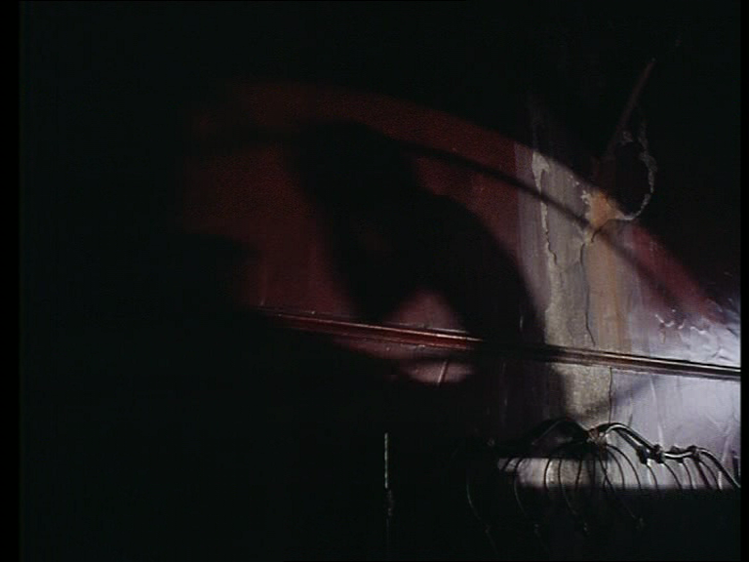

Medium shot from behind eric
Close up of Eric applying makeup- low light concealing his face
Medium Silhouette shot of Eric applying makeup
Close up of Eric’s hands with makeup
Lyrics by The Cure= “just paint your face and shadowed smile’
Diegetic lightning
Medium Silhouette shot of Eric applying makeup
Medium Silhouette shot of Eric applying makeup
Close up mirror – reflecting multiple eyes
High angle shot as Eric applies makeup
The Cure lyrcis- It doesn’t matter how you hide”
Close up of Eric applying black lipstick
High angle shot of Eric
Close up of crow commencing flight- crow squaks
The Cure lyrics-‘.slipping away from you’ ‘
High angle shot as Eric applies makeup
Close up as crow continues flight in the room and perches on cupboard
Medium shot Erics arms open cupboard
The Cure Lyrcis- They’ll find you if theyre wanting to”
Medium shot of case on cupboard
Close up of crow on cupboard
Close up of hand pushing through sleeve of black top
“so slide back down and close your eyes”
Medium rear shot of Eric’s back –revealing four bullet holes as he pulls top over his head
Medium shot of Eric as pulls top over chest
“sleep a while you must be tired”
low angle shoot of eric’s boots as he walks towards cat- window in background
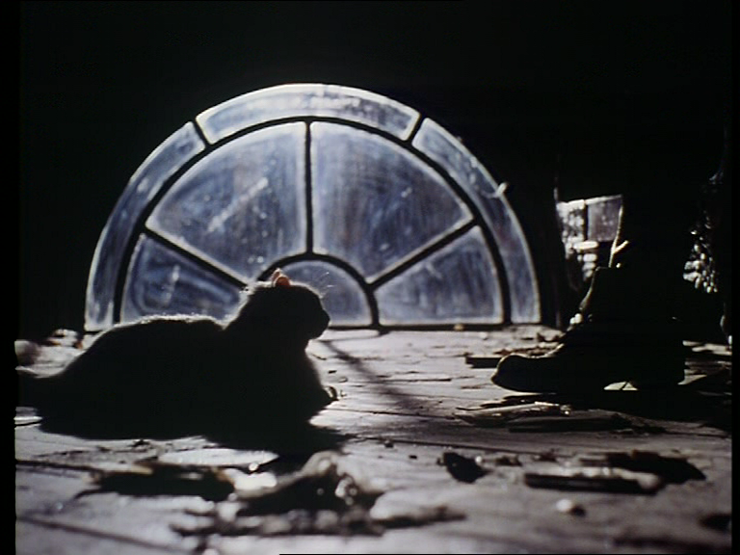

close up of crow flying from cupboard
Match on action- Medium shot as crow lands on Eric’s shoulder as he walks towards broken circular window
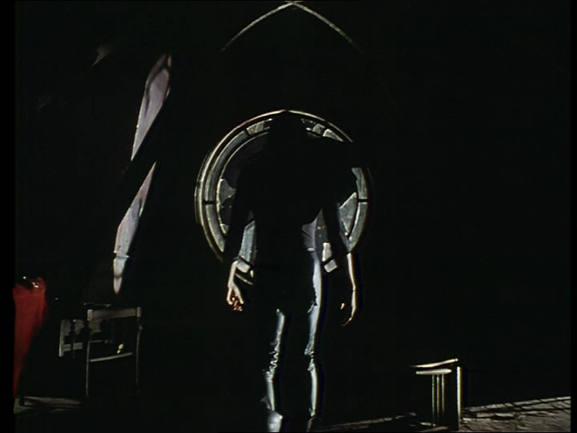

“As everynight I burn I hear the animals scream”
close up of crow on Erics shoulder
eye level close up Eric in silhouette with crow on shoulder
“everynight I burn feel the crow like dream’
Exterior Medium shot through circular window reveals Eric in mannequin makeup and black clothes with crow

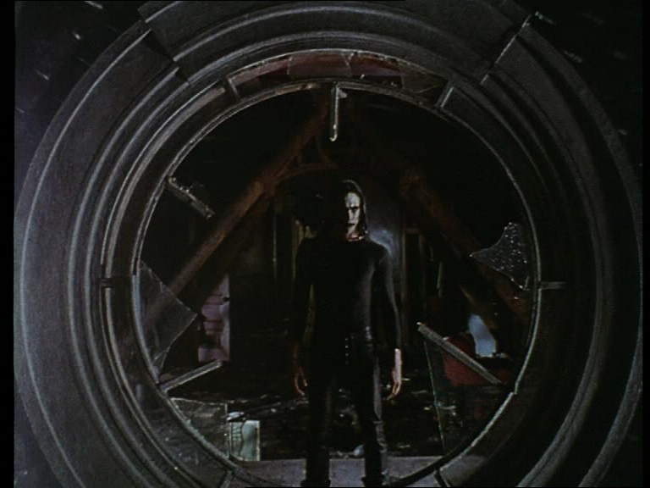on shoulder
lightning flashes – thunder rolls
camera tracks back -lightning flashes as Eric is framed in circular window of loft

