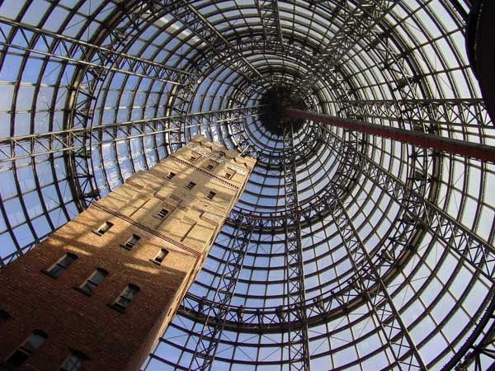
08
Fall
VET Use digital cameras to create photo images

[Student Name __________________________

Photography Cityscape Excursion

Students are not permitted to shop or play arcade games on this excursion
Students are representing the school and are expected to conduct themselves responsibly at all times.
In the event of any student having an accident or feeling unwell the Group leader must contact the Teachers immediately

Staff and Students will leave for first Destination- Melb Central Shot Tower in class Group

Each Group will be assigned with one SLR Camera + students to bring their own digital camera :

Each Group must follow the designated route –

Group Leader to report to teacher at 11.30 : check 1
-via mobile phone or in person
All students to meet for Lunch at Macdonalds Swanston st for check 2
Group Leader to report to teacher for check 3 at 2.pm
Final check 4 of all groups in the Media room at 3pm

Morning session 10-30 – 12.30 4 sections
1. Lonsdale st – Melb Central 30 mins
2. Melb Central to Bourke St Mall- Union lane- Swanston 30 mins
3. Swanston – Collins- Centre Lane- Degreaves St- Flinders 30mins
4. Flinders – Hosier Lane Flinders Lane to Swanston to Macdonalds
30 mins

Afternoon Session 1pm -3pm
1.Swanston- Federation Square – Princess Bridge – Southbank 45 mins
2.Southbank Promendade- Kings Bridge 30 mins
3Kings Bridge – Bourke St 30 mins
4.Bourke st – Lonsdale 15 mins

Please view MAP and follow written directions

Compositions to take
The walk has been designed to enable students to photograph a variety of compositions

Shot Tower – Melbourne Central Bourke St Mall - Street performers – Shop Window displays Union Lane – Graffiti Collins – Swanston – Cityscapes – Town Hall – St Pauls Centreway and Degreaves St - Cafes- Grafitti Flinders St – Shop Window Displays – Flinders St Station Federation Square – Hosier Lane Graffiti Princess Bridge- Southbank – The Yarra River and CityscapesBridges- Sculptures- Statues- Crown Casino – The Melbourne Aquarium – The Rialto- Modern Buildings- Old Buildings People –

Or try some of these

- Take a group portrait, for purposes of identifying the camera later on.
- Take a shot using the rule of thirds for your subject.
- Shoot a scene of ugliness, degradation or squalor.
- Take a bird’s eye view shot of a subject looking upwards at camera.
- Take a shot of a subject through a reflective surface or medium.
- Shoot a scene creating vast depth by using an aperture of f22 eg cityscape
- Take a depth of field shot with only the middle ground in focus. F5.6
- Freeze a water subject using fast shutter speed.
- Blur a water subject using small aperture and slow shutter speed.
- Shoot an extreme close up of a ‘willing’ subject’s face.
- Take a low angle shot of approaching pedestrians on footpath.
- Take a cluttered shot in the Bourke Street mall.
- Take a portrait shot with one side of the subject’s face in shadow.
- Take a low angle shot of an historically old building.
- Take a fast shutter shot of a waiter at work.
- In a dark, indoor environment, use a very slow shutter speed to show the interplay of light throughout the space.
- Take a close up shot of an emotional human face.
- Take a photograph dominated by geometrical shapes.

Remember the composition guides you have learnt in class

The rule of Thirds- Using Lines – Shapes- Framing

Experiment with the Camera- The A setting is for Aperture

F2.8 large aperture lets maximum light into the camera
F22. Small aperture lets minimum light into camera – but gives large depth of field

The S Setting is for the Shutter- experiment with Shutter speeds

1/60 is a slow shutter speed - whereas 1/1000 is a fast shutter speed good for freezing fast moving action

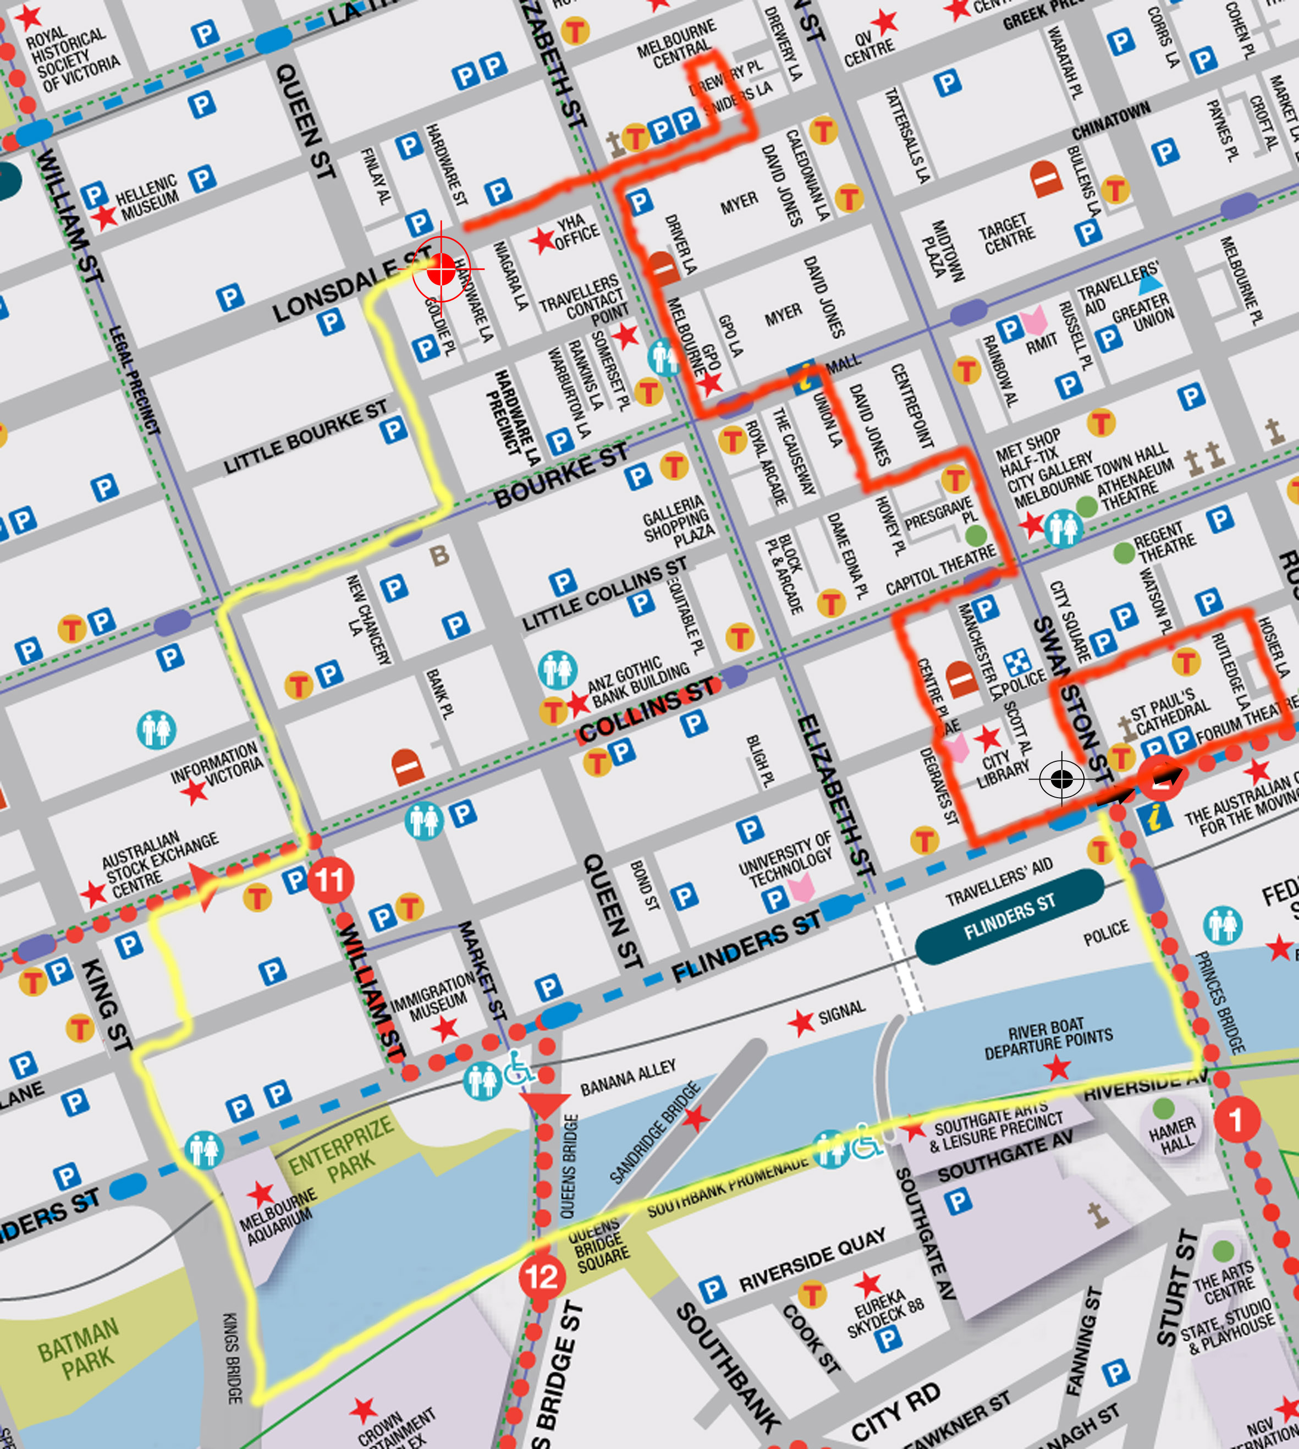

RED - Morning Session 10.30- 12.30
Lunch Macdonalds 12.30- 1.00
Yellow - Afternoon Session 1.00- 3.00pm
Media Room to return Cameras

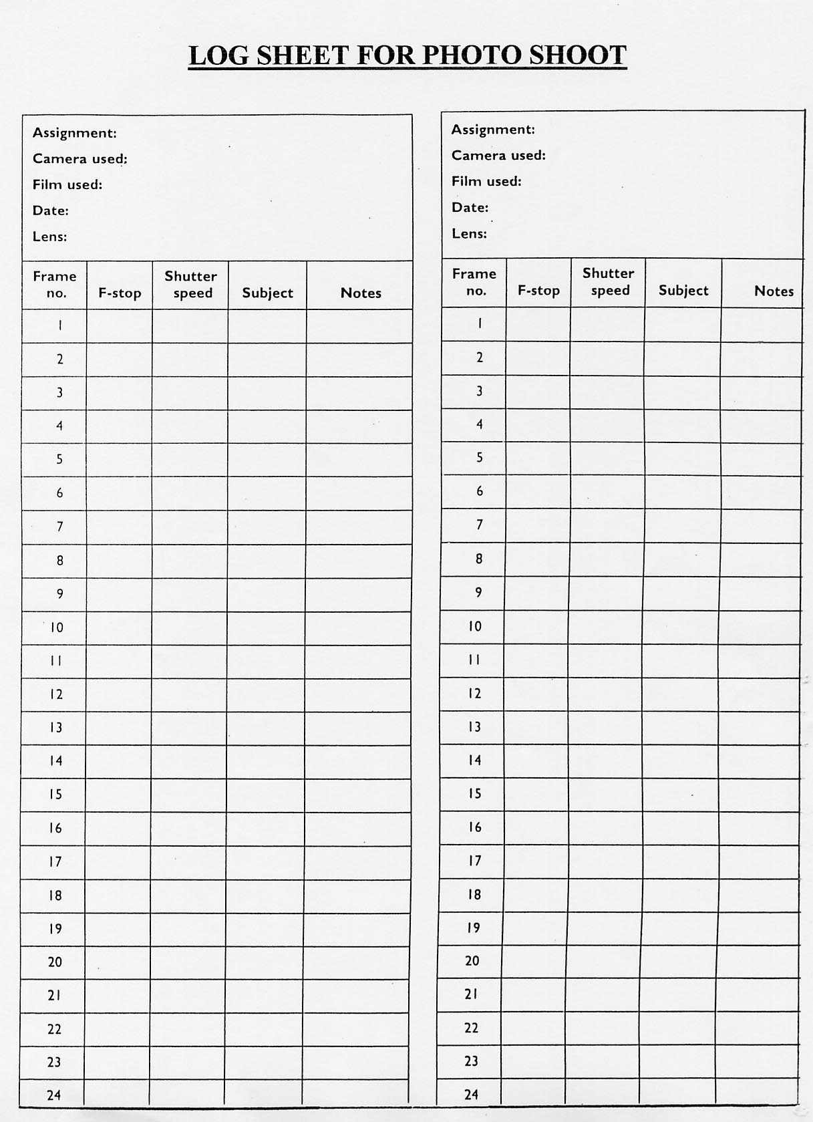

Walking Photography Cityscape Excursion

Proceed down Lonsdale across Elizabeth to Melbourne Central - Location – Atrium Shot Tower – take some photographs of this unique structure

Proceed back out of Melbourne central to Lonsdale st- back to Elizabeth St - travel down Elizabeth to Bourke St -turn left into Bourke St Mall - photograph any street performers
Interesting shop front windows- find Just jeans- and turn into Union Lane – where you can take photos of Graffiti on the lane wall

Continue through lane then turn left into Little Collins look up for cityscape photos continue to Swanston St – proceed along Swanston – turn left at Collins st - walk down to Centreway Lane turn left into lane - take photos of cafes -

Continue over Flinders Lane to Degreaves Lane- more cosmopolitan cafes to photograph

At Flinders st- turn left ----- look out for Display in The Closet Vintage clothing shop

Walk to Flinders / Swanston St intersection- many great photo opportunities here- St Pauls Cathedral / Federation Square/ Flinders St Station --- walk across to St Pauls Cathedral – continue walking along Flinders past ACMI centre-

Turn left into Hosier Lane – very artistic graffiti -- to shoot

Continue through lane into Finders Lane –turn left -- look for interesting compositions
e.g at 205 look through to Federation square- - Also The Westin Melbourne and as you reach Swanston st – look for the repitition of umbrella’s at Brunetti’s café

cross the road – and walk towards Flinders St Station- We are meeting upstairs at Macdonalds at 12.30 for lunch

1.00- - Cross the traffic lights to Flinders St Station- again great photo compositions here – cross the traffic lights to Federation Square – take some time to walk around Federation Square and take some compositions

Cross the road back to Flinders St Station and proceed to walk towards the Yarra bridge
On the bridge take some compositions of Southbank and the Yarra- and look across to the other side – Ferris Wheel

At the end of the bridge turn left – to the upper Terrace overlooking Southbank and the river- - take some shots here

Proceed into southbank—( upper level) walk to escalators- take shot of the large Globe
Proceed down escalator –then stairs to ground level

walk along Southbank boulevard - many things to photograph – bridges – river – cafes –statues -

Continue to Crown Casino – look for the steel sculptures on the bridge – and sculptures outside of Crown

Cross bridge to Melbourne Aquarium- again some good photos from the bridge- At aquarium – take a shot of the window display

Proceed past Aquarium ( Kings Way) at Flinders St – look up and take shot of Snap Crackle and Pop Billboard—carefully cross road- and continue to Flinders Lane turn right into Flinders Lane – walk to Rialto building – go up the escalator into Rialto Atrium

Look up – some very interesting angles and building shapes to photograph

Continue to Collins st - past mother and child sculpture

Turn right into Collins and then left into William St

Outside NAB building look for view of Southcorp and Oaks building to photograph
Look across the road at very old buildings to photograph

Continue along William at 140 take shot of glass building

At William and Bourke - take a shot of CGU building -with reflection

Turn right at Bourke St- look back down the street for cityscape photos

Proceed along Bourke st – past clock outside RACV building

Turn left at Queens St

Turn Right at Lonsdale st to Melb central- to train station

Return to school-- ALL CAMERAS MUST BE RETURNED AT THIS TIME TO THE MEDIA ROOM

