Youtube’s Impact On Our Society

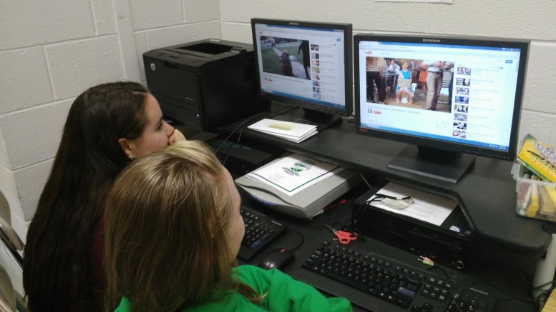
The amount of time we spend on YouTube can be very obsessive. In our society, we use Youtube for many purposes, and even in school. If you think about the amount of times you view YouTube videos daily, it can sometimes add up to thirty minutes to an hour. (Photo Courtesy of Kayla Fortson)
POSTED BY: KAYLA FORTSON, STAFF WRITER 2016-17 NOVEMBER 16, 2015
Statistics
Over the last two years, studies show that the growth of time users spend on Youtube is 60%.
- 80% of YouTube’s views are from outside of the United States
- You can access YouTube in 76 different languages, which covers 95% of the internet population.
- The average viewing session on mobile is 40 minutes daily.
- More than half of YouTube’s views are from mobile devices.
- 10% of YouTube’s videos can be viewed in HD.
- Over 700 YouTube videos are shared on Twitter each minute.
- YouTube is the third most viewed website after Google and Facebook.

Youtube, a video-sharing website, impacts our society a lot more than we might think. Youtube was founded over ten years ago on February 14, 2005 and has been an influence on our society ever since. When you click on a Youtube video, do you watch it because the title is relatable or because it’s humorous? Probably the latter, which is understandable because in our society it’s common to humor each other by sharing videos, pictures, or any kind of media to peers and family.

Although some videos on Youtube are made for entertainment, many videos have advice for people who are seeking help on various beauty how-to’s and tutorials. Famous beauty guru’s such as Zoella, Bethany Mota, Rclbeauty101, and Meredith Foster convey information and tips primarily to teenage girls such as routines, hauls, monthly favorites, DIY’s, expectations vs. reality, outfit ideas, and makeup/hair tutorials.

Artists and bands that have a Youtube account, specifically Vevo, play a big part in our society by releasing new singles or albums on their account, gaining viewers and fame. Undiscovered singers often gain spotlight on Youtube by uploading covers of popular songs ultimately getting feedback, hopefully leading to getting scouted. Singers that start on Youtube and got discovered are Justin Bieber, Carly Rae Jepsen, and Cody Simpson. Justin Bieber was spotted by a talent scout who arranged for him to meet Usher. Carly Rae Jepsen’s single “Call Me Maybe” was promoted by Justin Bieber after he tweeted ‘Call me maybe by Carly Rae Jepsen is probably the catchiest song I’ve ever heard lol’ to over 18 million followers at the time. Cody Simpson was scouted at the age of 12 by record producer Shawn Campbell, leading him to sign with Atlantic Records.

Youtube’s effect on the United States has given opportunities for people to upload song covers or original content for their videos in hopes of getting discovered from companies. Many Youtubers have simply posted a video on Youtube, without thinking about how many views and/or subscribers that they will get. Youtube also affects the United States by broadcasting presidential elections, politics, commercials, and recent news. Many Youtubers will post videos with amusing and unnecessary thumbnails to entertain and get viewers attention which can lead to a misinterpretation of the actual video.

Publically posting videos on topics related to worldwide news such as shootings, debates, and political campaigns can have positive or negative impact on viewers. Whereas some viewers will take the news positively and applaud the topic of the video, others may take it negatively by commenting unnecessary and useless comments, possibly targeting people in the video, resulting in a cyber argument. Some videos on topics such as political campaigns and debates can also be misleading to viewers if the uploader is not showing the full conflict, and only defending their side, resulting in a biased video. Biased videos show the negative impact on Youtube in our society by showing only what society wants to see, and not the major and foremost problem.

YouTube’s influence can be a positive or negative impact on our society by the diverse of YouTube videos. Many YouTubers upload opinionated videos on current events or topics from their perspective. If viewers believe and/or agree with the content of the video, they will most likely become influenced, regardless or not if the topic is positive or negative. Even though some videos on YouTube are not made to persuade or entertain people, the majority of them have a purpose.

Source: http://www.jeffbullas.com/2012/05/23/35-mind-numbing-youtube-facts-figures-and-statistics-infographic/

