Week 1

Text types and Literary Texts
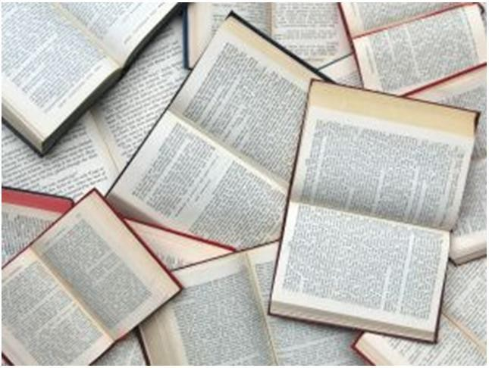
We assess and report against the Australian Curriculum. Each week we will be covering different parts of the curriculum in the course notes and activities. Make sure you read all of the notes each week and follow the instructions for activities very closely. If you are at all unsure about what to do then contact your teacher for assistance.

Learning Goals for Week 1

By the end of this week you will learn to:

- Identify and provide examples of the types of texts you have read.
- Critically discuss and analyse a short story.
- Identify the different types of genres and provide your own examples.
- Identify purpose and audience in different types of literary texts.
- Plan, create and present a short character description.
- Draft, proof-read and revise your work for accuracy in spelling, grammar and sentence structure.

‘Types of texts’ and you
Throughout the year you will come across many different ‘types of texts’, not only in this English course, but in many of your other subjects, as well as in your everyday life, texts are all around you!!
Before we have a look at the different ‘types of texts’ that we will get you to work with in English, we want you to have a think about the ‘types of texts’ that you have read in the past two months. For example, have you read a novel? Do you read the newspaper (either online or paper version), magazines or comics?
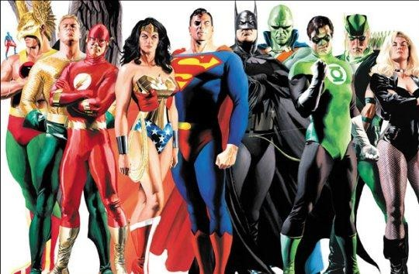

List the ‘types of texts’ that you have read below and provide examples of them.
SENSEDEND
Activity 1: My texts
Please also attach one example of some of your texts, such as a newspaper clipping, a
blurb from a novel, a magazine article, etc.
SEND

Text Type | Example
Magazine | Who Weekly

These are the text types that we will be looking at throughout the year:

Literary texts –
- Novels and short stories
- Poetry
- Plays
- Narrative films

Persuasive texts –
- Editorials
- Letters and emails to the editor
- Opinion pieces
- Opinion writing online

Informative texts –
- New reports
- Biographical texts
- Documentary films

Visual, multimedia and digital texts –
- Visual can include; cartoons, photographs, posters, charts, graphs, tables and other visual aids
- Multimodal texts can include; advertisements and television current affairs programs
- Digital texts can include; e-texts, websites and social networking sites

Texts at work
A text is a form of spoken, written or visual communication which is to convey meaning to an audience. A text could be – factual, literary, visual, media and everyday texts. Texts include – novels, poems, newspaper articles, films, reviews, jokes, cartoons, comic strips, advertisements, emails, scripts, diaries, letters, paintings, posters, photographs, brochures and autobiographies.
The choice of words in a written text enables the writer to introduce certain attitudes and feelings: for example, anger, informative, irony, genuine, sympathetic, critical or joyful. These attitudes and feelings form the tone of the text. It is through the writer’s tone that the emotional message of the text is communicated to the audience.

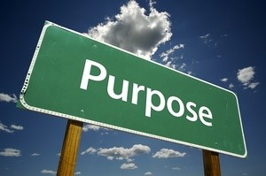
Activity 2: Identifying purpose and audience
SENSEDEND
SEND

1: Write down the purpose and audience for each of the following texts.

- A school report
  - Purpose:
  - Audience:

- A letter to the editor of a newspaper
  - Purpose:
  - Audience:

- A car manual
  - Purpose:
  - Audience:

- A travel brochure about travelling to Asia
  - Purpose:
  - Audience:

- Nursery rhymes
  - Purpose:
  - Audience:

- A television guide
  - Purpose:
  - Audience:

- The blurb on the back cover of a novel
  - Purpose:
  - Audience:

- A restaurant menu
  - Purpose:
  - Audience:

- A film script
  - Purpose:
  - Audience:

2: Reflect back over the texts that you identified earlier in Activity 1 and see if you can identify the purpose and audience that they are trying to target.
 | Text Type | Example | Audience | Purpose
 | Magazine | Who Weekly
Adapted from Sadler Rex & Sadler Sandra, Complete English Basics: A class and homework course 4, 2nd
Edition, Macmillan Education Australia Pty Ltd, 2011 (pp. 6 – 8)

Before we go any further it’s important to introduce you to some of the key terms and phrases that you will come across throughout the year. This will assist you in completing tasks throughout the year.

Key Terms:
Analyse – examine texts in detail in order to show the meaning

Compare – emphasise similarities and differences between two or more texts

Contrast – compare by showing the differences Demonstrate – show or explain; use evidence to prove Discuss – write in detail, giving arguments for and against
Explain – make clear the cause or reason, giving evidence in support

Express – show clearly in writing

Extend – give more detail; go further beyond

Generalise (make a general statement) – make a summary statement about information given, without specific details
Give evidence – include detail from text to support

Identify – give the name, nature, characteristics, etc. of a person or thing

Illustrate – make clear in writing, using examples

Interpret – explain the significance of the information given Justify – show to be right by using convincing evidence Quote – repeat words or data exactly from an original source
Review – examine (or re-examine) and discuss critically, usually in a written account

Summarise – choose the key points and express them in a shorter, clearer form
Add to this list throughout the year in your Everyday Words graphic organiser.
As you read through your weekly work identify any words that you have come across that you are not familiar with, and add these to the graphic organiser with a definition of that word so that you can refer back to it throughout the year.

Words you will come across throughout your weekly work: Autobiography – the story of a person’s life, written by themselves Biography – the story of a person’s life, written by another
Broadsheet – a newspaper with a large format and regarded as more ‘serious’ than a tabloid

Caricature – a depiction of a person in which distinguishing characteristics are exaggerated, usually for comic effect or to ridicule
Characterise – to build a picture of a character for the reader Colloquial – language used in ordinary conversations, not formal Context – the circumstances that form the setting for an event
Convince – to cause someone to think differently; to believe in, agree with or accept an idea

Criticism – the expression of disapproval of someone or something; a critical assessment of a text
Emphasis – special importance given to an idea, or stress laid on a word or words in speech

Generalisation – a broad statement made by inferring something from specific cases. For example ‘all dogs are vicious’.
Genre – a style or category of text

Metalanguage – a set of terms used for the description or analysis of how language is being used
Metaphor – language that makes a comparison by stating that one thing is another, in a non- literal sense. For example, ‘he is the giant of the team’.
Narrator – the person telling a story in texts

Persuade – to provide sound reasoning or argument; convincing and effective

Plot – the events of a story

Protagonist – the main character in a text

Rebuttal – ideas and evidence presented to contradict or nullify an opposing argument

Repetition – the act of repeating or restating a word or phrase

Sensationalism – in journalism, the practice of focusing on one shocking or curious aspect of a story that may not be the main point
Simile – language that makes a comparison by stating that one thing is like another. For example, ‘he was as brave as a lion’.

Stereotypes – assumptions about groups of people that may not be true

Subplot – a secondary story that is told alongside, and usually connected to, the main plot

Tabloid – a newspaper with pages half the size of a broadsheet, popular in style and dominated by sensationalist stories
Target audience – a group for whom a text is designed or intended

Themes – the main idea of a text, for example a novel or film might explore themes such as growing up, bravery or relationships
Add to this list throughout the year using the Everyday Words graphic organiser.
As you read through your weekly work identify any words that you have come across that you are not familiar with, and add these to the graphic organiser, with a definition of that word so that you can refer back to it throughout the year.

EVERYDAY WORDS
- Identify all the new words that you have encountered during the lesson, and list them in the left hand column.
- Over the next 24 hours, use the words as much as possible in your conversations.
- Record how you used the word, and note how you would explain the word to others.
- Be sure to continue using the words whenever you can throughout the next few days.

Word | How I would explain the  word | How I Used it

EVERYDAY WORDS
- Identify all the new words that you have encountered during the lesson, and list them in the left hand column.
- Over the next 24 hours, use the words as much as possible in your conversations.
- Record how you used the word, and note how you would explain the word to others.
- Be sure to continue using the words whenever you can throughout the next few days.

Word | How I would explain the  word | How I Used it

Learning about different ‘literary texts’

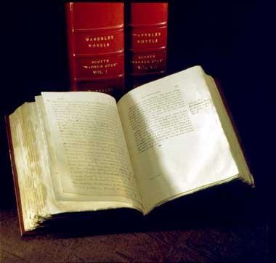
Novels
A novel is a piece of writing that is imagined or invented and allows us to enter the worlds and lives of the characters. But what exactly is a novel you ask?
A novel is made up of many elements and it is more often than not an imaginative narrative, which tells a story (plot) of imagined people’s lives (characters). Also, many novels explore broad ideas (themes) and an author conveys a message to the reader about these ideas.

Elements of a novel

Plot – the action of the story, what actually happens and/or takes place. Orientation – Complication – Rising action – Climax – Resolution.
Characters – many novels tell the story of an ordinary or believable main character, who is often referred to as the protagonist.
Theme – the theme is what the novel is about, it is not a summary of the events that take place throughout the novel. The theme is the main idea, problem or message expressed through the plot and characters.
Background or setting – this is the time in history, and the geographical location in which the novel unfolds. However, for some novels the background or setting does not play a big part in the narrative, whereas, in others it is an essential part of the narrative. For example, in Harry Potter and the Philosopher’s Stone the setting is particularly important – Hogwarts School of Witchcraft and Wizardry, Platform 9 ¾ and the Forbidden Forest present a vastly different world from the one we live in.
Language – it is important to note that the themes of a novel are also explored by the language the author uses. When reading a novel it is important to understand the style of the text, this means looking at the tone, language, sentence structure and imagery that is used by the author, as well as who the target audience is and the purpose of the novel.
Other things to consider while reading your next novel –

  - What does the novel reveal about the age, gender, society or culture of the author?

  - Is the author presenting a biased point of view of events, characters or places?

Short stories
A short story has all of the features of a novel, but as it is in a short self-contained form, it does not have the luxury of unlimited words. A short story deals with a single event or situation, and as a result every word must be carefully chosen to create the overall impression the author wants to achieve.
The Honey Thief: short story

The Honey Thief is a collection of short stories from Afghanistan, written by Najaf Mazari and
Robert Hillman. ‘Tenderly evocative’, ‘poetic’, ‘dreamy’, ‘wise’ and ‘imaginative’ are not usually the first words to enter our minds when thinking of Afghanistan, however, these words exactly describe the ideas and emotions stirred by this poignant story of a young boy and his insightful grandfather in the harsh landscape of Afghanistan. Najaf Mazari, a young shepherd boy who eventually became a master rugmaker, witnessed truly terrible things in Afghanistan. However, instead of letting hatred and violence consume him, he was able to transform these potentially soul-destroying emotions into hope. By 2001, Mazari fled the repression and brutality of the Taliban, and sought refuge in Australia. Mazari explains the optimism and charm of his writing with these words, ‘…I chose peace over fighting. I had seen enough bloodshed to turn me away from war forever. In my writing, I try to show how peace calls for more imagination than war. Once you can imagine peace, war seems primitive.’
Read the excerpt below from ‘The most intelligent of creatures’ taken from The Honey Thief,
and then answer the questions on the following page.
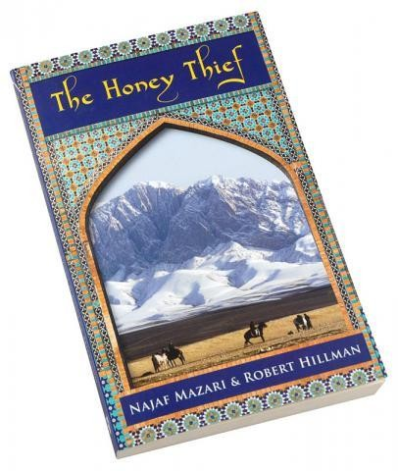
Each morning, Esmail told the boy one of the stories for which he was famous.
The first story he told was of a man whose hearing was so sharp that he could hear the sound made by cloud shadows as they passed over the land below.

‘And what sound do the cloud shadows make?” asked the boy.

‘A cloud moving fast makes a sound like this,’ said Esmail, and he put his lips together and whistled softly, almost too softly to hear. ‘But when the wind is light and the clouds travel slowly, they make a sound like a flower opening in the sun.’

Abbas smiled. He had a practical mind and he didn’t believe that the stories he was told by Esmail were strictly true.

‘My hearing is good,’ he said. ‘I can hear the sound of pebbles rolling when a red fox stumbles a long way off. But I have never heard a shadow.’

Nevertheless, he enjoyed listening to the old man. While they were being told, he believed the stores for the pleasure of it. The old man had tales to tell of horseshoe bats that flew

across the sky in such numbers that they blacked out the light of the moon; of brown bears that held conversations with human beings; of snow leopards that sang songs.

When he’s finished a story, Esmail would ask the boy if he’d enjoyed it. The boy would say, ‘A snow leopard cannot sing,’ or ‘Bears don’t talk,’ by he always said it with a smile. As he grew older, he understood that Esmail had such mastery as a storyteller that sometimes he would become fanciful just for his own amusement.

If the old man had only told stories of talking bears and singing leopards, he would not have built the reputation he had amongst our people, the Hazara. He was considered a man of learning, even though he had never been to school.

Men came to him when they were troubled and listened to his advice. He spoke quietly on these occasions, sometimes standing, sometimes sitting. He carried a staff with him everywhere, made from the wood of a gundy tree and worn smooth all along its length.
When he gave advice, he would tap the base of the staff on the ground, digging up the soil just a little, as if this helped him to concentrate. He gave advice on disputes between
families, on marriages, on children who were growing up wild.
O’Shea Rosemary, Insight English Skills 10, Insight Publications Pty Ltd, 2011 (pp.104 – 105)
SESNEED ND

Activity 3: Short story analysis
Read through the above extract once again and answer the following questions, which will help you understand how authors use descriptive language to create atmosphere, meaning and emotion.

1: What opinion does Abbas have of his grandfather’s stories? How is this conveyed in the short story?

2: What are his feelings towards his grandfather? Support your response with evidence from the text.

3: What do we learn about the qualities that Abbas possesses? Find a quote to illustrate your point.

4: Describe Esmail. His words convey details about the type of person that he is. What do we learn about him?

5: Identify your favourite piece of descriptive language, and discuss the emotions/reactions that it evokes from you.

6: Why was Esmail perceived to be a ‘man of learning’ and respected by his people, despite never having gone to school?

7: Are there different ‘intelligences’ other than those we gain from the study of books and theories?
Adapted from O’Shea Rosemary, Insight English Skills 10, Insight Publications Pty Ltd, 2011 (pp.106 – 107)
SEND
Poetry
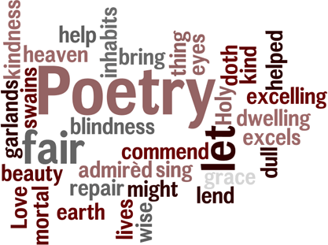
Unlike many other types of literary texts, poems often do not have a narrative; they do not tell full stories. Instead, poems often seek to create an impression, or to evoke an emotion. While poetry can be very flexible, and much of the challenge and enjoyment of poetry comes from the lack of absolute rules, you should be aware of some common features of poetry. In order to be able to understand poetry, it helps to understand form, voice, metre, rhyme and imagery.

Plays
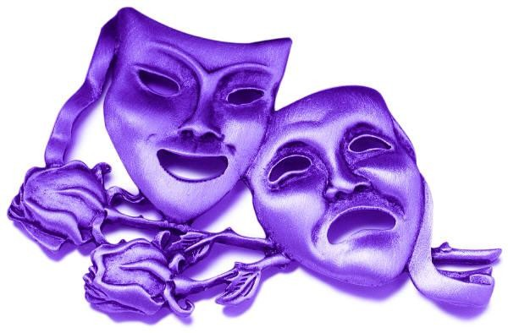
The main characteristic that distinguishes plays from the other literary forms that we have looked at so far, is that plays are written to be performed. Most modern plays are performed in theatres and on stages with sets that re-create the play’s location, and with actors that play out the action and deliver the dialogue. One interesting consequence that happens when staging a play is what happens to the narrative
voice. While the audience is able to see what the characters are like and what the play is about through the characters, their dialogue and their actions, there is usually no narrator to guide the audience. Therefore, without a narrator to help the audience, the playwrights need to make careful choices to convey information about the characters and story.

Narrative Films
Studying narrative films requires you to think about the film-making process, in particular the collaborative nature of film-making. Whilst a novel is written by an author working in relative isolation, a film is a group effort, as the director is responsible for most of the stylistic and structural choices. However, it is also important to consider the influence of the screenwriter, producer, cinematographer, set designer, costume designer and editor.

Genre
SEND
‘Genre’ is a French word that means kind or type. All literary texts can be categorised into different genres – fantasy, crime, romance, horror and Sci-Fi.
All genres have their own common features and characters that are particular to that genre. For example, a fantasy text has a world of dragons, ogres, giants, heroes, heroines, witches and wizards. The Harry Potter series would fit into this genre.
Can you think of any other genres? If so list them below and the literary texts that they relate to.
SENSEDEND

Activity 4: Genres in Action

1: List any other genres that you have come across and list the book that it relates to. For example;
- adventure genre would be Hunger Games.

2: Use words from the box below to answer these questions.
Who am I?
- I travel into space.
- I am a dead body.
- I bring legal action against people.
- I am similar to a magician but use evil spirits.
- I share in a crime.
- I suck on the blood of living people.

What am I?
- I am a place where prisoners are kept.
- I am a place where the dead are buried.
- You would have trouble finding your way out of me.
- I am an underground prison.
- I am sometimes called a falling star or a shooting star.
- I am an angry argument.
 | Fantasy | Crime | Romance | Horror | Sci-Fi
 | labyrinth | detective | captivating | malevolent | satellite
 | magician | accomplice | infatuated | vampire | astronaut
 | ogre | investigator | quarrel | ominous | interplanetary
 | disappear | alibi | attractive | corpse | mission
 | mysterious | custody | embrace | cemetery | meteorite
 | enchanted | jail | mutual | dungeon | asteroid
 | sorcerer | prosecutor | Affection | tomb | orbit
Adapted from Sadler Rex & Sadler Sandra, Complete English Basics: A class and homework course 4, 2nd
Edition, Macmillan Education Australia Pty Ltd, 2011 (pp. 64 – 65)

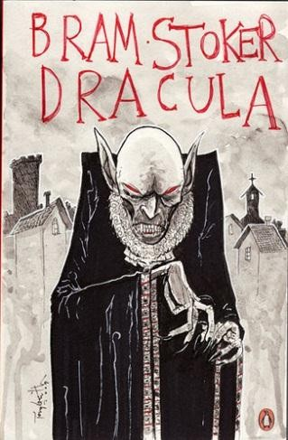
Characters
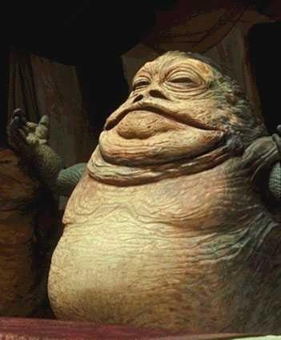
Using the examples below we would like you to create a fictional creature or character of your own that belongs to one of the genres listed on the following pages. You need to ensure that you make your character interesting by providing details about the character’s appearance.

Jabba the Hutt
His head was three times human size, perhaps four. His eyes were yellow, reptilian – his skin was like a snake’s, as well, except covered with a fine layer of grease. He had no neck, but only a series of chins that expanded finally into a great bloated body, engorged to bursting with stolen morsels. Stunted, almost useless arms sprouted from his upper torso, the sticky fingers of his left hand languidly wrapped around the smoking-end of his water- pipe. He had no hair.
From Return of the Jedi by James Khan

Dracula
His face was a strong – a very strong – aquiline, with high bridge of the thin nose and peculiarly arched nostrils; with lofty domed forehead, and hair growing scantly round the temples, but profusely elsewhere. His eyebrows were very massive, almost meeting over the nose and with bushy hair that seemed to curl in its own profusion. The mouth, so far as I could see it under the heavy moustache, was fixed and rather cruel-looking, with peculiarly sharp white teeth; these protruded over the lips, whose remarkable ruddiness showed astonishing vitality in a man of his years.
From Dracula by Bram Stoker
Sadler Rex & Sadler Sandra, Complete English Basics: A class and homework course 4, 2nd Edition, Macmillan
Education Australia Pty Ltd, 2011 (pp. 67 – 68)

In order to help you write your character description it is important that you use adjectives, all good writers use adjectives to make their subjects more interesting to the reader. An adjective adds colour, shape, size, strength, feeling or some other quality to a noun.
SENSEDEND

Activity 5a: Writing in detail – using expressive adjectives

Replace each of the adjectival phrases below with a strong adjective from the list below. We have completed the first one for you.

destitute terrified anxious hideous furious ancient gaunt villainous spotless precious colossal jubilant feeble delicious spacious idiotic perilous solemn minuscule parched ravenous insolent ferocious vivacious
 | very poor | destitute | very weak
 | very angry |  | very stupid
 | very tasty |  | very valuable
 | very ugly |  | very serious
 | very roomy |  | very small
 | very fierce |  | very lively
 | very hungry |  | very risky
 | very large |  | very happy
 | very wicked |  | very thin
 | very rude |  | very worried
 | very dry |  | very clean
Adapted from Sadler Rex & Sadler Sandra, Complete English Basics: A class and homework course 4, 2nd
Edition, Macmillan Education Australia Pty Ltd, 2011 (pp. 67)
SEND
SENSEDEND

Activity 5b: Writing in detail – my character
SEND
Using the examples above as a guide we would like you to create a fictional creature or character of your own that belongs to one of the following genres:
- Horror
- Crime
- Western
- History
- Adventure
- Thriller
- Fantasy
- Romance
- Supernatural
- Science fiction

You need to ensure that you make your character interesting by providing details about the character’s appearance using expressive adjectives to help you, and your description needs to be between 100 – 150 words.

For content:

References

Johnstone Ryan & Horne Michael, Oxford Year 10 English Australian Curriculum, Oxford University Press, 2012 O’Shea Rosemary, Insight English Skills 10, Insight Publications Pty Ltd, 2011
Ramsey Margaret, The Complete Guide to English Usage for Australian Students, Nelson Cengage Learning, 2011 Sadler Rex & Sadler Sandra, Complete English Basics: A class and homework course 4, 2nd Edition, Macmillan Education Australia Pty Ltd, 2011

For images:
http://learn-english-india.blogspot.com.au/2012/01/importance-of-english-language.html http://www.transpositions.co.uk/2010/10/are-labels-useful-or-why-im-not-sure-aboutchristian- literature/
http://www.acpmagazines.com.au/magazines.htm http://janellemccullochlibraryofdesign.blogspot.com.au/2012/06/is-this-week-end-of-print-media.html http://www.reddskull.com/
http://www.netrafic.com/blog/your-audience-is-your-priority/ http://lifeinthefastlane.com/2012/09/purpose/ http://pogomonster.wordpress.com/2011/07/10/reflections-on-finishing-another-novel/ http://ecodirectory.com.au/business/new-internationalist-shop/honey-thief http://soulfulinsights.blogspot.com.au/2012/06/poetry.html http://www.freewebs.com/midmichfamilytheatre/graphics.htm http://blog.crowdfunder.co.uk/2010/11/04/the-success-of-crowdfunding-films/ http://en.wikipedia.org/wiki/File:JabbaTheHutt.jpg http://www.flickr.com/photos/24905220@N00/3402406560/ http://bioeventspr.com/tag/event-planning-2/

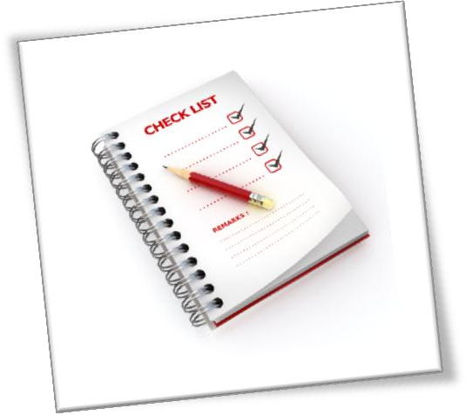
Checklist . . .

This week I have attached and sent the following to my teacher:

Activity 1: My texts

Activity 2: Identifying purpose and audience Activity 3: Short story
Activity 4: Genres in action Activity 5a& 5b: Writing in detail

SUBJECT English

STUDENT NUMBER STUDENT NAME
MODULE A WEEK
TEACHER
PLEASE CHECK THAT YOU HAVE ATTACHED:
- Activity 4: Genres in action

- Activity 5a & 5b: Writing in detail

- Activity 1: My texts

- Activity 2: Identifying purpose & audience

- Activity 3: Short story

REVIEW, REFLECT AND ASK

I found this week’s course work: ( ) Very interesting  ( ) Interesting  ( ) Sort of interesting  ( ) Not interesting | I think the work was:  ( ) Too easy  ( ) Easy  ( ) OK  ( ) Got me thinking and challenged me  ( ) Hard  ( ) Too hard
Questions I have about this week: (Why? What? When? Who? How?)

TEACHER’S COMMENTS

Some great things about your work were:

Please consider doing the following next time:

