Year 11 Photography
The SLR Camera Students in pairs will practice using some functions of the SLR FILM Camera
1.Motion
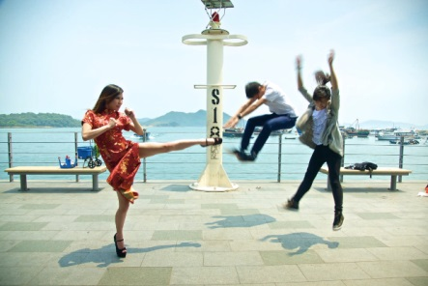
1. Select a fast shutter speed : On your camera turn the dial 1/500 sec Have your partner run or jump in the air to determine if you can freeze motion . Try a range of action compositions using faster shutter speeds. E.g. 1/1000 sec

2. Now select a slow shutter speed e.g. 1/60 or 1/30 sec and take the same photographs to create motion blur.
3. Set your camera shutter at 1/60 sec: This time have your partner run and using the panning technique follow your partner in motion and press the shutter release button. By panning your subject should be sharp but the background will be blurred also giving a sense of motion
4. A variation on this is to try to take a shot of your partner with a shutter speed of 1/60 - but in the background have 1 or 2 other students run by. This should also create background blur
4. Try the following exercise. Using a long shutter speed of somewhere around a 1/4 second, take a picture of someone who is slowly waving her arm back and forth. Because the arm moves across the image, it does not stay in one place long enough to register on the film and "disappears."
2.Depth of field
Find a subject, preferably a fixed subject (a subject that is not moving). For example a flower or your partner - anything you can within the school Make sure your subject is in the foreground and that there is background behind your subject
Set the shutter at 1/125 sec
Set your aperture to its widest opening, or set it to the smallest f/stop number- which may be f2.8 or f5.6 Take a picture of your fixed subject.
Now, change your aperture setting to say, f/8 and take a picture of your subject again. Next, change your aperture setting to its smallest opening. In other words, set it to the highest f/stop number, for example, f/22. Take a photo of your subject again.
3.Portrait - take a portrait shot of each other - 1 close up - 1 medium shot ( look to use a complementary background for your subject
4 Alia scape - take a photograph that you feel best captures the essence or a feature of Alia College
5. Architecture – take a photograph showing a feature of the architecture of the Alia College building – consider framing - form – texture – balance

