The Crow
Opening
Black screen
Non diegetic - rhythmic drum cymbal beat
Diegetic Police siren ( creates a mood of danger)
Note how the use of sound is important to establish mood before the first screen shot – how may this be received by the audience?
Establishing long shot cityscape- as fires burn from buildings below
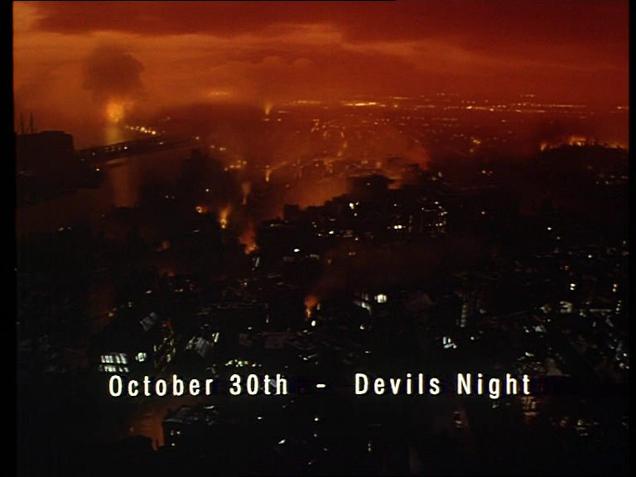
Screen text October 30th- Devils Night
Haunting non diegetic music
Women’s voice from police base radio’s control car
Note how the use of sound is important to establish mood
Combines with
Establishing shot cityscape- re sky as fires burn from buildings below
Camera tracks forward across roof tops
Voice narration from young girl (Sarah)
“People once believed when someone dies a crow takes their body to the land of the dead.
Camera decants suddenly ( turns to left) and appears to replicate the flying movement of a crow
Narration continues “But sometimes –something so bad happens that a terrible sadness is carried with it and the soul cant rest. Then sometimes just sometimes the crow can bring that soul back to put the wrong things right”
Camera tracks forward to a medium shoot of circular window of a loft high above street level. A policeman is framed within the circular window and many others behind him appear to be investigating the room. The room is bathed in diffused red light
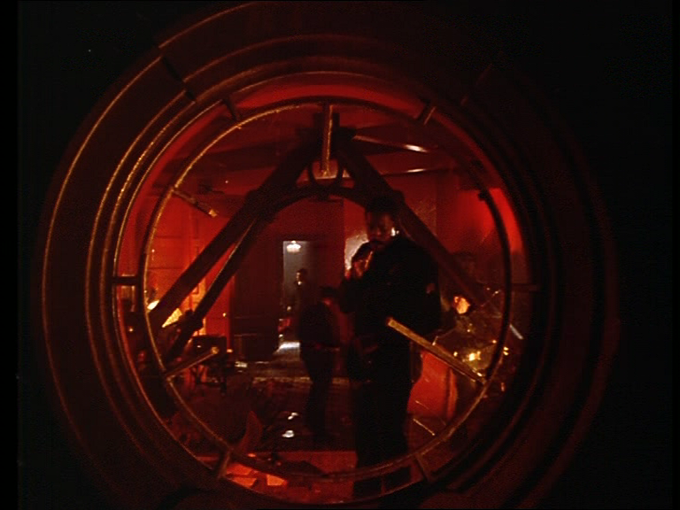
The camera cuts to a point of view shot from the policeman looking out of the window at a body lying on the pavement surrounded by other police, whilst an police helicopter’s spotlights illuminate the scene and police sirens ring out
The camera cuts back to a close up of the policeman smoking a cigarette. Looking concerned. A medium shot is used as he turns back to the room and discards his cigarette.
Sound diegetic
Police sirens
Police chopper
Police radio
Note how the use of sound is important to establish mood
camera
A close up of a photographers flash bulb
Close up of policeman opening case and putting on forensic gloves – indicates a crime scene being investigated
Sound – non diegetic – sad jazz trumpet sonnet
Note how the use of sound is important to establish mood
Camera- Medium shot as Sgt Albreacht walks forward from window
Medium shot – paramedics attend to blood soaked wounded women
Close up as policeman uses instrument to check fingerprints on vase which suggests that someone has committed a crime
Sad Jazz sonnet continues
Echoed Voices of paramedics
Note how the use of sound is important to establish mood
Medium shot Albreacht- reaches towards table( Haloween pumkin lamp in background
Close up as Albreacht reaches for photo revealing couple
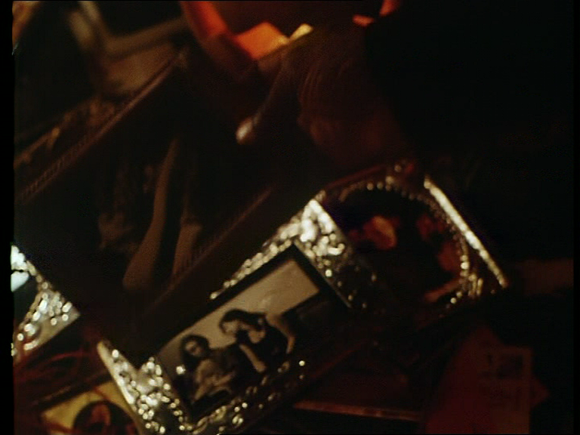
Close up of photographers flash gun- indicates a forensic police photographer is recording evidence
Close up of second photo of couple embracing
Medium low angle shot of Albreacht
Sad jazz sonnet
Close up of photo of the women embracing in the photo- camera flashes
Medium shot of women lying on the floor with bloodied face and oxygen mask
Sad jazz trumpet sonnet increases in volume- to emphasise tragedy
Medium shot of Albreacht in right of frame as he removes a photograph of a rock band taped onto a poster promoting a Haloween night performance
Low angle shot of police photographer
Rapid use of editing is used to create urgency through the following sequence of shots
Photographer’s flash fires
Close of band member ( EricDraven) –flash gun again illuminates photo
Close up of prior photo of couple embracing this time focusing on band member- Eric- flash gun illuminates
Close up of portrait photo of Eric
Medium shot of Sgt Albreacht as he turns and surveys the floor of the room- as he kneels down use of match on action shot reveals him picking up paper form fllor-
Point of view shot as he draws what appears to be an invitation towards his eyes
Point of view close up – reveals wedding invitation – Mr Eric Draven and Shelley Webster
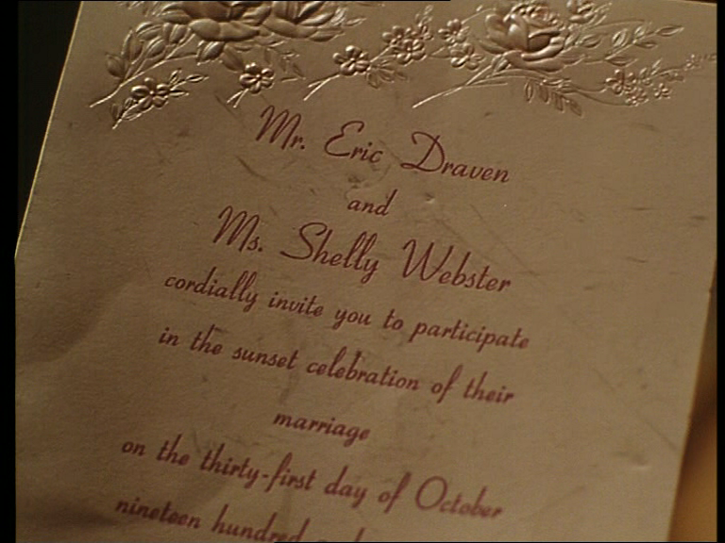
Sad jazz trumpet sonnet continues
Policeman calls out – “ Hey Sarge”- - ( first line of dialogue in the film)
Medium shot of Albreacht as he turns to policeman and he replies- “Yeah” shot reveals policeman standing by wedding dress on stand
Good use of mise en scene here- position of characters- Albreacht to the right of frame- looks towards wedding dress in centre of frame-( main focal point for the audience) use of back and side lighting illuminates veiled material of wedding dress. Gothic Candle chandelier hangs above
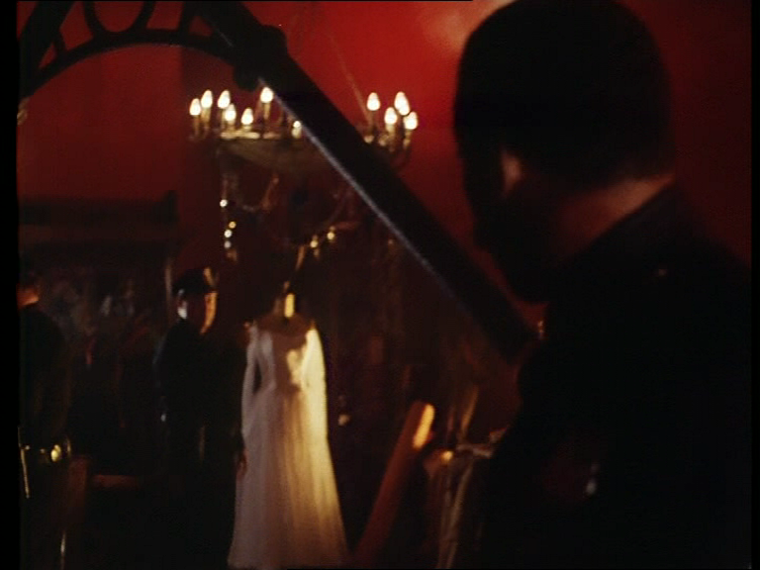
Police man stands to the left of the wedding dress. The walls of the loft are painted red
Medium shot of Albreacht as he walks towards policeman by wedding dress and announces –
“It’s Shelley Webster and Eric Draven wedding was tomorrow night”
Cut to high angle medium shot revealing paramedics attending to Shelley
Cut to Sgt Albreacht next to wedding dress
Policeman – Who the f gets married on Haloween night
Albreacht replies- Nobody
Sad jazz trumpet sonnet continues
Cut to close up of Shelley in oxygen mask fighting for life
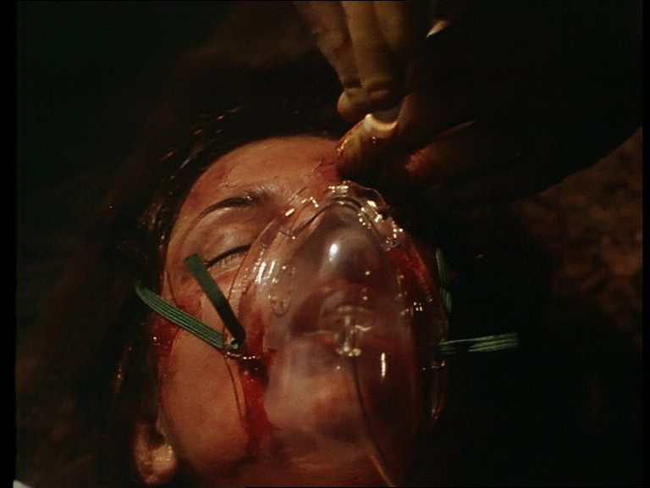
Medium shot as paramedic gets up and approaches Sgt Albreacht
“Sir – weve got to move her”
close up Sgt Albreacht- who replies
“ Do it”
shot reverse medium shot of Paramedic who goes back to Shelley and other attending paramedics- “Okay guys lets do it”
cut to low angle shot of older policeman framed in circular window- Devil’s F--- night what’s the count now?
Shot reverse medium shot of Albreacht- “ 143 fires”
Shot reverse medium shot of older policeman “ There slacking off from last year”
Medium shot Albreacht “ 3 Hours to go maybe they’re just slow starters”
Medium shot reveal paramedics moving Shelley on a stretcher
Cut away shot to crow landing on beam outside the building
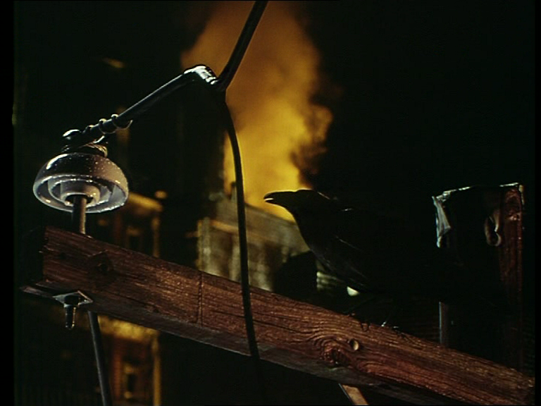
Sound of Crow squak
Low angle camera shot at ground level of police surrounding Erics body
Voice of Police Detective-
“you guys just cant come in like this and take her away there are procedures to stick by”
Cut to medium Sgt Albreacht downstars entering the street
Cut to close up of Shelley on stretcher
Voice of police chief-
“You guys should have cleared it with me first”
Medium shot of Albreacht on the street walks toward police chief (who the audience see for the first time) standing by Shelley on the stretcher–- Police detective says to Sgt Albreacht-
“Is this the victim”
Sgt Albreacht replies- “ No its Emilia Earhart( suggesting sarcasm to detective)
(In 1928, she was the first woman to fly as a passenger across the Atlantic Ocean. Then, in 1932, she became the first woman to pilot a plane across that ocean. In 1937 whilst attempting to fly around the world her plane vanished and she disappeared)
“We found her detective and you missed it” ( hints at hostility towards Police Detective)
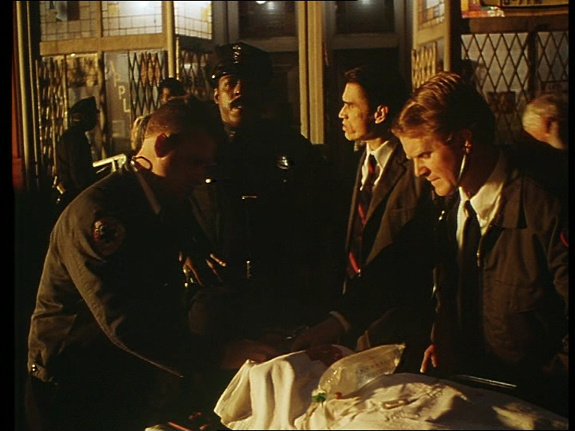
Detective replies-
“I don’t care what her name is” ( indicates his ignorance- Police Detective is immediately portrayed as an authoritarian – lacking intelligence)
Camera cuts to close up of leg riding skateboard
Dectective continues-
“I didn’t give the order to move her”- ( trying to assert his superiority)
Dectectives voice continues over medium shot of young girl riding skateboard pushing her way through the crowd of onlookers – then cuts to point of view low angle shot of girl looking at Erics body on the ground
“Jesus Albreacht I can see why they took away your Gold shield “
Close up of Albreacht replying
“Yeh I wasn’t a big enough of an arsehole- come on lets go”
Shot reverse shot of detective looking very angry
Cut to extreme close up of crow observing event- sound of crow squaking
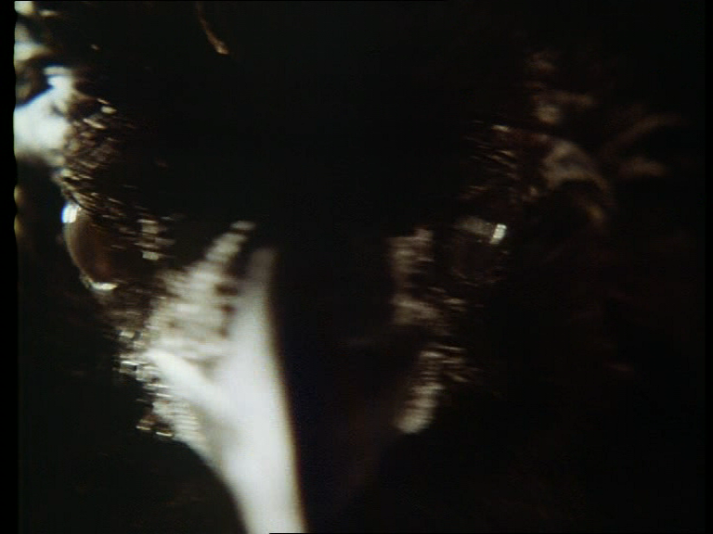
Cut to Sarah amongst crowd rushing forward
Cut to paramedics wheeling Shelley on stretcher
Voice of Sarah- “Shelley!”
Medium shot of Sarah, Albreacht and paramedic wheeling Shelley to ambulance
Sarah- “wheres Eric”?
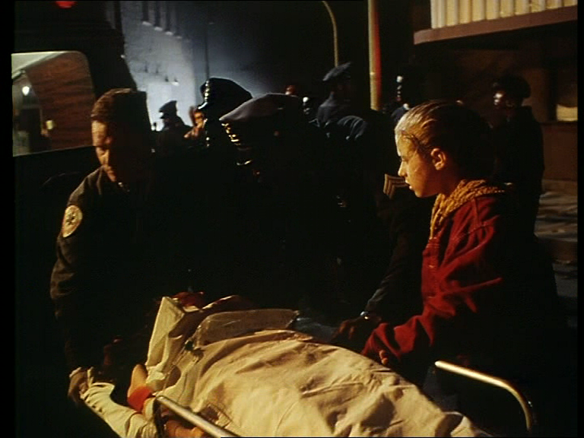
Albreacht- “Just don’t worry about it”
Medium shot as Shelley on stretcher reaches ambulance
Shelley- “ Tell him to take care of Sarah”
Tilt up shot from Shelley’s perspective of Albreacht and Sarah
Albreacht- “Look how well?- Look you just lie back – cmon cmon
Haunting celtic music
Note how the use of sound is important to establish mood
Close up shot of Shelley in agonising pain- she gasps
Medium shot paramedics lift Shelley into ambulance
Camera tracks back as Albreacht gently moves Sarah back
Albreacht- “Are you Sarah”
Sarah – “ Yeah”
Albreacht – “ Yeah look your sister, she’s gonna be ok
Sarah- “She’s not my sister, Shelley just takes care of me, she’s my friend
Sound of Ambulance siren denotes ambulance leaving
Close up of Sarah – “and Eric - you lied to her about Eric”
Shot reverse close up of Albreacht
Albreacht- “ I had too”
Shot reverse close up Sarah
Sarah- “And your lying to me about Shelley, she’s gonna’ die isn’t she
Shot reverse close up Albreacht
Sgt Albreacht- “Hey arh”
Close up Sarah putting hand to head
Close up Albreacht
Albreacht- “Hey cmon- its ok”
Cut to medium shot of Sgt Albreacht comforting Sarah as camera tracks back
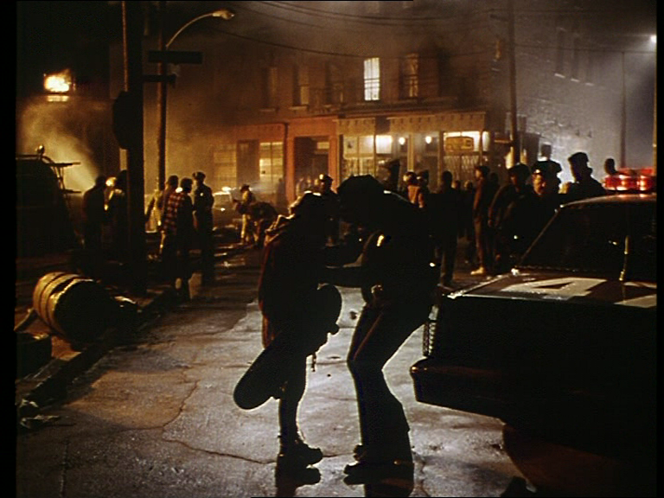
Shot freezes then fades to black – end of opening sequence
------------------------------------------------------------------------------------------------
From the opening the audience can identify
The location- Detroit during Devils Night- October 30 . The city is ablaze and appears in anarchy
Narrative information- Narration by - a young girl
“People once believed when someone dies a crow takes their body to the land of the dead. “But sometimes –something so bad happens that a terrible sadness is carried with it and the soul cant rest. Then sometimes just sometimes the crow can bring that soul back to put the wrong things right’
Settings- Gothic in style and architecture : Events have occurred in a loft of a building where a couple have been murdered
Characters- Shelley webster fights for her life: Photographs reveal her partner Eric- a rock musician has been thrown from the loft window and lies dead on the pavement.
Police Sgt Albreacht investigates crime scene- has tense relations with a senior detective who arrives late on the scene
Sarah- young girl who initially provides narration arrives at the scene. It is revealed Shelley and Eric look after her –suggesting she is without family care
Conflict- A couple have been murdered
Genre- Combination of different film genres- Science fiction- drama- suspense- filmic style of film noir
So what are the audiences expectations of what the film will be about? how it may develop?
Narration “People once believed when someone dies a crow takes their body to the land of the dead. But sometimes –something so bad happens that a terrible sadness is carried with it and the soul cant rest. Then sometimes just sometimes the crow can bring that soul back to put the wrong things right
What would the audience make of this?
The audience observe a crime scene- would this suggest the film may further examine or be developed around this event
Conflict- a young couple due to be married the next day –have been murded would the film explore this conflict?
Characters- The young couple- Albreacht and Sarah- would there relationship be developed further?
The crow- and the symbolic references made by Sarah in the beginning of the film- would this be developed and play a significant role?
Is the fact that the crow appeared outside the loft and was shown again observing the scene on the pavement have any significance?
How have production elements been used to complement the narrative
Use of camera shots/ angles
Mise en scene -Visual composition - how have the combination of settings-costume- lighting – position and movement of characters within the frame conveyed mood , atmosphere and information to the audience
Use of lighting- the red diffused light in the loft- the top and side lighting used to illuminate Shelley’s wedding dress
Use of editing- changes in rythym and tempo- when Albreacht examines photographs at crime scene-
Street level – when Albreacht tries to comfort Sarah- ( more sustained –longer camera shots)- to represent the sensitivity of the discussion between Sarah and Sgt Albreacht.

So how does the story develop from the opening sequence?
Medium Shot of crow landing on cross – camera tracks back to reveal cross is above church steeple
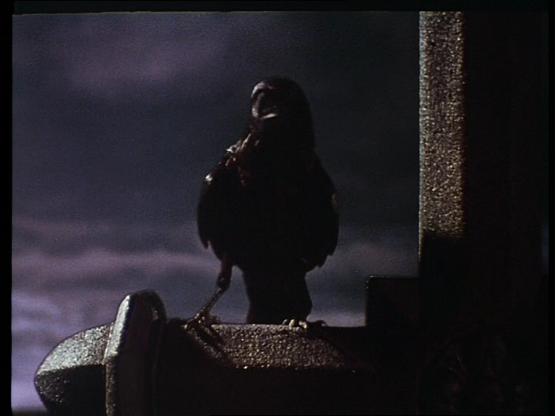
Screen text- One Year Later
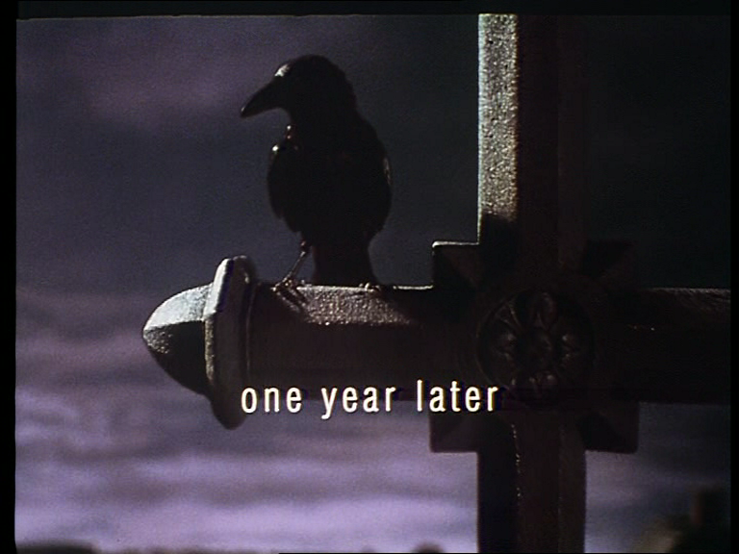
Camera begins to tilt down steeple
Narration from Sarah “ A building gets torched all that is left is ashes – I used to think that was true about everything, families, friends , feelings. But now I know that if love proves real for two people who were meant to be together nothing can keep them apart”
How may this draw upon her initial narration in the opening of the film?
Soft romantic celtic music
Low angle shot of Sarah’s legs as she walks through cemetery camera tilts up to reveal Sarah looking at grave
Cut to close up of grave with inscription of Shelley Webster
Music increases in volume
Medium shot from behind grave stone showing Sarah places flowers at foot of grave
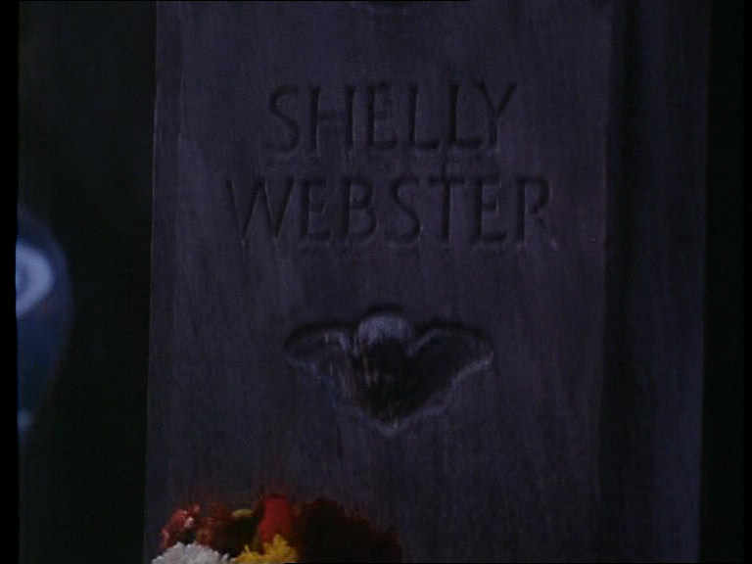
Medium shot as Sarah moves to next grave
Close up of Sarah’s hand places whit rose at foot of second grave
Close up of grave showing inscription of Eric Draven
Medium shot of Sarah looking at graves
Sarah- “Later”
Medium shot of Sarah leaving gravesite
Sound of crowssquaking as crow flies across frame and lands on Eric’s grave
Medium close up of Sarah who turns to look at crow
Rain begins to fall
Close up of crow sitting on top of tombstone
Medium shot of Sarah
Sarah-“What are you looking at night watchman
Extreme close up of crow- crow squaks
Medium shot as Sarah turns and leaves cemetery
Close up of crow pecking at Tombstone
Music heightens in tone
Medium long shot of Sarah leaving cemetery gates
Cut to long shot of Sarah skateboarding away from cemetery down street

