Photography Worksheets Answers

Worksheet 1

A good photographer is someone who spends time learning how to use
Their equipment : Practices : Tries different techniques :

2. Advantages of digital photography
Inexpensive
Can view images as you take them so can make instant adjustment to settings

No messy expensive processing

- The image sensor has replaced film

4 Moving around the subject / trying different angles / viewpoints

Q5 MYTHS

1. Need lots of expensive gear
2. Only professionals can get professional results
3.The camera knows best
4. Photography is too complex to understand
5 There are no rules in photography

6. Why is Digital SLR cameras superior to standard point and shoot cameras?

High quality viewfinder- what you see is what you get
Have interchangeable lenses –choice correct lens for the right situation
Power up quickly
No shutter lag – fast shutter response
Can take several photos per sec
Better auto focus system
Superior picture quality - because of bigger image sensors
Greater control
Complete creative control- don’t have to rely on the camera

7. What are the 6 most important settings on an SLR Digital camera?

- Shutter speed
- Aperture
- Metering mode
- Auto focus
- White balance
- Exposure mode

- What does SLR stand for and what does this mean
Single lens reflex: Viewfinder looks through same lens used to take the photo- what you see are what you get
Viewfinder is bright clear and easy to use –

9. Viewfinder is usually the only way to see what you are shooting- most don’t have a live display on the LCD

10 What is the correct way to hold the camera for steady shooting?
Rest against forehead or eyebrow
Your left hand cradling the camera
Right hand to steady the camera –manipulate the controls and to press the shutter button

11. What is the advantage of using a tripod?
Forces you to think about settings composition and what you are trying to accomplish

12. Why shouldn’t you use the machine gun approach?
Rather than take a lot of shots
Approach photography – take time think about shot

Worksheet 2

1. Every lens has a _focal length that is expressed in millimeters

2. A small mm lens provides wide field of view - wide angle
A larger focal length provides narrow field of view - telephoto

3. What is the term used to describe a variable focal length of a lens

Where the focal length can be changed

4. What does function does the aperture perform in the lens -

Adjustable diaphragm –which allows more or less light

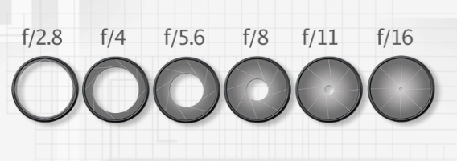

5.Smaller aperture number settings allow less light
Larger aperture number settings allow lighter

Q6 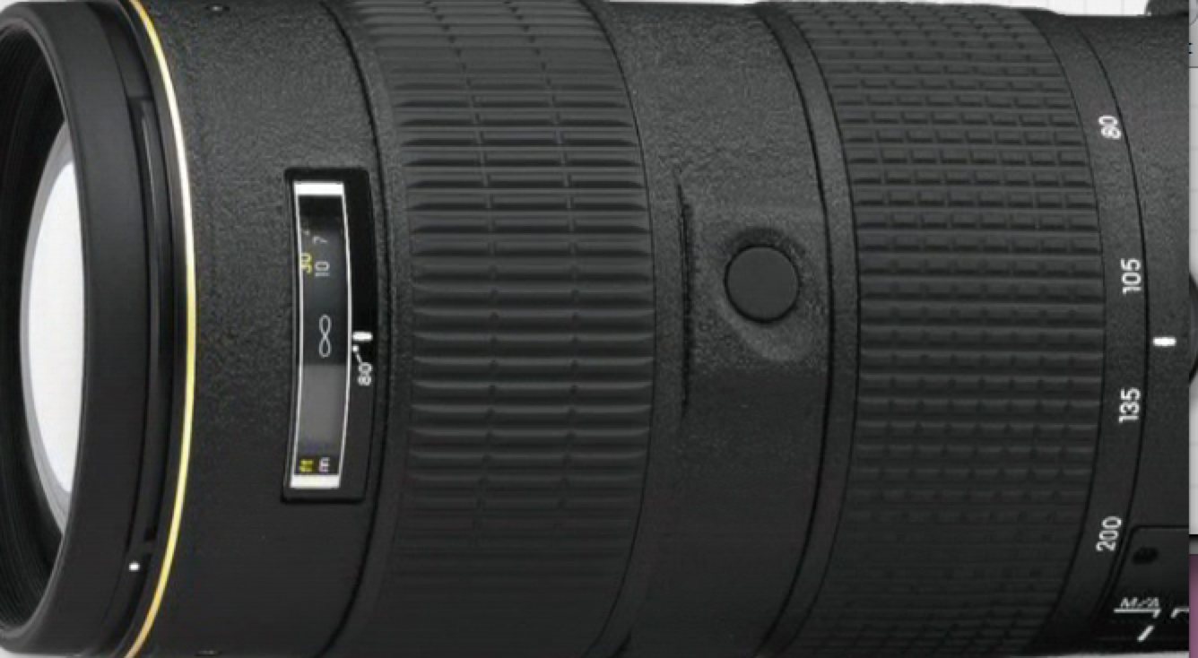 A lens with a large maximum aperture has the advantage of what features?
2.8 fast lens-

They provide brighter images
Shoot at faster shutter speeds in dim light
Shoot with a shallower depth of field

Q7. What are the disadvantages of fast lenses?

More expensive
Bulky
Heavy

Q8. How would you find what the maximum aperture was on a lens?

Look for number on the lens-
May have a range -can be 2 maximum apertures – one for zoomed in one for zoomed out

Q9 why do some zoom lenses have variable maximum aperture

Costs less to make

Basics of exposure

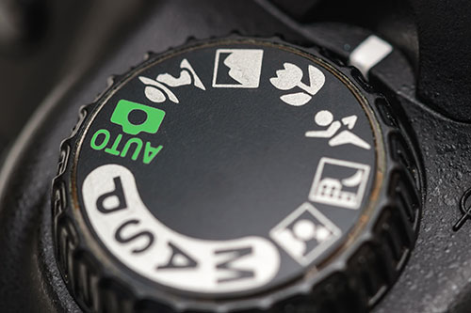

1. What is exposure?

Refers to how much light is allowed into the camera when you take the picture and how sensitive the camera is to that light when it hits the image sensor

2. Why would an image be overexposed- too much light – will look bright and washed out

3. Why would a picture be underexposed – too little light – will look too dark and murky

4. What are the 3 features of the DSLR that control exposure?

Aperture: Shutter Speed ISO

5. What does Shutter speed refer to-
Regulating the amount of time the shutter remains open when taking the photo

6.What is the ISO- Adjustable setting controlling how sensitive the camera is to light?

Higher the number the better for shooting low light- electronically amplifies the signal that’s being generated by the image sensor

7. What is the lowest ISO setting on an SLR camera for good results?

Lowest ISO -100 or 200 for best results

7.fast shutter speeds such as 1/100 sec-
Freeze motion

8/ Slow shutter speeds such as 1/10 sec
Create motion blur

- What does depth of field mean

Distance in front of and beyond the subject that is in focus

- What control determines the depth of field?
The aperture

11. The smaller the aperture the greater the depth of field - egg f16

The larger the aperture – f2.8 the smaller the depth of field

Chapter 4

What does the auto setting function?

Auto Setting - give total control to the camera – for aim and press – camera cant tell what you are shooting - not best creative choice

Landscapes
Portraits
Close ups
Sports action modes

Why is this considered “ not the best option”?

Not the best options as don’t allow control over shutter speed and aperture

Q According to the presenter great pictures are often taken at?

Great pictures are taken at extreme settings

QM= Manual- in this mode you have to monitor lighting and set shutter and aperture yourself – can be

QP program auto – advanced variation of auto allows you to have some influence – over shutter and aperture

Q2 best choices

Aperture priority and aperture priority

AV– Aperture priority – Aperture Value

S or TV – time value

With these 2 can chose the exact aperture or shutter

In Shutter 1/100 – camera will choose best aperture to go with it

Or
In Aperture priority if I decide to shoot f16 - camera will automatically chose best shutter speed to go with it

Remember - Choices for exposure settings will be limited by available light?

If the case camera will give warning or refuse to take the picture

Another option is to raise the ISO to make the camera more sensitive to light – when you double the IS0 double the sensitivity and shoot at a faster shutter speed

A good way to judge exposure – is to play back on LCD to check exposure

Another way is to view the histogram display - an ideal histogram will have measurable graph from left to right with peaks in the middle- if no representation to the right – underexposed- or to the left- overexposed

