Introduction to Digital Photography Worksheet
Name __________________________________________

1 According to the presenter being a good photographer is not about how much equipment you own it’s about?
______________________________________________________________
2.What are the advantages of digital photography?
1. ____________________________________________________________
2. ____________________________________________________________
3 ____________________________________________________________

3.What component of the digital camera has replaced film in cameras?
(A) Digital image sensors
(B) Lens
(C) Photo paper

4.What can make big creative differences in how your photos appear?
- How expensive your camera is
- Different exposure settings
- The amount of lenses you have
- The size of your photographic prints

5. What are the 5 myths of photography?
1.____________________________________________________________
2.____________________________________________________________
3.____________________________________________________________
4.____________________________________________________________
5.____________________________________________________________
6. Why are Digital SLR cameras superior to standard point and shoot cameras?
1_____________________________________________________________
2 ____________________________________________________________
3_____________________________________________________________
4.____________________________________________________________

7. What are the 6 most important settings on an SLR Digital camera?
1.
2.
3.
4.
5.
6.

8. What does SLR stand for and what does this mean?

______________________________________________________________
______________________________________________________________

9.How do you view your picture on an SLR camera?
______________________________________________________________

10. What is the advantage of using a tripod?

______________________________________________________________

Chapter 2

1. Every lens has a __________________ that is expressed in millimetres

2. A small mm lens provides _________________________________
A larger focal length provides _________________________________

3.What is the term used to describe a lens where the focal length can be changed
___________________________________________________________
4. What does function does the Aperture perform in the lens ?
_____________________________________________________________

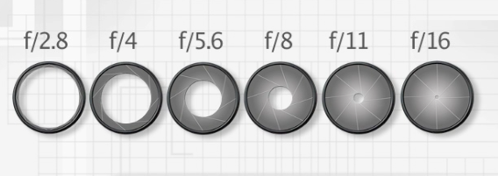
5.Smaller aperture number settings allow ___________________________
Larger aperture number settings allow ___________________________

Q6 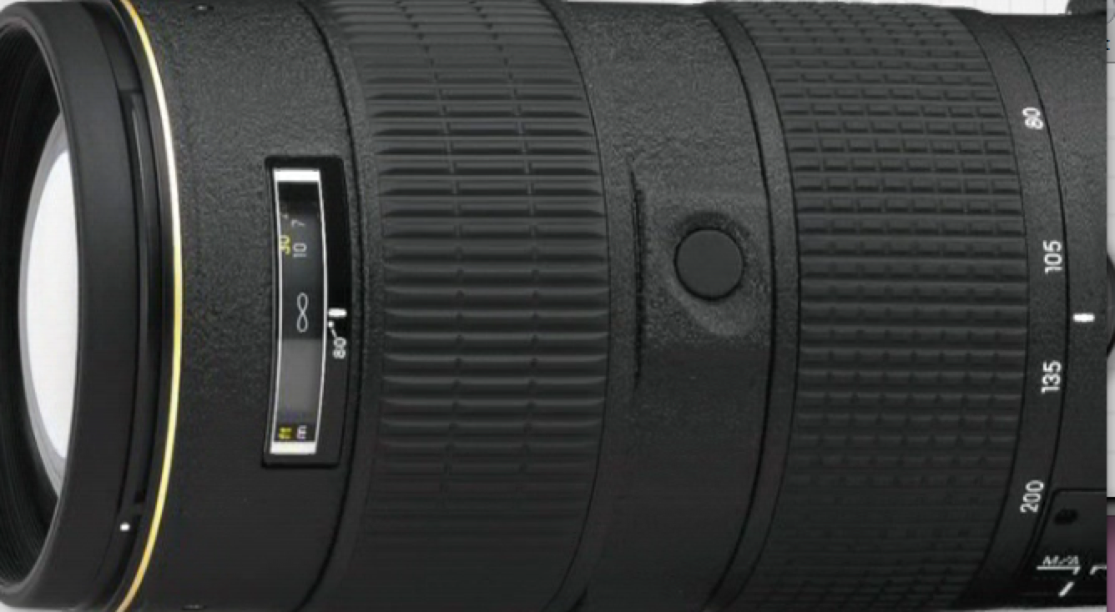 A lens with a large maximum aperture has the advantage of what features ?
1.____________________________________________________________
2.____________________________________________________________
3.____________________________________________________________

Q7. What are the disadvantages of fast lenses ?
1.____________________________________________________________
2.____________________________________________________________
3.____________________________________________________________

Q8 . How would you find what the maximum aperture was on a lens ?
______________________________________________________________

Chapter 3 Basics of exposure
1.What does the term exposure mean?

______________________________________________________________
2. Why would an image be overexposed?
______________________________________________________________

3. Why would a picture be underexposed?
______________________________________________________________
4. What are the 3 features of the DSLR that control exposure?
1.
2.
3.

5. What does Shutter speed refer to?
______________________________________________________________

6.What is the ISO-?
______________________________________________________________

7. What is the lowest ISO setting on an SLR camera for good results ?
______________________________________________________________

7.Why would a photographer use a fast shutter speeds such as 1/100 sec?
_____________________________________________________________
8/ Why would a photographer use a slow shutter speeds such as 1/10 sec?
______________________________________________________________
9.What does depth of field mean

______________________________________________________________
______________________________________________________________
- What control determines the depth of field?

______________________________________________________________

11.What aperture setting would provide a large depth of field ?
______________________________________________________________

12/ What aperture setting would provide a small depth of field
______________________________________________________________

