Australian media at a crossroads amid threats to diversity and survival

May 10, 2017 2.51pm AEST

Republish our articles for free, online or in print, under Creative Commons licence.
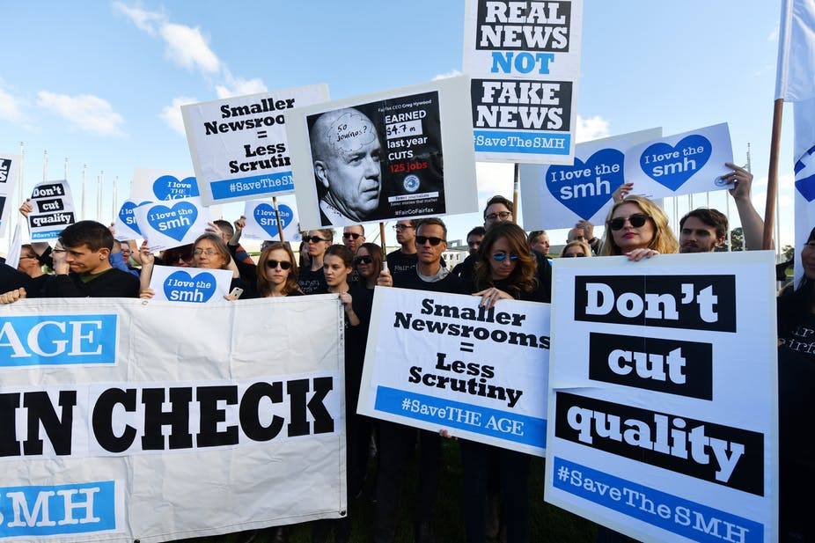

Striking Fairfax journalists protest out the front of Parliament House, Canberra.
Instead of just writing the headlines, the Australian media have been busy making them this week. Striking Fairfax journalists boycotted the federal budget coverage in protest at their bosses cutting 120 editorial jobs, while their bosses flirt with selling the newspapers to an American capital equity giant.

Meanwhile, the federal government again promises to overhaul the media landscape, beginning in the budget by rewarding Australia’s biggest media players with slashed broadcast licence fees.

It would also seem the cordiality of media billionaire Rupert Murdoch, who introduced Prime Minister Malcolm Turnbull to US President Donald Trump at their first face-to-face meeting in New York last week, was returned in yesterday’s budget.
Treasurer Scott Morrison confirmed the leak that A$30 million will be provided over four years to encourage subscription TV networks (read: Murdoch’s Foxtel) to increase coverage of lower-profile events like women’s sports.

Murdoch’s son, News Corporation’s co-chairman and Channel Ten investor Lachlan Murdoch, was a budget winner too. Loaded with debt, Channel Ten’s pleas to replace the $130 million licence fees for TV and radio networks with a flat fee totalling $40 million were answered.

The budget loser in this instance is the taxpayer, who owns the spectrum the commercial free-to-air broadcasters use. On the upside for Channel Ten viewers, this gives the network a little more breathing space as it works to restructure debt – or face an unlikely future – by the end of the year.

The budget dividends for Australia’s commercial media follows Communications Minister Mitch Fifield’s renewed calls on the weekend to change the Australian media landscape by scrapping some ownership restrictions.

The first restriction Fifield wants to scrap is the 75% reach rule, which prevents TV networks from broadcasting to more than three-quarters of the population. The second is the much-discussed “two-out-of-three” rule, which prohibits a company owning more than two of print, TV or radio in one market.

The government’s arguments that these rules have been outdated by technology is timely for Fairfax, as it seeks to sell off its online real estate money-making powerhouse Domain. This week, the highest bidder was a consortium led by US-based TPG Capital, more renowned for its investment in Airbnb and Uber than quality journalism.

So far, the offshore consortium has failed to convince Fairfax shareholders that its $2.2 billion bid for Domain and the publisher’s major metropolitan titles (The Age, Sydney Morning Herald and the Australian Financial Review), plus events and digital ventures, is a good enough deal for Fairfax shareholders.
So, what does this busy week in the headlines mean for Australia’s quality news journalism? Nothing positive.

History shows us every time there is significant reform of media regulations, the biggest media proprietors benefit at the expense of news diversity.
Cross-media ownership law changes in the late 1980s resulted in a frenzy of print media company acquisitions and mergers. Twelve of the 19 metropolitan daily newspapers changed hands; three of them changed ownership twice. And it hastened the death of all evening papers.

Certainly that was in a different time, well before the existence of the commercial internet and digital news sites like Huffington Post and BuzzFeed. Yet this century, Australia still has one of the most concentrated media news ownership environments of any developed democracy.

While there might be a reasonable argument that the internet has theoretically made redundant the 75% reach rule, the same cannot be said for the two-out-of-three rule.
The two-out-of-three rule is pro-competition policy designed to ensure media ownership diversity. Advocates for changing this rule commonly argue that news content already crosses these mediums: publishers are broadcasting, printing, tweeting, snapchatting, pod and vodcasting all thanks to digital technologies and the internet.

These advocates also argue that new entrants like The Guardian, Daily Mail and The Conversation offer greater diversity than before. This is all true, and these different news voices are good for Australian democracy.

But this argument underplays the role of audience fragmentation and proprietorial media power. These digital media entrants are not a substitute for law changes that would likely result in fewer big media operators in Australia’s most dominant news media markets: radio, television and print.

The US provides a good example of why caution is needed in any changes to the Australian media landscape. The US, like Australia, appears to have many and diverse news voices. But scratch the surface and the vertical integration of its major media companies has seen rapid consolidation of ownership over recent decades.
For example, in 1983, 90% of American media was owned by 50 companies. By the second decade of this century, that proportion is owned by just six companies. Among the biggest of the US-based media titans is Rupert Murdoch’s News Corp.

This concern about concentration of media ownership is premised on a public interest notion that news media is not a commodity like other products. It is ascribed a special role in society that is important to a healthy democracy – to provide a well-informed citizenry, and to enable critical scrutiny of political and other elites in their exercise of power.

Fewer voices means more power to a few, more convergence of content and less diversity, and a real danger of less scrutiny.

Critical scrutiny involves having a variety of perspectives and diverse viewpoints that are evidence-based, so that citizens can make up their own minds. The quality of a democracy relies on the idea that voters have every opportunity to be well informed when they cast their vote.

Fifield’s proposed changes to Australia’s media regulations need to pass the Senate first. At this point, opposing parties like the Greens and Labor have raised concerns about altering the two-out-of-three rule. Without their backing this leaves the Coalition government requiring the support of ten out of 12 crossbenchers.
Debate on the bill is expected next week. Together with Fairfax’s uncertain future, it is sure to generate more headlines.

