SAC preparation Study Guide
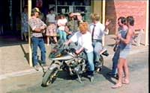

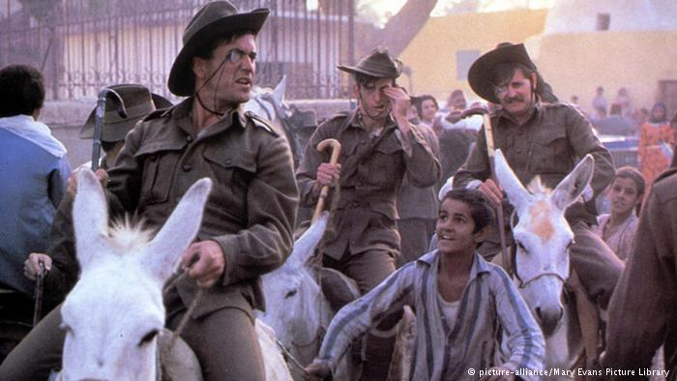

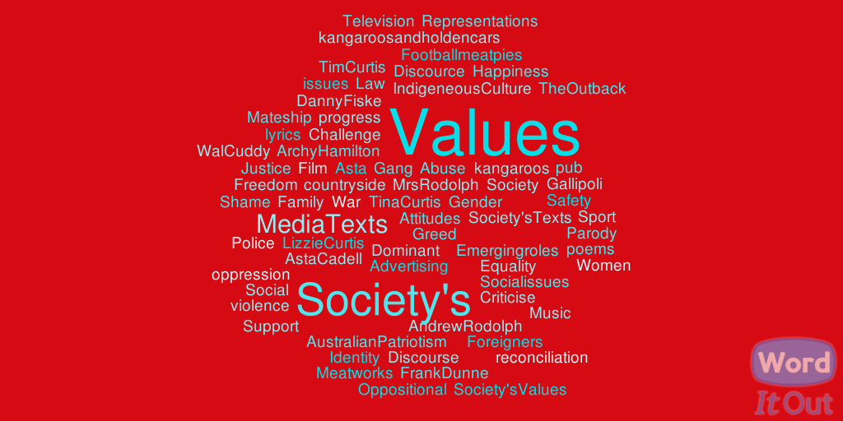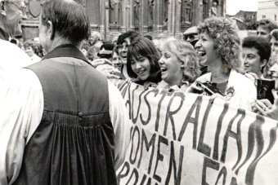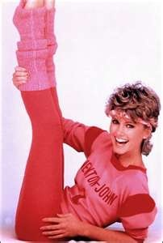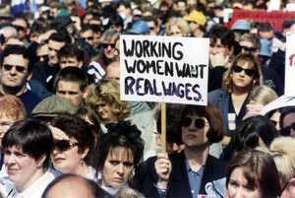
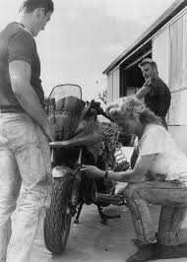

Key knowledge
• The nature and form of an idea, a value, an attitude or a discourse evident in selected media texts
• The construction of representations in media texts and how these reflect values in society
• Values held in society as represented and distributed through media texts
• The relationship between dominant, oppositional and emerging values represented in media texts
• The relationship between discourses or social issues and media texts
• Appropriate media language and terminology.

Key skills
• describe a social issue or discourse that is constructed, represented and distributed through media texts
• identify, compare and contrast representations in media texts
• analyse the relationships between dominant, oppositional and emerging values in society and media texts
• discuss and analyse the relationship between a discourse or issue, society’s values and media texts
• apply and use appropriate media language and terminology.

The nature and form of an idea, a value, an attitude or a discourse evident in selected media texts
VALUE
The Oxford dictionary defines values as…principles or standards of behaviour; one’s judgement of what is important in life.
DISCOURSE
Refers to the creation of meaning through the relationship between texts, audience and media organisations in society. A discourse is like an ongoing discussion about an idea or social issue”.
The texts we will study for example are part of a discourse on gender roles: and or National Identity
As mentioned in the key knowledge values have to be defined in terms of dominant, oppositional and emerging. We can of course also discuss concepts such as traditional values and alternative values.

Describing Values can rarely be described in one word, e.g. marriage, equality or feminism – there is an implied attitude inherent in the term.
Students should put the word “that” before the value e.g. “In rural Australia in the 80’s that men were considered the dominant gender as they had greater status as the breadwinner in farming agriculture and manufacturing jobs, where women were considered the homemaker ”. In this way an attitude towards the value is clearly identified
Or that Shame reflects the dominant social value in 1980s urban Australia that there should be greater gender equality, that men and women are capable of performing the same roles
Values -a principle, standard or quality considered worthwhile or desirable. When held by individuals, they are personal values.
Social values – as above, but when held by groups within society, they become social values. They are ideas and beliefs held consciously or unconsciously.
Dominant values – the values held in society by the dominant group, e.g. the majority of people, often older, more powerful.
Oppositional values – values that oppose those held by the dominant group.
Emerging values – new sets of values that are coming to be held by an increasing number of people in a society, particularly the younger and more independent

Representations: Representations in media texts are constructed to reflect social values. Media representations are the ways in which the media portrays particular individuals, groups, communities, institutions experiences, ideas, or topics from a particular ideological or value perspective
Understanding representation is all about understanding the choices that are made when it comes to portraying something or someone in a mass media text. It's impossible to portray every aspect of an individual in a photograph, or even in a feature film, so certain features of their personality and appearance get highlighted, and are often enhanced, when it comes to constructing the representation that the audience will see
When you're analysing representation, think about the following questions:
•Who or what is being represented? Who is the preferred audience for this representation?
•What are they doing? Is their activity presented as typical, or atypical? Are they conforming to genre expectations or other conventions?

•Why are they present? What purpose do they serve? What are they communicating by their presence? What's the preferred reading?
• How are they framed? What production elements are used to construct them – e.g. costume speech, camera shots and angles , visual composition, music, editing
Sample Questions / Responses:
NB: The responses do not provide students with definitive answers – some would require further examples relevant to the question. This however may provide a guide of how to get started and to encourage you to think about how to construct a good response
1. Name the texts that you studied for media texts and society’s values this year.

Question 1 (2 marks)
Identify and describe a social issue or a discourse that you studied this year.
Examiners Report. This question was largely well answered, with the majority of students being able to identify a social issue or discourse. Students who simply referred to a discourse without providing a description could not achieve full marks. Students who responded with a value rather than a discourse were not awarded any marks.
The discourse of Australian national identity in the 1980s where the maintenance of traditional stereotypes and ideologies negated the advancement of an inclusive society.
The discourse of Gender roles in the 1980s Australia where women struggled to achieve the same status, opportunities and freedom as men.
Question 2 (4 marks)
Explain how the social issue or discourse that you identified in Question 1 is represented in a media text that you studied this year. In your response, discuss how the representation has been constructed.
Examiners Report Responses to this question reflected a significant lack of understanding about how representations are constructed in media texts. Many students simply described characters or examples, without any significant understanding of the construction of these as representations of a social issue or discourse, despite the question explicitly asking for an explanation of the construction. Better responses discussed lighting, framing, costume, dialogue and/or plot as devices that constructed the representation.
This question did not require students to write about values, but instead focused on representations in media texts. However, students could acknowledge values if this supported their explanation of the representation but was not the focus of the response.

Sample
A social issue in 1980’s Australian society was gender inequality were woman were still defined by traditional stereotypes and struggled to achieve the same status, rights and freedoms as men.
This is represented in Shame through the representation of : select from ( victims) Lizzie Curtis Lorna Tina Curtis ( protagonist) Asta Caddell) (The Oppressors) The Mateship Group Wal Cuddy Mrs Rodolph ( Institutions) The Pub: The Meatworks: The Countryside
Describing representations
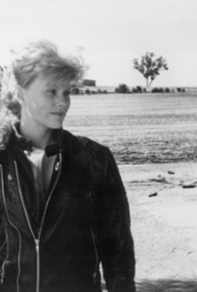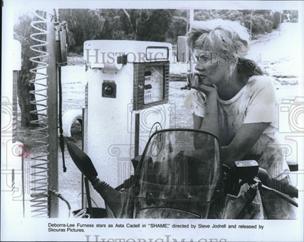
When examining the social values in a text, values are rarely stated explicitly. Rather, it is up to you to look closely at representations within the text and think about the way these have been shaped by the values, views and attitudes of the period in which it was produced.
All media texts are constructed. It is because these representations are constructed that they often, very unintentionally, reflect the social values of the period of production. If you are able to successfully identify and describe representations within your text and comment on how these representations reflect social values, you’ll give yourself a real edge when it comes to the Social Values SAC and the VCE Media exam.
When describing representations, it is important to make references to appropriate codes and conventions. If you’re studying a film or television program, you might like to consider how the following codes contribute to the representations in the text and, ultimately, what they reveal about social values during the texts production period.
• Camera techniques. How has the camera been used in this text? Films often feature more adventurous and stylised use of camera compared to situation comedies. Nevertheless, when studying such television texts, you might like to consider why particular shot sizes have been used and the effect this has on the audience. Why a close is up used to show a particular character and what effect does it have on the nature of the representation?
• Acting. How does acting contribute to the representation of a character? What does this reveal about social values during this period?
• Mise-en-scene. How does mise-en-scene contribute to the representation of characters and institutions? What type of costumes are the characters wearing? How do these reflect the values and attitudes of the period in which the text was produced?

• Visual editing. Editing is an important part of the production process. When we watch a film or television or program, the editing often appears seamless and natural Nevertheless, editing decisions make an important contribution to the representation. In a sitcom, after a joke, the editor might choose to cut in on the expression of one character instead of another.
• Lighting. The lighting of characters or scenes might reflect values held during the text’s production period. Why is one character lit more generously than another? Again, films often contain more stylised lighting compared to situation comedies, which are often filmed on sound stages with high key lighting. However, if you are studying such a text, you might be able to find examples of how lighting contributes to the representation.
• Sound editing. Sitcoms are often filmed in front of live studio audiences and their reaction to jokes is mixed in later. In other cases, pre-recorded laughter is added to the final mix. What does the audience reaction tell us about the social values of this period?
• Dialogue can often be very revealing about the values and attitudes of the production period. What do characters say? What does this reveal about the values, beliefs and attitudes of the time?
• Music. Music often makes an important contribution to representations in a film or television program. What does the use of music tell the audience about particular characters or situations? What does its use reveal about social values during the production period?
Example of a Representation
Indigenous Australians
In the opening sequence when Asta (after crashing her motorbike) enters the local hotel of the small country town of Ginborak. In this composition an aboriginal man is shown sitting outside the hotel on the balcony floor. A medium to close up eye level shot is used which invites the audience to pay attention to his representation. His long white beard suggests he is an Aboriginal elder. His appearance in old clothes, suggests a low economic status. What is significant however is that he sits alone, away from the groups of men that stand together outside as Asta enters the hotel? he appears an outcast and marginalised from the main group of men standing outside the hotel. His character has no dialogue or significance in the narrative reflective of indigenous people at this time having 'no voice" or simply no access to being heard".
So how would this representation reflect social values of the production period?
The aboriginal elder’s representation as an outcast or marginalised reflects social values of the texts production period. During the 80s indigenous Australians experienced poor health , education and social living conditions. Whilst some members of indigenous culture received some land concessions, the majority of aboriginal people experienced hardship. During this

Period a Royal enquiry into aboriginal deaths in custody found that racism was endemic in Australian society. During the 80s it emerged that whilst white Australia began to recognise aboriginal people they remained secondary to white Anglo Australians.

Question 3 (6 marks)
Analyse the relationship between a social issue or a discourse that you studied this year and how society’s values are represented and distributed through media texts.
Refer to two or more examples from the texts that you studied this year.
Examiners report this question required students to analyse the relationship between a social issue and discourse and how values were represented and distributed via two or more examples. Some students drew on historical contexts to analyse the relationship between the texts and the discourse/social issue, whereas others focused on the content of the texts to form their response. Both of these approaches were acceptable. Better responses were able to use two or more examples to underpin their analysis of the representation of values in texts and to reference these examples in their analysis.
Sample-one text is mainly discussed here –with some references to further texts You will need to give further discussion of a second text in order to answer in depth – e.g. Gallipoli and or Advertisements/songs
During the 1980s Australia women strove to achieve greater equality with men but encountered resistance and discrimination through traditional cultural ideologies and attitudes which prevented the full advancement of gender equality. Women were still stereotyped in the maternal role of home maker and mother. Such stereotypes were reinforced through the media particularly in advertising campaigns. The male stereotype as the worker and provider were celebrated through many campaigns from work wear espousing men’s “ Hard Yakka” , to beer commercials rewarding a hard earned thirst . The women’s role as the mother was reinforced through advertising jingles where mums “outa be congratulated “ or good on you mum, for selecting Tip Top Bread. Paradoxically women in the 80s had emerged into new roles. They were increasingly employed in traditionally male roles as evidenced by Mary Gaudron as Australia’s High Court Judge. Married women no longer stayed at home with 53% of married women with children working. Organised feminism became stronger. The equal opportunity and sex discrimination act saw the emergence of sexual liberation, while homosexuality came “out” and began to be re-created as “gay identity”. This was a very new , diverse and different Australia.
The 1987 Film Shame employs a melodramatic narrative to depict a remote Australian country town resistant to change and rife with a culture of discrimination and violence towards women. The film serves as a catalyst to expose the abuse of women still prevalent and encourage the audience to align with Asta, the films central figure to defeat male violence and advance greater equity for women. Asta is represented as a strong, positive, independent woman, rational, astute, self -possessed and charismatic, having as a barrister the professional power of the law and also the customarily male clothing of bikie leather and jeans. Through its representations of characters and inclusive male institutions of mateship, the Pub and the law the film attempts to challenge dominant rural values that

sought to negate the emergence of women’s rights, freedoms and equality. Asta Cadell the film’s central protagonist reflects an urban contemporary professional woman of the late 80’s whose central role challenges the caustic and sexual abuse still experienced by women in a remote country town.
Intrinsic to the representation of gender and suppression of women are how the film exposes mateship as a constraint to women’s equality. Unlike the traditional myth of the bush legend represented in Peter Weirs Gallipoli where mateship is celebrated as a virtuous male quality, Shame’s social realist treatment of the country town undercuts the myths of mateship and the decent man of the bush. The positive characteristics of Archy and Frank as patriotic, supportive, respectful, with sporting prowess are in stark contrast to the oppositional values of boys in Shames Ginborak. The film focuses on an intrinsic aspect of mateship, the obsession with conformity, through drinking violence and pack rape and subsequently redefines male bonding. It disavows the feminine and virtually excludes women. Its spaces are the so called pub and street, and the milk bar too, spaces where women are verbally and physically threatened and abused In a climate where Anita Coby’s murderers were sentenced to life imprisonment, the boy’s actions remain unpunished and serve to further polarize the audience to condemn them
The misappropriation of the law represented in Shame serves to conceal the culture of rape and abuse of women in the town. Police Sergeant Wal Cuddy is portrayed as overweight, aging country policemen, passively complicit towards the rape culture that has a grip on the town. As the narrative progresses it becomes evident that it is Cuddy's lack of law administration that allows the terror inflicted upon the town's women to become a rite of passage for the young men. When Sergeant Wal Cuddy angrily utters his most objectionable line of all to Asta about Lizzie Curtis; death at the hands of Andrew Rodolph “ Well I hope your bloody satisfied” it is the townswoman Tina who replies,” No Wal –were not bloody satisfied –not by a long way-mate”. Inspired by Asta and through their abhorrence towards Cuddy the women have realised their own strength, courage and compassion.
Question 4
Society’s values shape the construction and reading of texts. These values are in a state of constant evolution, and tension always exists between dominant, oppositional and emerging values.
Discuss the relationship between dominant, oppositional and emerging values in society, and how they have been represented in one or more media texts that you studied this year.

Examiners Report Students found aspects of this question challenging, especially if they were not familiar with the concept of relationships or tensions between values in texts. Again, students who studied more than one discourse or social issue found it difficult to respond, as their responses lacked the depth that the study of a single discourse or social issue would provide. Many students did not answer the question correctly, simply giving examples of dominant, emerging and oppositional values without any discussion of the relationship or tension between them. Other students simply defined these terms, and as a result could not achieve high marks. Of concern was the number of student responses that did not discuss all three types of values. Oppositional values did not appear to be equally represented in comparison to dominant and emerging values

Sample: You should work on several examples of where the traditional values of Ginborak are met with oppositional values of contemporary urban values and the tension this created in the narrative.

Texts both reflect and challenge the values in a society. As such, they often come to reflect the tension between dominant, emerging and oppositional values of the production period. The 1987 Australian film Shame(1987) examines the conflicting attitudes towards the discourse of gender roles and equality existing between rural and urban societies of the production period. The film’s central character Asta Cadell an independent and professional urban woman seeks help and refuge in the small country town of Ginborak after a motorcycle accident prohibits her touring holiday. Visually defined as leather clad bikie, her figure initially is not identified as a male or female. The adverse reaction of the men outside the pub opposed to her arrival and removal of helmet-are evident by their wolf whistles and leering comments. The hotel patron’s mill in groups outside the hotel where an aboriginal drinker sits alone, marginalised and outcast from the other drinkers. This would support Justice Muirhead the head of the Royal Commission into Aboriginal deaths in custody findings in 1988 that "Racist attitudes are endemic in Australian society". However the audience is positioned to feel sympathy for the indigenous drinker reflective of emerging values of reconciliation.
When Asta casually walks into the hotel to seek a room she exhibits contemporary urban values of the production period where she believes she has the right and freedom to travel alone and seek accommodation in the local pub. The hotel appears to be exclusively fraternised by men who quickly gather around Asta at the bar and offer crude remarks “ You can stay at my place love”, indicating oppositional views and sexist and demeaning attitudes creating tension when a women happens to intrude into their domain.
The Local police Sergeant Wal Cuddy condescendingly places his hand on Asta’s shoulder and announces “You wouldn’t want to stay in a rough joint like this” as he guides her out of the hotel, reinforcing the dominant values of the hotel patrons where a pub is no place for a lady. The men’s catcalls and offers of bed are opposed against Asta’s more utilitarian enquires about bike repairs and (single) accommodation: their dishevelled appearance and her smarter looks: their gazes of psychic neediness and hers of self-assurance. The functional style and character representations facilitate strong identification from female viewers who have ever entered an Australian Pub alone. The dialogue, mise en scene, and acting reinforce the tension experienced between the dominant traditional values of the town’s men and the oppositional values of urban Australian women where the equal opportunity act and women’s rise into positions of authority during the 1980s had shaped contemporary values.
When Asta reaches the Curtis garage, the narrative so organises the scene to endorse her mechanical skills and determination to repair her motorcycle, as well as Tim Curtis’ generosity in lending his tools. Tim’s acceptance that Asta is skilfully equipped to repair her motorbike opposes garage hand Gary’s unhelpful sexism; ”Not today Sweetheart”. Accommodated in the Curtis Sleep out Asta soon sees a logical extension of the drinkers innuendo and gawping. Lizzie is brought hobbling home by father Tim and Grandma Norma after-it is later confirmed being raped. Lizzie’s face is traumatised and drained: Asta’s look is sensitive and sympathetic .When Lizzie soon runs out from what appears to be family

recriminations -“Tell them to Stop”, it is Asta who comforts her thus initiating the female bonding that is crucial to the townswomen’s growing opposition to rape. It is her father Tim at this time that is unwilling to acknowledge and confront the terrible crime committed on his daughter
In the following encounter between Asta and some of the town’s young blades, her ready feminist wit directly challenges masculinise positions and exposes the brittleness of macho identity held by the mateship group of young men. A group of boys surround her in the milk bar with taunts about her jeans ;”Kinda looks butch in them trousers…Hey butch, you own a dress?”. She looks coolly at Bobby and says “Not in your size”. Recognising her superiority , his mates laugh at Bobby aligning masculinist identification with Asta as assertive confident women.
In the street outside , the sense of threat to Asta deepens as suave Danny backed by half a dozen of the older boys, repeatedly asks her for a drink. She twice declines . The camera adopts a low angle shot of the pack lounging on and around their cruising machine where mateship is reduced to a pack mentality which opposes the positive stereotype of masculine identity and camaraderie celebrated in Gallipoli and The Man from Snowy River in the 80s.Male violence is posed as a threat, but one that Asta seems well equipped to deal with, it shows her moral –political if not physical superiority over the youths.
The following scene the next morning launches a structural alternation that recurs through much of the film, between opposing male violence and female action. Asta’s compassion for Lizzie is in stark contrast to policeman Wal Cuddy who sneers “How’s the, er, family Tim. Cuddy’s lack of law enforcement is negligent and complicit in preserving the towns secret . Whilst Police corruption was rife in the 80’s the outcome of the 1987 Queensland Royal Commission resulted in the dismissal of the Police Commissioner and police officers announcing that the misappropriation of the law was unacceptable. Cuddy’s lack of law enforcement evokes tension and disdain from the town’s women and the audience. This is brought to a head later in the film when Asta is attacked by a group of young boys whilst collecting repair parts for her motorbike at night at the railway station. Only at this point in the film when it becomes narratively necessary in terms of a women’s action against rape, does Asta reveal her profession as a Barrister , to the townspeople and to the viewer. The woman embodies law as principles of justice. Wal whose name symptomatically reverses the law represents its local perversion. Her final “ I couldn’t be bothered to lay charges” lets Wal off the hook for the moment but not before the film has marked the townswomen’s support for Asta with Rita’s cry of “Good on ya love”. Whilst the narrative function establishes Asta as the female outsider to the male rape culture endemic in the town, it also shows the outsider beginning to catalyse change in that culture; on the male side by defeating the boy rapists and denouncing the cop and on the female side, by bonding with the towns women and sowing the seeds of their resistance to male violence.
Peter Weirs Gallipoli (1981) also demonstrates the tension that exists between dominant and oppositional values. Gallipoli continues to be considered the vehicle of Australian culture. Like some Australian films, it is responsible for the resurgence in national feeling in the 1980s. Popular music, such as Peter Allen’s “I still call Australia home” and Men at Works Down Under reinforced Gallipoli’s call to national patriotism The film attempts to reflect values from its production period where classes are reconciled; upper middle class Archie and his aboriginal mate Zac the station hand who supports Archie as he challenges the defiant and oppositional values of racist Les to a race across the desert. Archie ‘s

friendship with Zac acknowledges the struggle of indigenous Australians through Mabo and land rights claims , yet Les’ racism and opposition to Archy” You friends with blacks now Archy” reflects Justice Muirhead, Head of the Royal Commission into Aboriginal deaths in custody summary that "Racist attitudes are endemic in Australian society".
Whilst Gallipoli celebrates the virtues of the iconic Australian bushmen and larrikin, patriotism and mateship it reflects a disdain for other cultures. However a flood of post-war refugees and immigrants in the 1950s and 1960s had transformed the population mix in Australia. Refugees from Central and Eastern Europe settled in the cities. Greeks and Italians arrived, many establishing farms in rural areas and working on national development projects. They were in the 1970s joined by floods of refugees from Vietnam. Australia had become multicultural and diverse. Yet Gallipoli often parodies other cultures where the Australian soldiers mimic their superior, British officers, by riding donkey’s arid offering mock salutes in defiance. The Egyptians are presented as sly traders when a company of Australian soldiers attempt, to redeem an overpriced souvenir and Egyptian women are prostitutes with no morals. There is clearly tension between traditional attitudes yet to acknowledge a multicultural inclusive society.
The representation of women in the film is restricted and confined to maternal roles or supporters of the war effort. The absence of women can be perceived as excluded from the myth-creation concentrating on male figures and virtues. The ironical opposition here is that roughly a half of the nation was missing in the national myth, as there is always similar ratio of men and women in every society. In opposition to the dominance of men in shaping national identity and the lack of homage paid to women reinforced in Gallipoli was the women’s movement WAR, (Women against Rape), where their protest on Anzac day in 1981 culminated in 61 arrests.
Gallipoli celebrates the social values it represents. It is selective in its representations, which ultimately glorifies the notion of the "Bush legend" The film does however respond to changing social attitudes towards war by emphasising the sense of loss and futility of the events on Gallipoli. The closing shot of the film is a frozen image of Archy running as the fatal shot is heard. This ironically opposed Australia’s, involvement in what, is today viewed as a foreign war.
In a decade after the Vietnam War, attitudes had clearly changed which questioned Australia’s involvement in foreign wars. Yet the complexities of returned soldiers feeling isolated and alienated due to the growing disdain for war predicated “I was only 19” by Redgum which attempted to counter and oppose the disdain towards returned soldiers and helped shift public conscience and understanding.

Know key events of the 1980s in Australia Review notes in The 80s folder in the Project Drive
Review other texts folder so you can refer to other texts such as television commercials or songs – to reinforce your discussion. Even try YOUR OWN RESEARCH

Overview
Remember these things when studying ‘Media texts and society’s values’:
• Discourse refers to the creation of meaning through the interrelationship of texts, audiences and media organisations in society.
A discourse is like an ongoing discussion about an idea or social issue.
• Social values are the values, beliefs and attitudes held in a society.
• Social values can be dominant, emerging, oppositional or alternative.
• To understand the social values in a text, you must have a clear understanding of when and where it was produced.
• Do not make simplistic generalisations about a text’s production period.
• When writing about social values identify and explain them clearly.
• Social values cannot be reduced to single words like ‘love’ or ‘family’.
- Create your own notes: Study write practice responses

- Most importantly be prepared for success in the SAC and best of luck

