YEAR 9-10 Cinematography Exercise Two

This exercise demonstrates important filmmaking concepts, including:

- Handheld camera movement. When it’s done in a controlled and purposeful way, handheld camera movement can add a sense of realism and urgency to your shots. This filmmaking exercise has a number of opportunities to practice handheld camera movement. Don’t worry if it takes a few times to get it right!

- Continuity editing. This is the most important lesson to learn from this simple activity. Continuity editing, or matching on action, is one of the most important lessons you can learn as a filmmaker. When you film something from two shot sizes or angles, recreating the performance of the actor both times, you will be able to cut seamlessly from one shot to the other as the actor performs a particular action. Cutting on action creates a seamless bridge between two shots that your audience won’t notice. The motion will flow smoothly from one shot to the next. More importantly, this allows filmmakers to move between different shot sizes and camera angles without zooming or moving the camera unnecessarily. When shooting action from different angles, it’s important that to make sure that the actors recreate their performances precisely. If your actor is standing in the wrong place, or has a different expression on their face, cutting between two different shots will create jarring lapses in continuity.

Students will again need to exercise creativity if filming this sequence if alone
You can modify this sequence to shoot in your back yard -or front garden. You may need to draw upon assistance from another member of your family however it is still possible to film this sequence by yourself providing you have made yourself a DIY tripod . Also do not be too worried about references to aperture settings as these are unlikely on your phone

SHOT 1 | CU
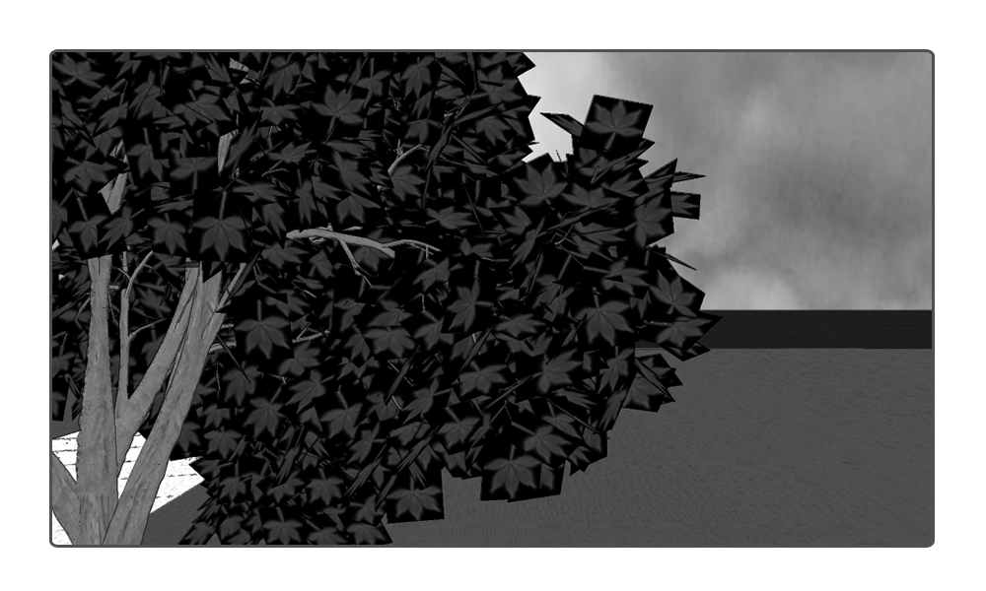
In the establishing shots for your film, we’re going to create a bit of atmosphere. Look around at your location and find something that looks interesting or atmospheric. When you’re shooting these establishing shots, set your camera manually to use a wide aperture like f1.8. This will give you shallow depth of field and a cinematic look.

SHOT 2 | CU
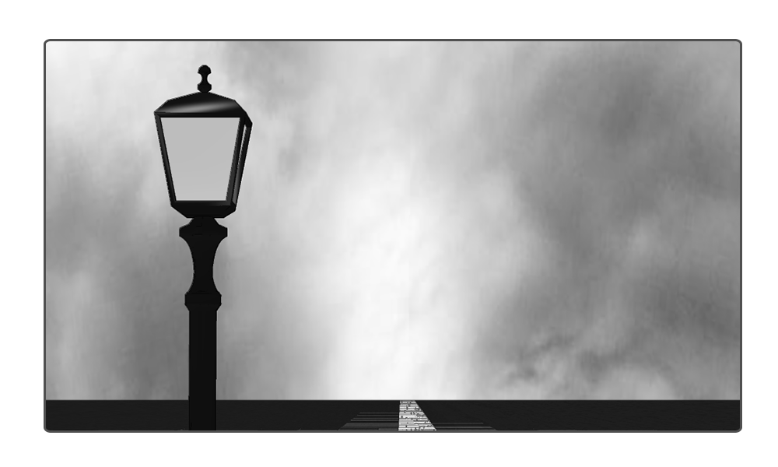
Again, the purpose of these two establishing shots is not only to orient the audience and let them know where the scene is going to unfold but also to create a bit of atmosphere. Spend a bit of time looking around your location for interesting shots that will help to create a sense of foreboding and isolation. In shots like this one, it’s a good idea to ensure that no one is in the frame. We want to create the sense that our character is alone and vulnerable.

SHOT 3 | LS
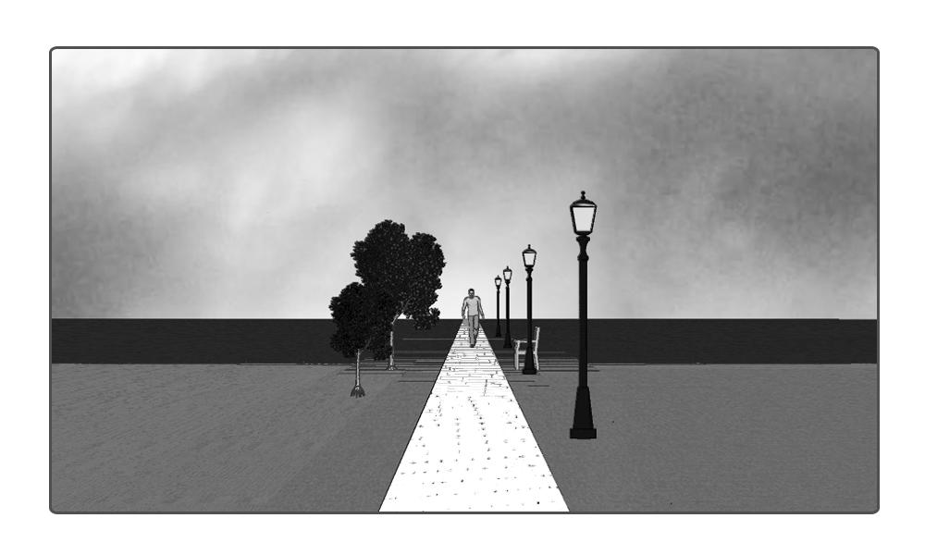
In this long shot we’re going to get the first glimpse of our character. When capturing this shot, let the camera roll for at least ten to twenty seconds. You can always decide during post-production how long this shot should go for. You want to allow enough time to elapse to create atmosphere without boring the audience too much.
SHOT 4 | CU
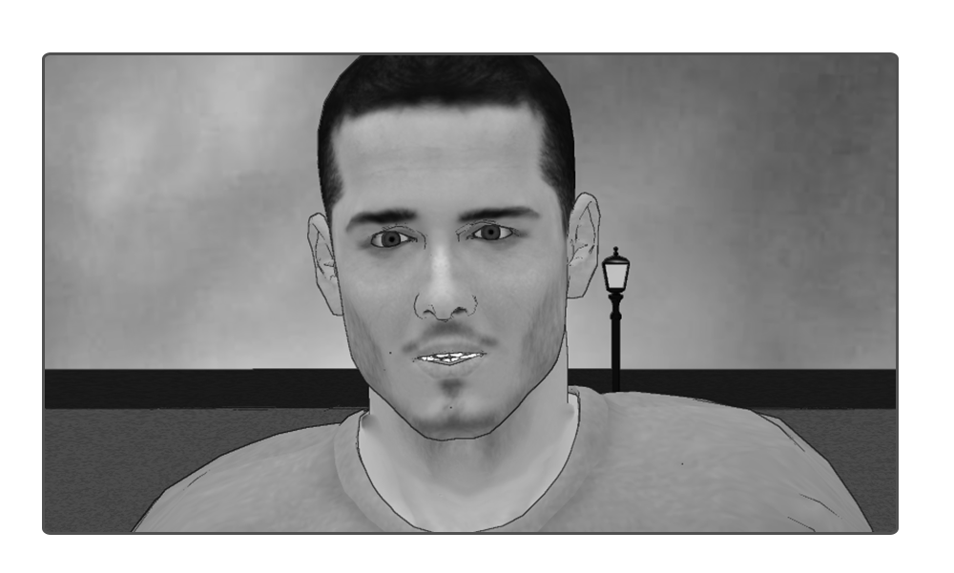
In this shot, you finally get the camera off the tripod and have an opportunity to capture a handheld shot. Track your character as they’re walking forward. When you reach a mark, your character is going to stop slowly and pause, a look of concern crossing their face as they get the feeling that they are being followed. You will need to walk backwards, so ensure that there’s nothing to trip over. Try to maintain a close up while reducing camera shake as much as possible. Keeping the lens wide, at 18mm, is one way to achieve this. In this shot, the close up serves two functions. First, it show the audience how our character is feeling. Second it creates a sense of foreboding by putting our character close to the threat that lurks outside the frame.

SHOT 5 | ECU
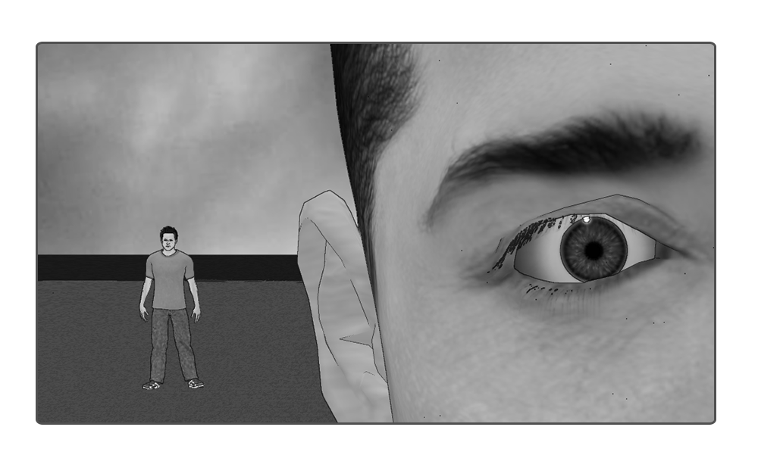
As a look of concern crosses our character’s face, we’re going to cut to an extreme close up of their eye on the right hand side of the frame. When you’re shooting this shot, it’s important to use a wide aperture, like f1.8, so that the character in the background is out of focus. This shot will be much more effective if the audience can’t make out the figure standing over the character’s shoulder. When you’re directing the actor, make sure that they use the same expression of dread from the previous shot so you can create a smooth match on action.

( if you don’t have a second person -don’t worry just focus on the concerned characters face )

SHOT 6 | MS
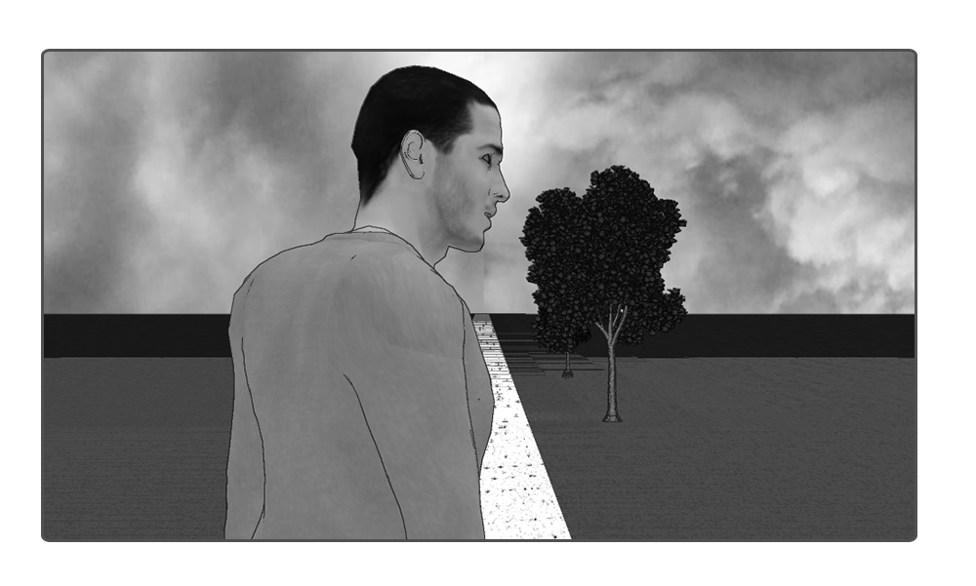
In this medium shot, the character will start with their back to the camera and slowly turn around.

Shot 7 | CU
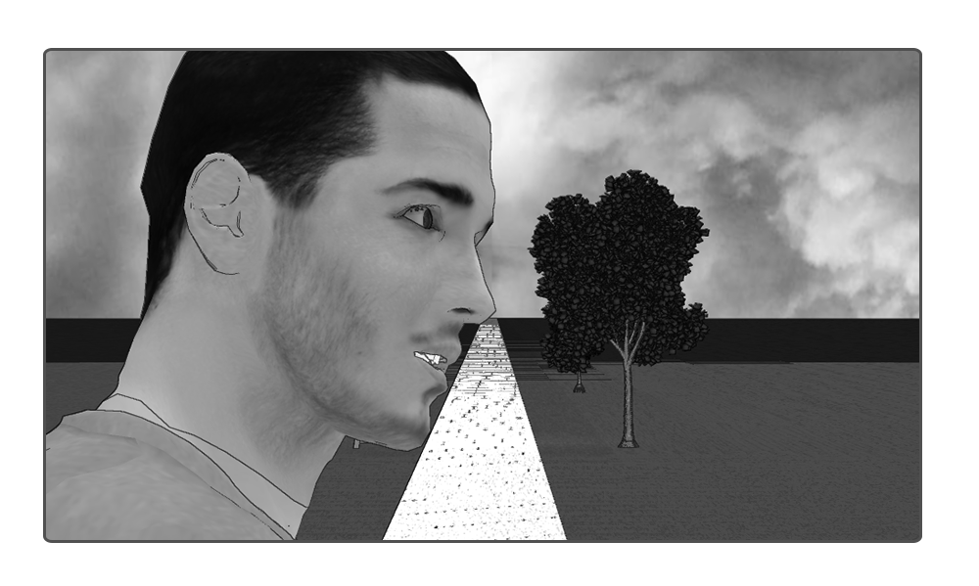
In this close up we are going to repeat the action that we filmed in the previous shot. The actor stands back to camera and slowly turns around.

SHOT 8 | ECU
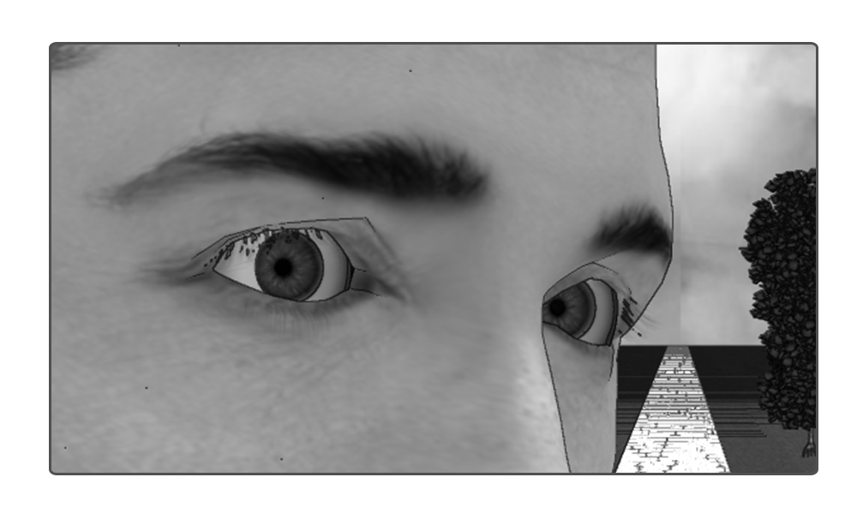
In this shot, we again film the same action from the previous two shots. The character stands with their back to camera and slowly turns around with a look of apprehension. Hopefully the character stops with their eyes directly in the middle of the frame.

SHOT 9 | LS
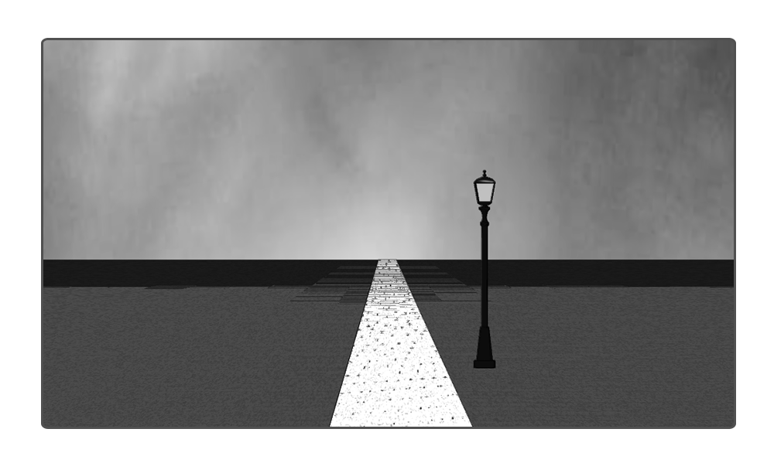
In this shot, we’re going to capture a static point of view shot from the perspective of our character. It’s important that no one is in the frame because that would diffuse the tension that we’re trying to create. Film bout ten seconds but keep in mind that we will cut this down significantly in the edit.

SHOT 10 | ECU
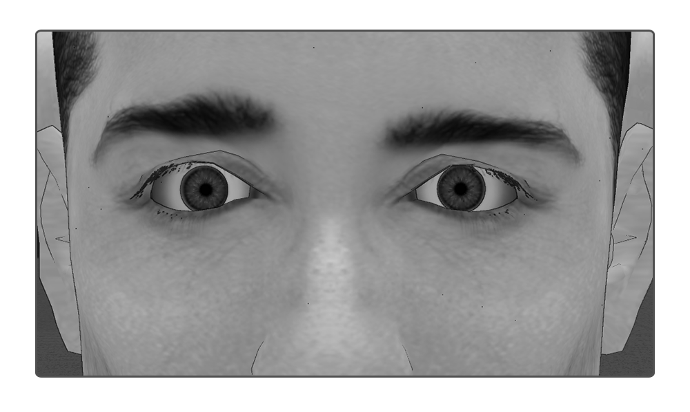
An extreme close up on our character’s eyes, a look of relief on their face.

SHOT 11 | CU
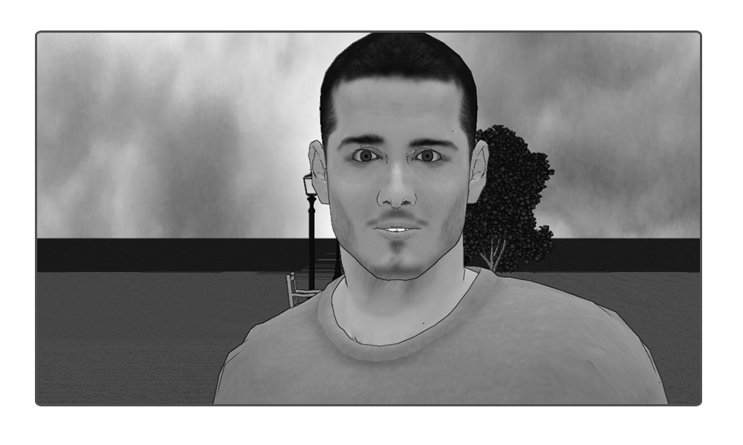

In this shot, with a look of relief on our character’s face, they will turn and continue walking. Film as much of this as you like but make sure that the performance is consistent with the previous shots. A different expression on your character’s face will make it difficult to cut between these two shots.

SHOT 12 | LS
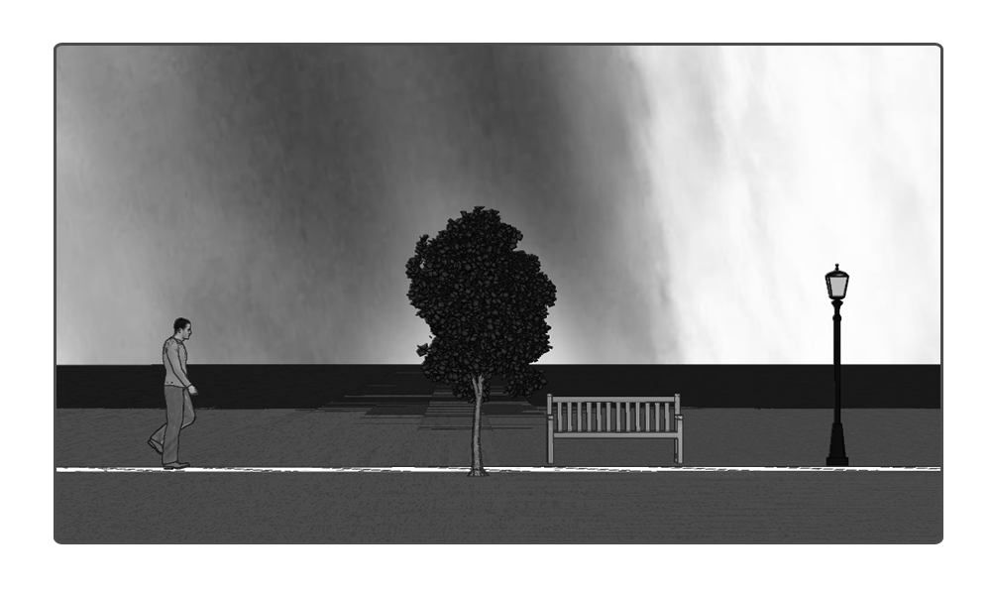
In this long shot we’re going to film our character walking across the frame. We won’t use all of this footage but it’s always a good idea to shoot more than you need so you have added flexibility when you’re editing. Keep in mind that we are continuing to create a sense of foreboding and isolation so make sure no one else is in the frame.

SHOT 13 | LS
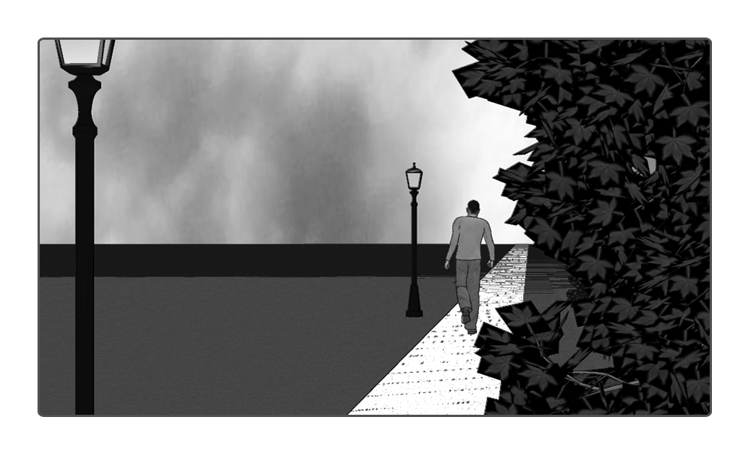
This is a handheld shot from the perspective of our stalker. Set the aperture to f1.8 and have the character in focus in the distance with a foreground element, in this case the leaves, out of focus. Although this shot is handheld, try to keep it as steady as possible while mimicking the slight movement of someone peering around the foliage.
SHOT 14 | CU

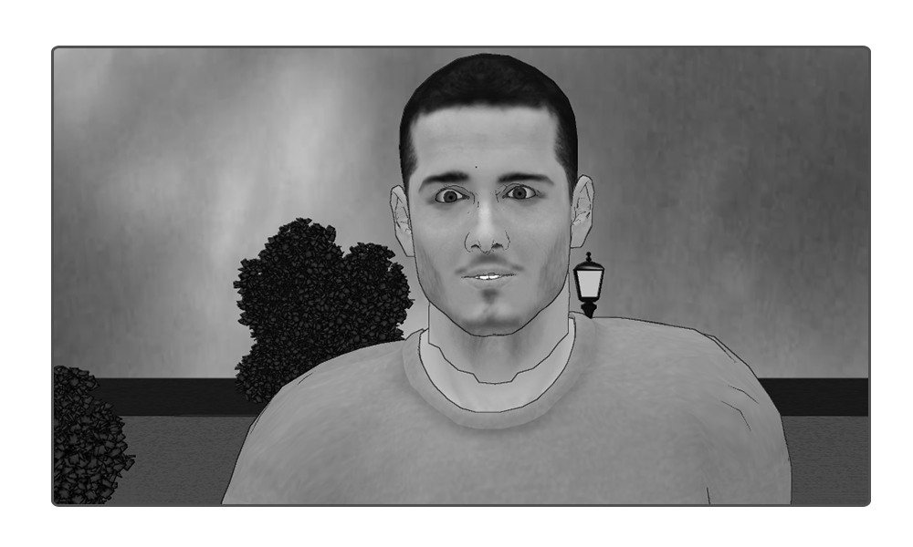
.

This is another handheld tracking shot of our character walking towards the camera. Keep the close up tight and the movement as smooth as possible

SHOT 15 | LS
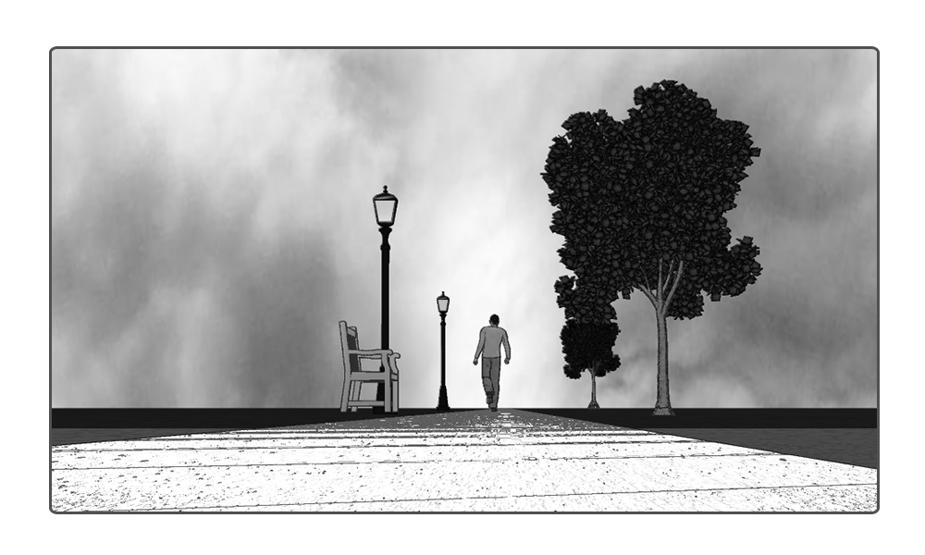
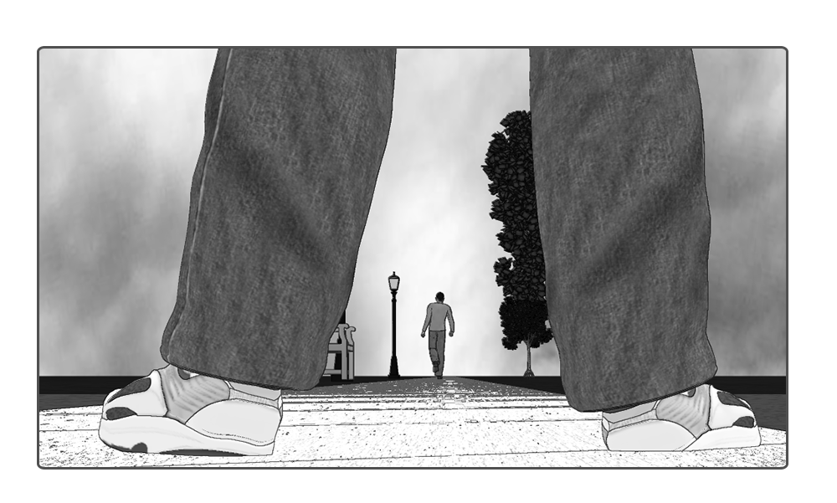
In this shot, we’re going to have our character walking into the distance for a few seconds. Try to hold this as long as possible. Slowly, our stalker is going to step into the frame. With this shot, keep your aperture at f1.8 so that the stalker’s feet are out of focus.

Again if you don’t have a second person don’t worry -just film the shot with yourself or another person

SHOT 16 | MS
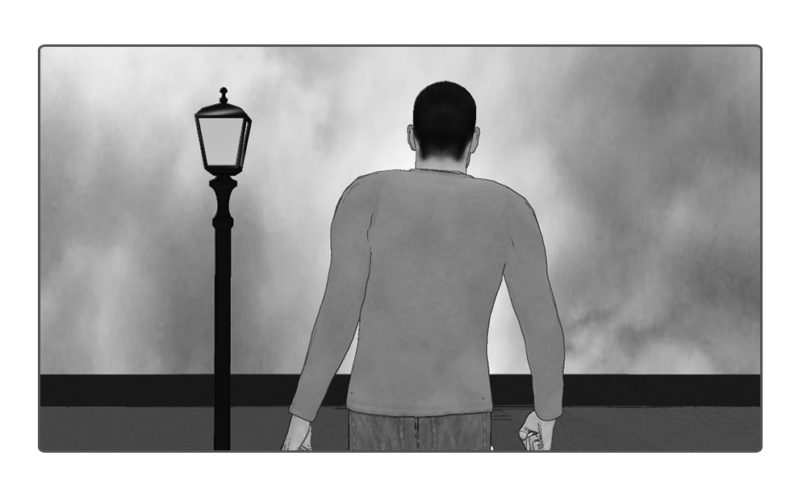
In this medium shot, we are going to use handheld camera movement to imply that our stalker is drawing closer. Track the subject handheld while gradually moving close.

SHOT 17 | CU
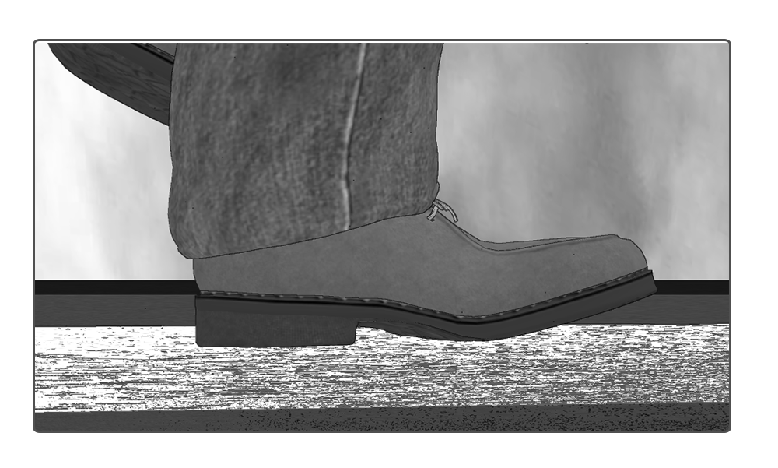
To show the stalker gradually drawing close, we’re going to have a close up of our character walking through frame. Allow a couple of seconds to elapse and then have the stalker walk through frame, too. Screen direction is very important here. In the previous shots, our character has been moving from left to right across the frame. We need to maintain that same direction or the audience will pick up on the discontinuity.

To create the illusion of another person -you could film a low angle shot of yourself in different shoes – walking slowly across the frame – If you have access to sound in your edit app – here is where you could insert dramatic music – You could then end your exercise at this point : - otherwise continue

SHOT 18 | FS
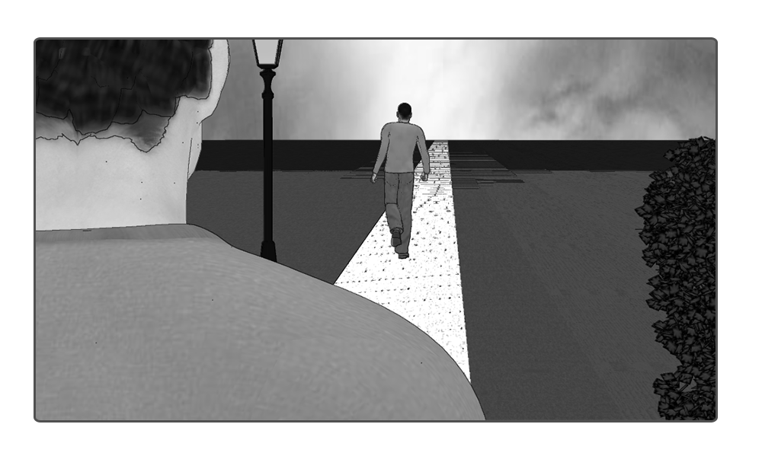
As the stalker draws nearer, we are going to cut to this over-the-shoulder shot. Once again, you will need to track the characters with a handheld shot. Keep it as smooth as possible. Your aperture should be set to f1.8 and you should have the main character in focus. This should mean that the stalker is obscured, creating a sense of suspense.

SHOT 19 | ECU
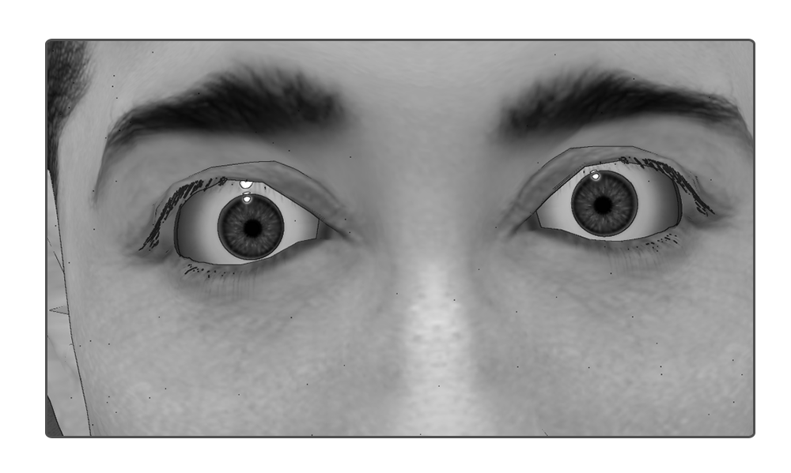
Our character steps forward into focus, their eyes go wide suddenly…

SHOT 20 | CU

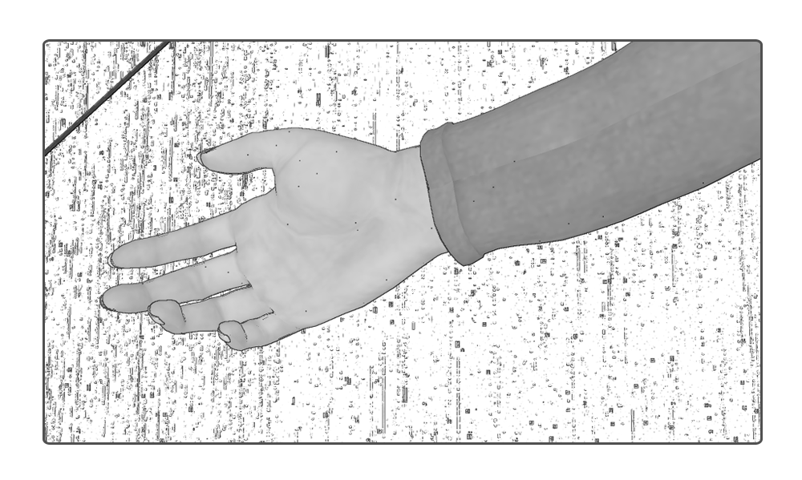
We have a shot of the concrete, our character’s lifeless hand falls into frame. Hold the shot for a few seconds.
SHOT 21| CU
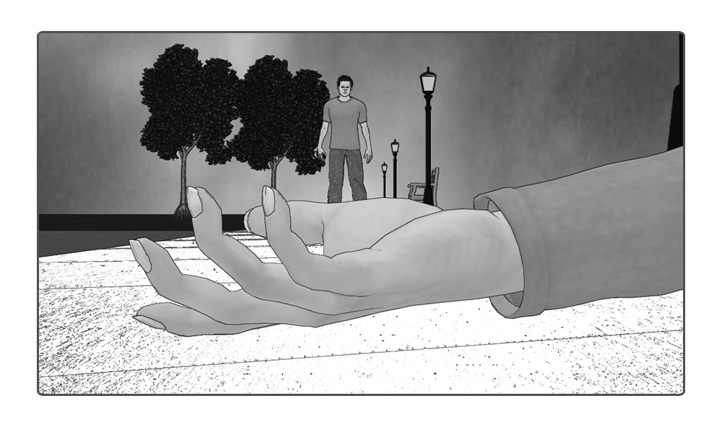
In this shot, we are going to have our aperture set to f1.8. The character’s lifeless hand will be in the foreground and, out of focus in the background, we will see the mysterious figure. Depending on the width of your lens, you might need to tilt up slightly using the tripod to reveal this character.

SHOT 22 | CU
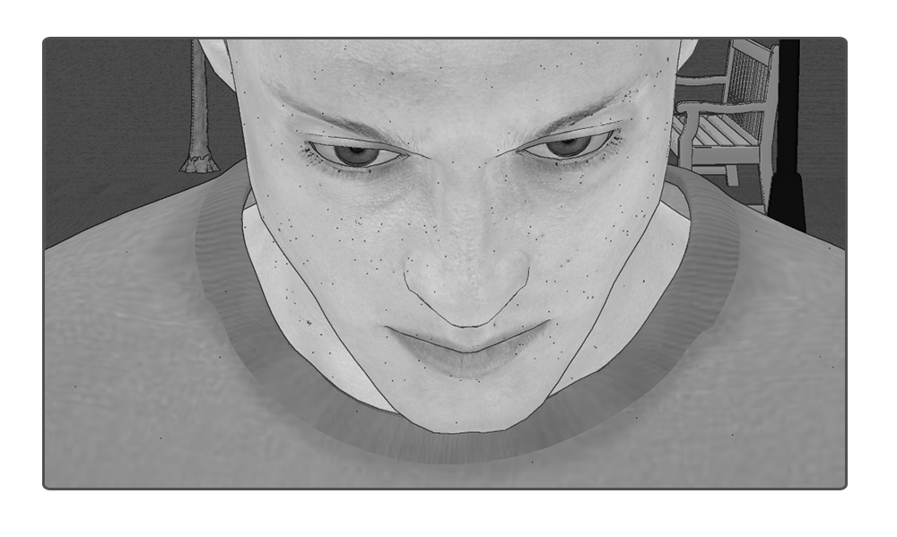
In this shot, we’re finally going to have a close up of the antagonist, motionless and impassive, an evil look on his face while he holds a Kubrick Stare.

POST PRODUCTION
During post production, you should if you can add atmospheric sounds and music

