Lighting

Lighting
Lighting not only allows an audience to see the action in a film, it shapes and frames this action drawing attention to objects characters and actions thus illuminating far more than what is on the screen. The colour and quality of the light positions the audience to read the shot or scene in a particular way. Lighting works both literally and symbolically employing both visual codes and conventions to suggest interpretation

Expressive lighting is a style of lighting used to represent greater meaning in relation to characters, settings, mood and themes. Example- a character is lit from behind making them glow, perhaps they are the angel that will save the situation. When a character is lit from below they may appear aggressive.

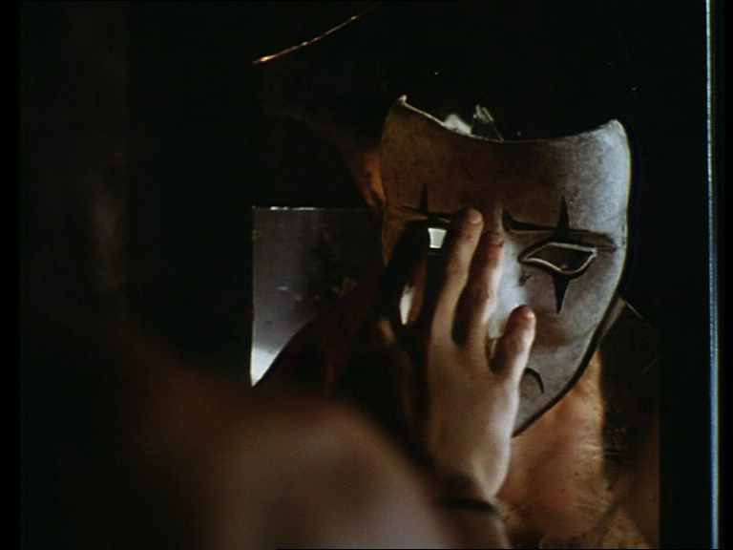

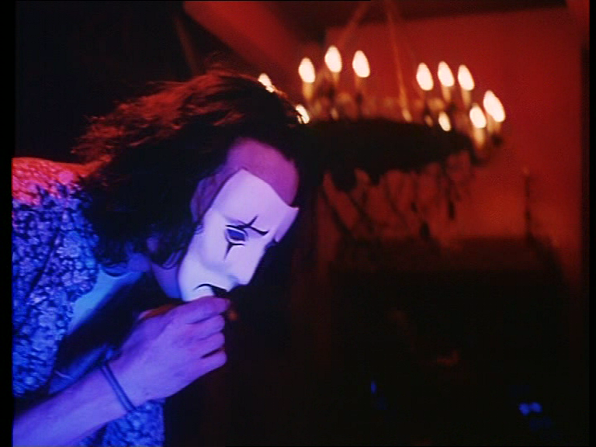

A good way to respond to a question on lighting is to discuss contrasting lighting . This scene is entitled All made up- when Eric returns to the apartment after he has been ressurected from the grave; Whilst Eric reminicesses about Shelley and applies the mannequin mask to his face the lighting is low key, using backlighting and side lighting. This lighting creates shadows around Eric and grey tones suggesting his isolation and sadness without Shelley. When he has a flash back recalling wearing the mask to surprise Shelley the lighting is high key,using a key (frontal) and source ( side lighting and top lighting) to create warmth and highlight colourful tones. This represents the warmth and bond of Eric and Shelley’s relationship

Another sequence you could refer to is the scene where Darla ( Sarah’s mother is with fun boy- administering heroin. The light is low key with the predominate use of side lighting which creates dramatic shadows reflective of Darla’s demise into the gang members lifestyle. This lighting is in strong contrast to the scene where Darla returns home after Eric’s warning to care for Sarah. As Darla prepares breakfast for Sarah the lighting is high key using a combination of key light- (frontal) and source lights ( side and top lighting) to bath the room in soft warm light reflective of Darla’s return to be a mother and care for Sarah

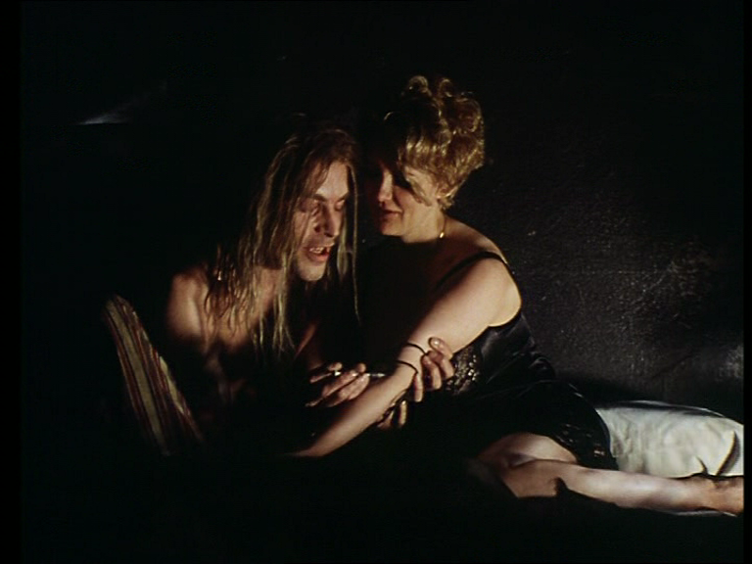

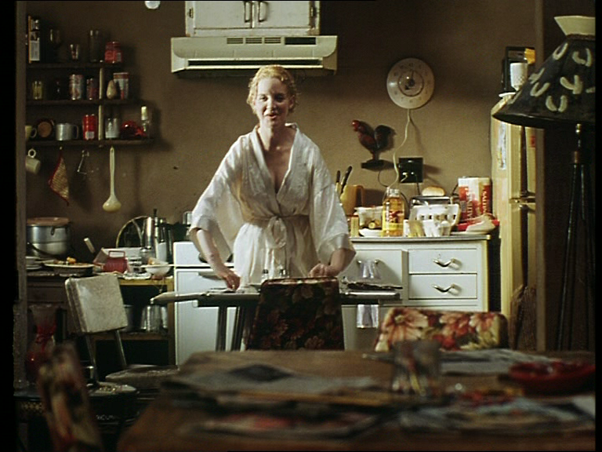

remember

Frontal lighting and its tendency to eliminate shadows. Front lighting does little to reveal form or texture since the shadows are mostly hidden from view; as a result it can make things look flat. However soft diffused frontal lighting can also be quite flattering to some subjects for this very reason
Sidelight used to sculpt the characters features. Side lighting is very good for showing form and texture and lends a three-dimensional quality to objects. Shadows are prominent and contrast can be high as a result. Side lighting can be used to throw dramatic shadows onto surfaces such as walls and create atmosphere
Backlighting defines depth by sharply distinguishing an object from its background. It is usually a high contrast situation and can often look very atmospheric and dramatic. Most of the time the image will be predominantly dark with dramatic pools of light. The rim lighting that occurs in this situation can be very useful for defining forms among the shadows. This kind of light is very effective for lending drama to an image.
Under-lighting suggests that light comes from below the subject..often distorts features. This kind of lighting can be used to creative effect. We instinctively recognise things that don't seem right, and this can be used to create specific moods by manipulating the lighting to convey emotions and responses.
Top Lighting usually appears along with light coming from other direction. Under hard light it can lend an air of mystery by casting dramatic shadows which conceal most of the forms beneath them:

Key Light ..primary lighting source of an image , providing the dominant illuminating and casting dominant shadows
Source Light used to fill in or soften or eliminate shadows

The direction that we view a light source from has a profound effect on our perception of it, and on how the objects in a scene will appear. Choosing which direction your main light is coming from is one of the most important decisions you can make since it will have a great deal of impact on how a scene will appear, and also on the emotions your image will convey.

High key images have a predominance of white or very light tones and tend to look light and airy. High key lighting is often (but not always) soft, and detail is generally low

Low key images have by their very nature very little light in them. Contrast is usually high and the lighting hard. Low key lighting can create a very moody atmosphere and is often used to this effect. The most obvious setting for low key lighting is night time, but it can also be found in other situations such as storms and in interiors. Exaggerated use of low-key lighting can be found in horror films, where underlighting (placing a light under a face or an object) gives a dramatic, often distorting effect. Low-key lighting is often seen as expressive

