Year 11 Photography

As an introduction to Photography students are required to take photographic compositions using their ipad or digital camera during class. Students are permitted to take compositions around the school grounds but must not take photos of any class or disturb any class.
Students are challenged to use their imagination to represent images of the following themes. Try to avoid obvious or explicit images or take the same photo of your classmate.
From your range of Photos – select 5 images you believe provide the most interesting representations and place them in a folder – or print them for this Assessment 1 Photography task

Tired
Heavy
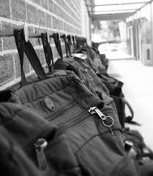

Round
Repetitive
Express
Creative
Shabby
Open
Loud
Scary
Perfect
Hungry
Risky
Big
Dinosaur
Times Up

Learning even just the basics of photography takes a bit of work and one of the more complex ideas is the relationship between ISO, aperture, and shutter speed. German photography blog Photoblog Hamburg has a graphic explaining how it works.
The graphic does a reasonable job at explaining how the amount of light you let it affects a photo, how certain settings can increase noise, and how focus changes. The top section represents aperture, the middle shutter speed, and the bottom ISO. It’s not a perfect representation of exactly what you’ll get, but it’s a nice visualization that helps you understand the basics.
