The Manic Pixie Dream Girl
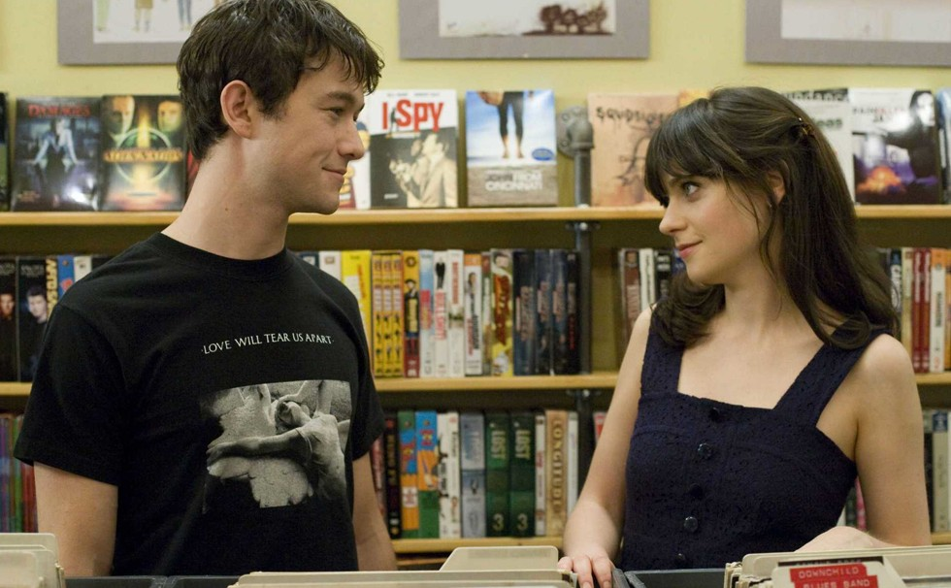
The term Manic Pixie Dream Girl was coined by Nathan Rabin in his review of Cameron Crow’s Elizabethtown: “The Manic Pixie Dream Girl exists solely in the fevered imaginations of sensitive writer-directors to teach broodingly soulful young men to embrace life and its infinite mysteries and adventures.” Manic Pixie Dream Girls are incomplete characters who don’t seem to have a life of their own. Their sole purpose in the narrative is to help the male protagonist learn more about themselves and their purpose in life.
SIX MANIC PIXIE DREAM GIRLS
Claire Colburn (Kirsten Dunst) from Elizabethtown is the character that defined the Manic Pixie Dream Girl stereotype. She meets Drew Baylor (Orlando Bloom) on a flight, starting a quirky and charming conversation. At the end of the film, she provides him with a map and CD that leads him out of his depression.
Adventureland’s Em Lewin (Kirsten Stewart) is the young and carefree theme park attendant who enjoys impromptu midnight swims and helps James Brennan (Jesse Eisenberg) cope with the somewhat dubious hardship of having to take a summer job.
The “flaky and irresponsible” Penny from Seeking a Friend for the End of the World proves that all you need to be a Manic Pixie Dream Girl is a quirky haircut, a collection of LPs and an overwhelming sense of optimism to help Dodge Petersen (Steve Carell) track down his high school sweetheart.
In Almost Famous, Penny Lane (Kate Hudson) explains that she’s not a groupie, she’s the one who inspires the music of the film’s fictional band Stillwater. She’s a carefree spirit who one day dreams of going to Morocco.
In Garden State, Sam (Natalie Portman) is a quirky compulsive liar who helps rescue Andrew Largeman (Zack Braff) from his funk. Sam’s interests include impromptu dancing and The Shins.
In 500 Days of Summer, the eponymous Summer enjoys browsing record stores, yelling obscenities in the park and, like all Manic Pixie Dream Girls, helping the male protagonist realise his dreams.
ACTIVITY 1
Watch the Feminist Frequency’s video about Manic Pixie Dream Girls and answer the following questions.
1. What is a trope?
2. According to the video, what is a Manic Pixie Dream Girl and what role does this character usually play in films?
3. How are these characters represented?
4. Briefly describe the characters that the video examines, noting the films that they appeared in and the role they played in the narrative.
5. How does this stereotype perpetuate the idea of the muse and why is this damaging?

