2 In the opening sequence of The Crow discuss the types of Camera Shots used and their effect or how they have been used to introduce settings, mood, possible themes and story.

Sample response

At the commencement of the film an establishing long shot reveals a grim Detroit nightscape, complemented by screen text, indicating it is October 31 Devils night. The camera tracks forward inviting the audience to survey the gothic rooftops, and observe that buildings are ablaze suggesting a state of anarchy. The bleak mood created in this panoramic shot is further reinforced by the narrative voiceover of a young girl who indicates that a crow has the power to resurrect a soul to correct bad things that have occurred.

In context with this narrative information the camera movement diverts from slowly tracking across the rooftops to transcend to a point of view decanted flight motion of a crow. The audience is further engaged to witness and partake in the crows journey until the camera’s simulated flight slows in rythym to reveal a medium shot through a broken loft window of a crime scene.

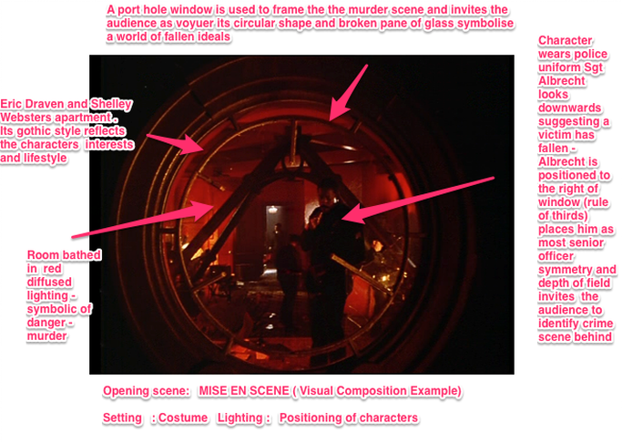

movie still shows camera shot and elements of mise en scene (visual composition)

A medium shot reveals a number of police examining the carnage in the loft, punctuated by a high angle point of view shot from the window to street level where a victim lies dead on the side walk. The camera cross cuts back to a close up of a Police Officer in the loft who appears distressed by the sight of the slain victim thrown from the window.

The tempo of camera shots in the loft intensify through a montage of close ups of photographs of the victims in rythym to a photographers camera flash bursts.

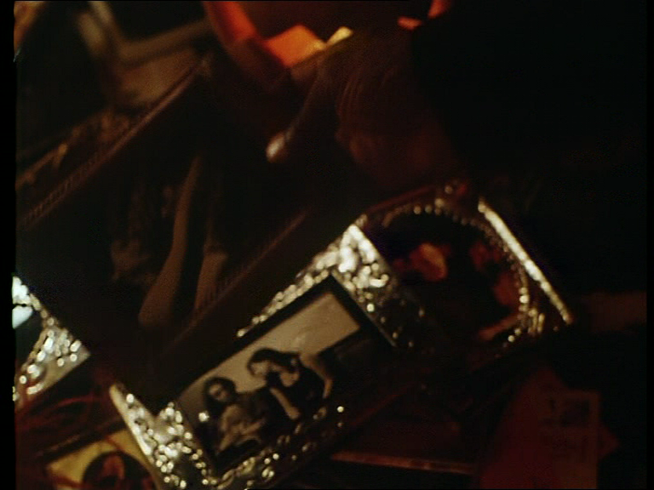
Close up – photo of Eric Draven with band members

A high angle medium shot is used to isolate a document lying on the floor, that is slowly picked up by the Policeman. Through a point of view close up shot the audience identifies that it is a wedding invitation for the assumed murdered couple, Eric and Shelley, which enhances the emotion and tragedy of the scene.

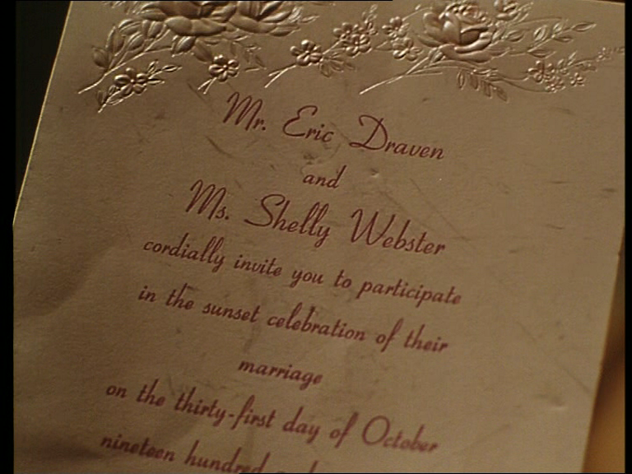
Close up of Wedding Invitation

The causal motivation of the Police Officer’s dictates his further surveillance of the room , represented through a slow tracking in medium shot revealing a wedding dress on a stand.

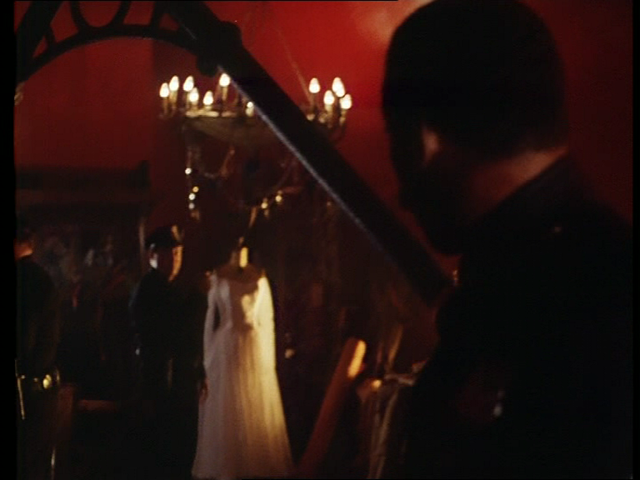

The camera then cuts to a high angle close up shot revealing the soon to be bride, lying on the floor with blood smeared face and oxygen mask, fighting for life, further enhancing the drama of the scene A low angle medium shot of police and paramedics raise the women’s body onto a stretcher.

