Video Shooting Exercise #1
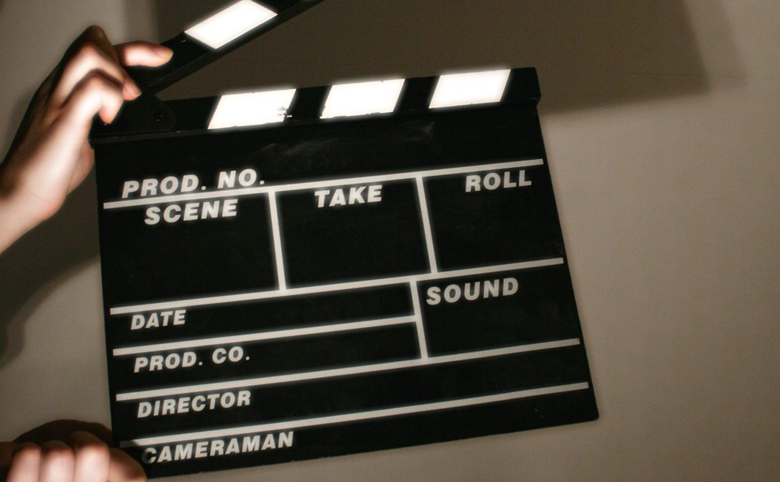

Shooting Exercise #1 is an opportunity for students film a scene with their mobile phone
This exercise demonstrates important filmmaking concepts, including:

- Depth of field. In the establishing shots and during the conversation, we’re going to use a wide aperture, f1.8, to create a shallow, cinematic depth of field. Manipulating your aperture in this way lets you focus your audience’s attention on something within the frame. In this scene, we want to emphasise the facial expression of these characters.

- Shot size. When you are shooting a conversation like this, you don’t have to maintain the same shot size throughout. Next time you are watching a dialogue scene in a film or television program, watch how the director moves the camera closer to the actors as the scene becomes more intense. In this sequence, the camera gets closer to the actors as the scene progresses – medium shot, medium close up, close up.

- Jump cuts. A jump cut occurs when two visually similar shots are edited together, creating a jarring jump from one to the next. Although jump cuts are usually considered a mistake, they can be used to show the progression of time by filming a sequence and cutting large chunks out of it. In this sequence we’re going to demonstrate how long our character has been waiting by using a series of jump cuts to show the progression of time.

- Shooting order. The storyboards in this sequence are presented in edit order. When shooting something like this, however, it doesn’t always make sense to film it in the order that you are going to cut it together. You can work much quicker and use fewer camera set ups if you film it out of sequence.

SHOT 1 | CU
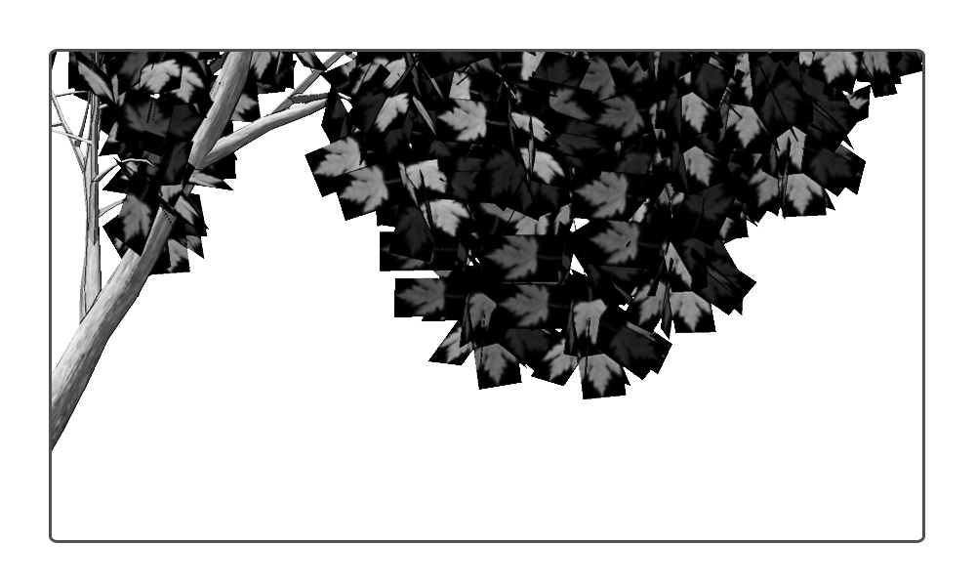
The first two shots of this sequence are going to be establishing shots to give the audience a sense of where this scene is going to unfold.
Go outside in your front or backyard to film -or if the weather is poor you could always
Film this exercise inside in a lounge room -with some obvious modifications
Establishing shots like these don’t always have to be static.

SHOT 2 | ELS

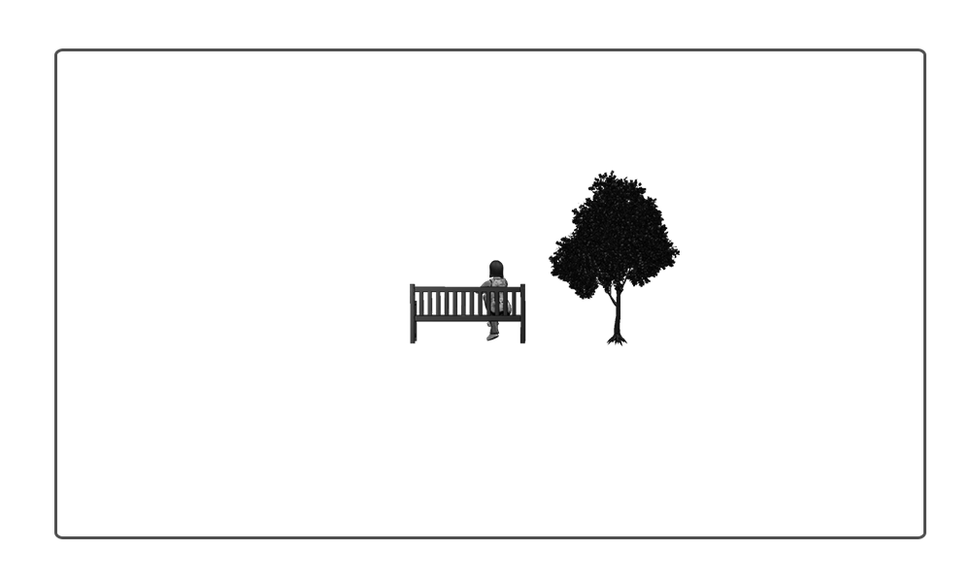
In the second establishing shot here, the character is visible.- either yourself or a family member It might be nice to use a slow zoom in on the subject. When performing camera movement like this it is always important to show restraint and control. In the second shot for this scene, you needn’t have a shot like this with the character visible in the distance. You might simply choose to have another establishing shot similar to the first.

SHOT 3.1 | FS
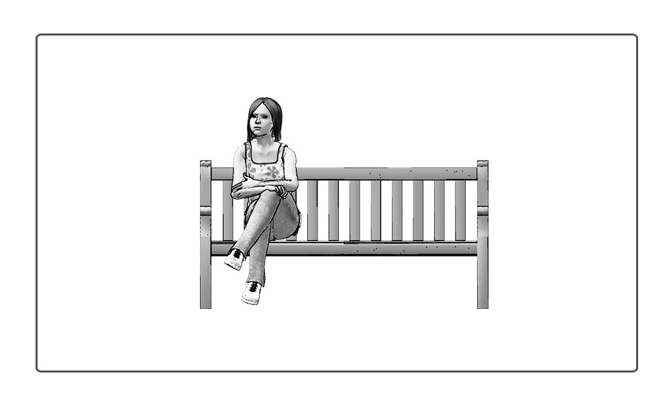
When you shoot a scene like this, the edit order isn’t necessarily the best shooting order. Throughout the sequence there are a number of full shots like this and it would be more efficient if you shot them all at the same time. Having exactly the same camera position will also help achieve the jump cuts that are used throughout this sequence. In this shot, the character looks around impatiently, looks down at her watch and then back up again.

SHOT 4 | CU
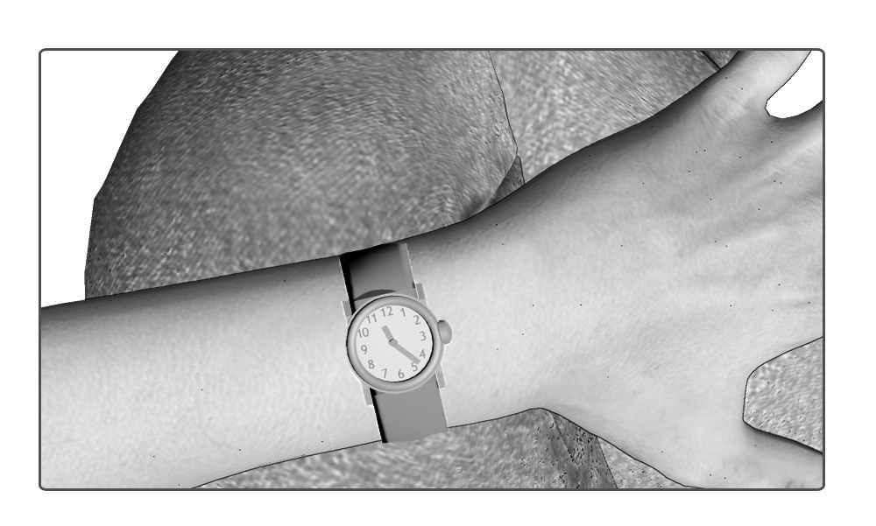
This is the first of two inserts to show the character looking at his or her watch. Using point of view shots like these are a terrific way to get your audience to identify with your character. Capture at least five seconds of this shot, although you probably won’t use that much in your completed sequence.
SHOT 5 | ECU
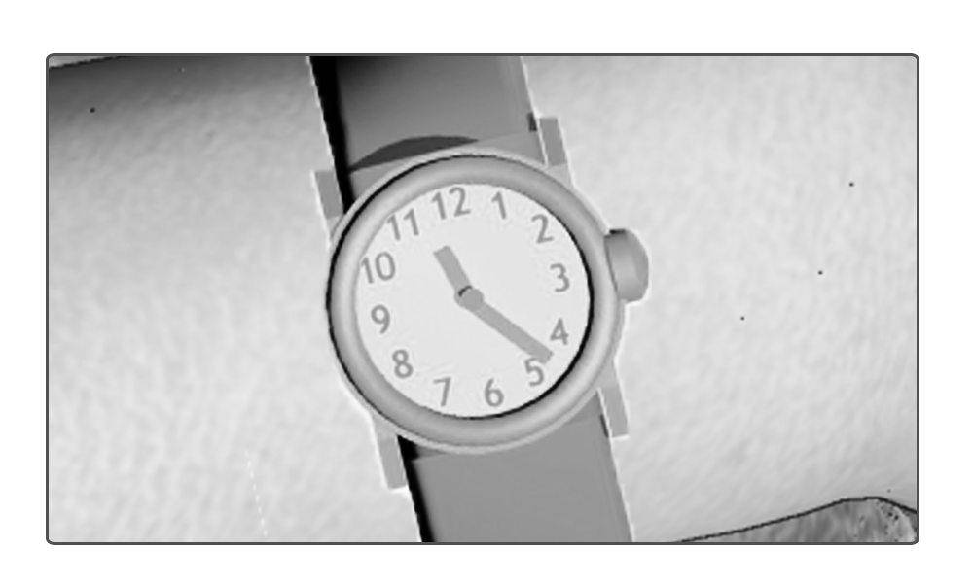
To illustrate the importance of the time to our character, as well as clearly show the time for the audience, we’re also going to film an extreme close up of the watch. Again, you will need to capture at least five seconds of this but we probably won’t use quite that much when the final sequence is cut together.

SHOT 5 | MCU
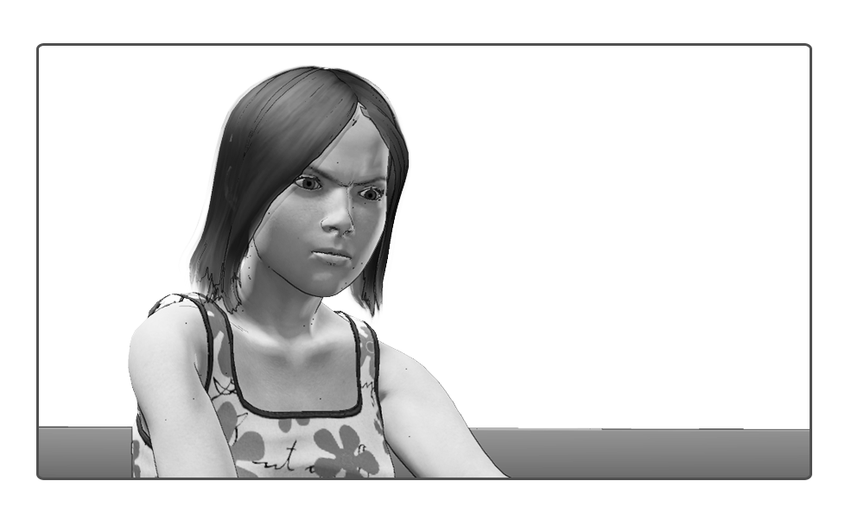
In this shot, we are going to use a medium close up to illustrate the frustration of our character as she waits for her friend. In this take, you should have your actor wait for a couple of seconds, look down at her watch and look up again in frustration. If outside try to have yourself or your subject seated on a bench or chair – if inside use a couch
SHOT 3.2 | FS
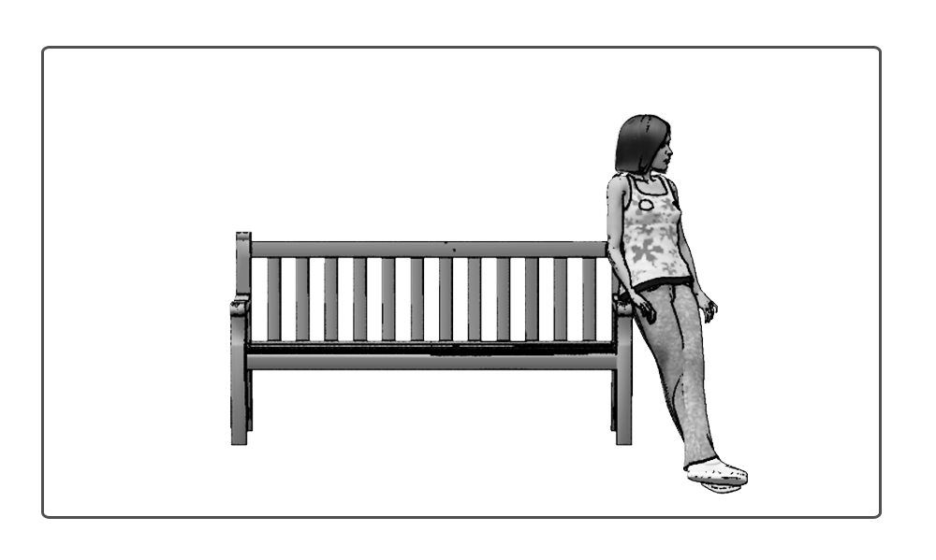
This is the first in a short sequence of jump cuts. When visually similar shots like these are put together, they cause a jarring jump in the continuity which implies that time has passed. In this sequence of jump cuts, we’re going to show our character pacing about, playing with her phone, sitting on the ground, tapping her foot impatiently, basically anything you can think of to demonstrate her boredom. As long as there is a substantial difference between where she is standing in the frame, you will create a noticeable jump cut. Consider capturing up to ten seconds for each of these jump cuts although, again, you probably won’t use quite that much in the final edit.
SHOT 3.3 | FS

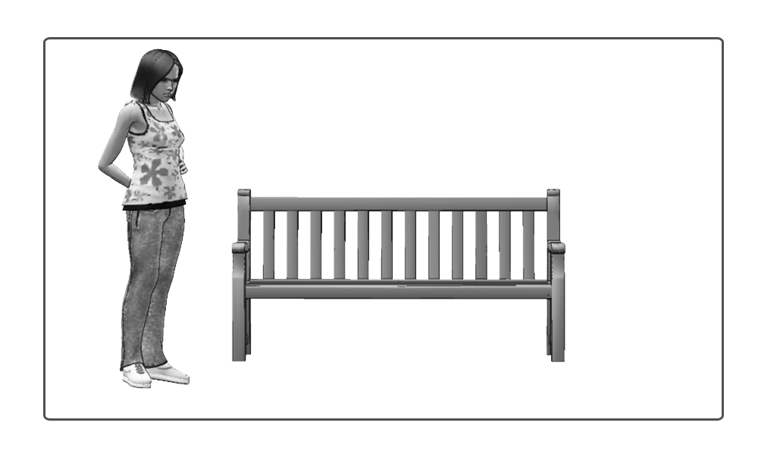
In this shot, our character stands off to the left of frame. She is tapping her foot impatiently.
SHOT 3.4 | FS

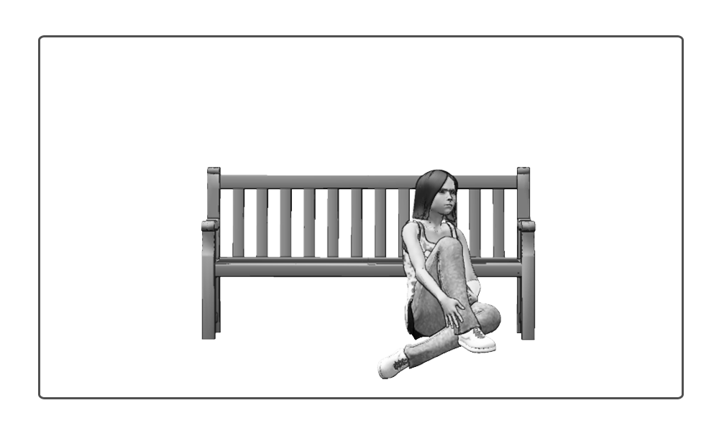
Another in this series of jump cuts. Here the character is slumped against the bench. You could have her playing with her phone or nodding off to sleep.
SHOT 3.5 | FS
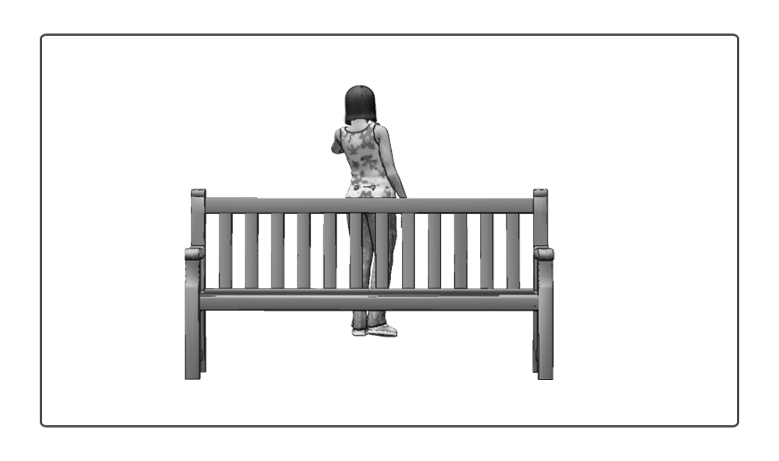
The final in this series of jump cuts shows our character pacing around in the background and checking the time impatiently.

SHOT 3.6 | FS
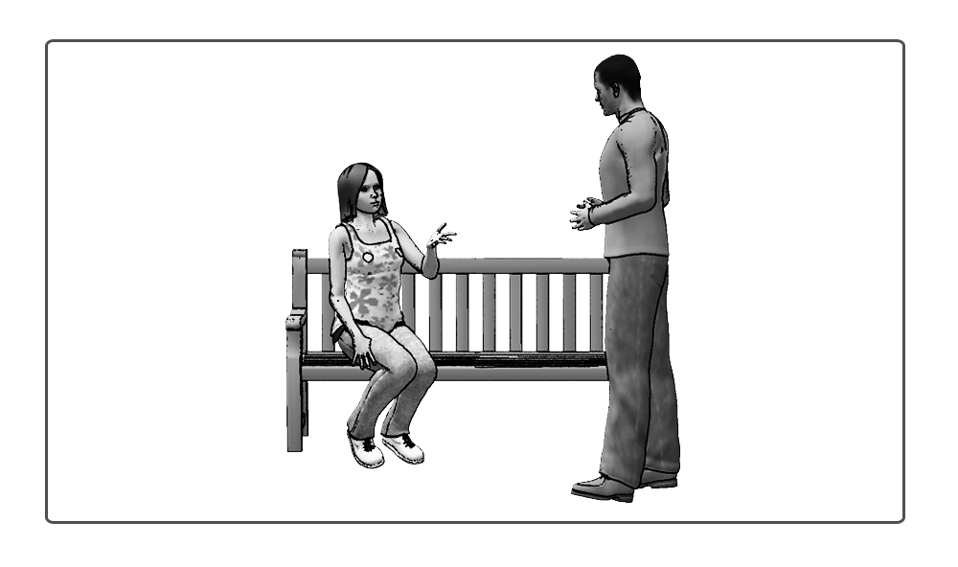
In this full shot, our character is sitting on the bench, waiting when she notices someone who then walks into frame. “Hey,” he says. Because we are shooting the dialogue out of sequence, it’s only necessary to get the first line. Keep in mind that we’re going to be cutting to close ups of the characters shortly, so it’s important to maintain continuity between these shots. If your characters are doing something in this master shot, you need to remember their positions between camera set ups.

If you don’t have another person to film – you could end the sequence here

SHOT 6.1 | MS
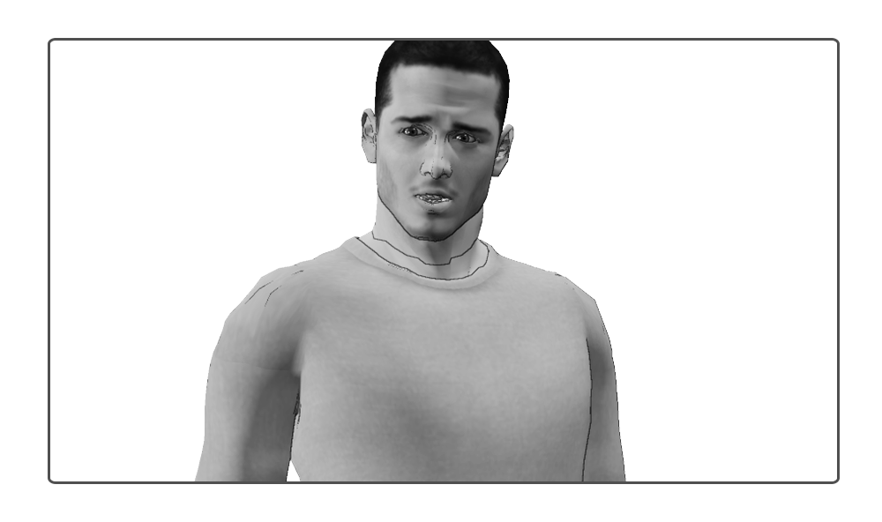
This is the first in a series of lines of dialogue that we’re going to shoot. When shooting dialogue like this, it’s important to think about headroom and eyeliner matches. The character should be looking where the person they are speaking to is sitting. In this case, it’s almost a point of view shot so we’re probably going to set up the camera on the tripod pretty much where the other actor was sitting and get our actor to look directly into the camera. When you are shooting dialogue like this, ensure that your actor allows a few seconds of silence, as if they are listening to the other character talk, before and after the line. This will give you a bit of freedom when you’re cutting the scene together. In this medium shot, the character says, “Hey.” When you are editing, you can choose to use this line from the full shot or medium shot, depending on which works best. Keep in mind that we’re shooting all of this character’s lines at the same time, so don’t turn the camera around just yet, move onto his next line of dialogue!

SHOT 7.1 | MS
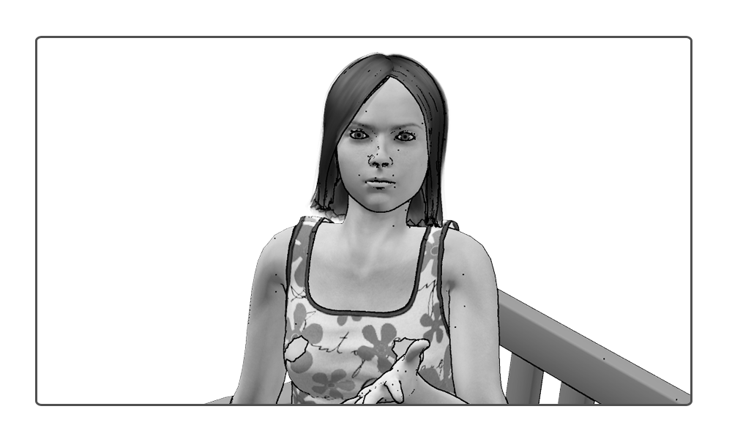
This is the first shot of our other character’s dialogue. Keep in mind that you should shoot these lines separately. We’ll put them in order when we cut the scene together. This saves time by having fewer camera set ups. In this medium shot, our character says, “You’re half an hour late. We’ve got to study for this exam.”
SHOT 6.2 | MS

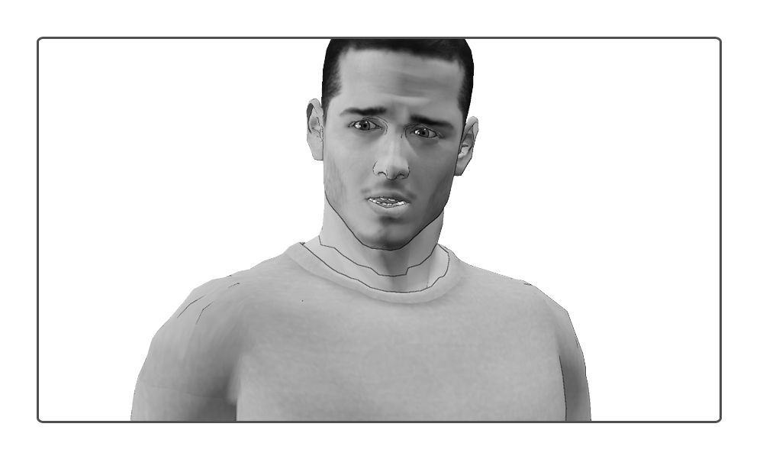
When you are shooting a scene like this, getting closer to the actors with each edit creates greater intensity by bringing your characters closer to the actors. After shooting Shot 6.1, move the camera closer so that you’ve got a medium close up like this. In this shot, your character sheepishly says, “I’m sorry, I kind of lost track of time.”
SHOT 7.2 | MS
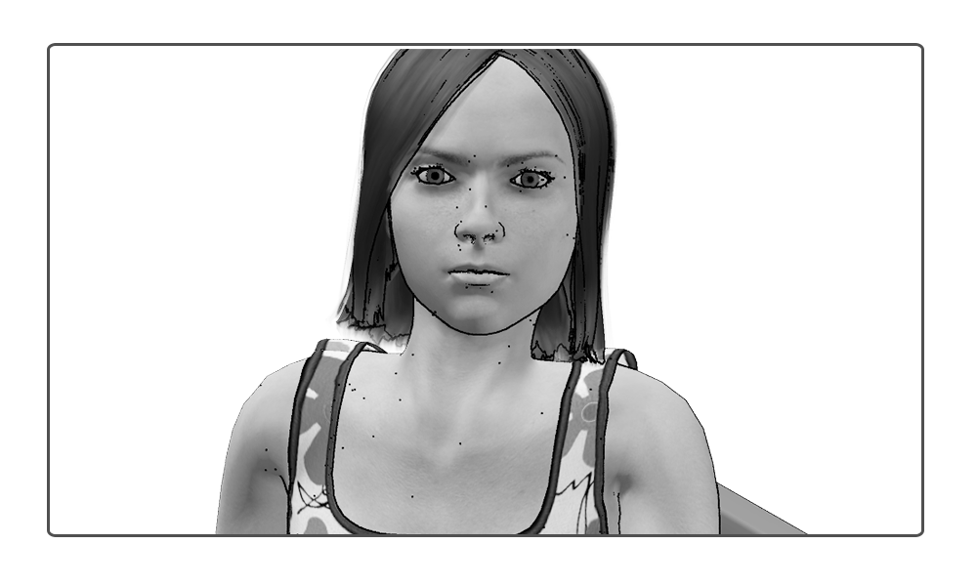
Once again, you will shoot this directly after Shot 7.1. In this shot we’re going to move the camera slightly closer to our subject so that we’ve got a medium close up like this. “What were you doing?” she says in an annoyed voice.

SHOT 6.3 | CU
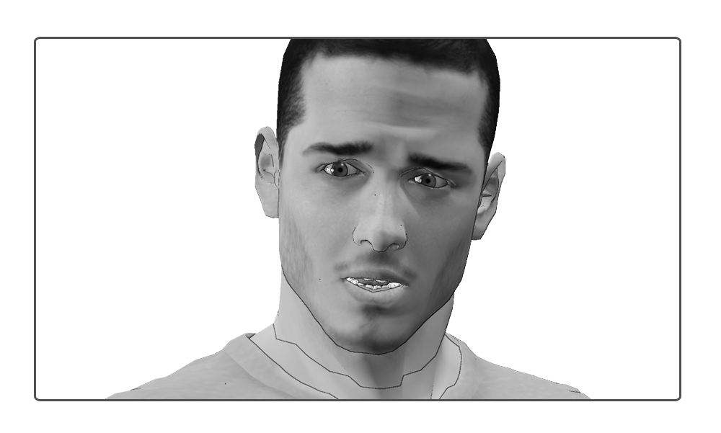

After shooting the previous line, we’re going to get the camera closer again. This time we’re going for a close up. The conversation is reaching its most intense moment and we want to get our audience as close to the characters as we can. “Uh…there was an emergency,” he says, halfheartedly.
SHOT 7.3 | CU
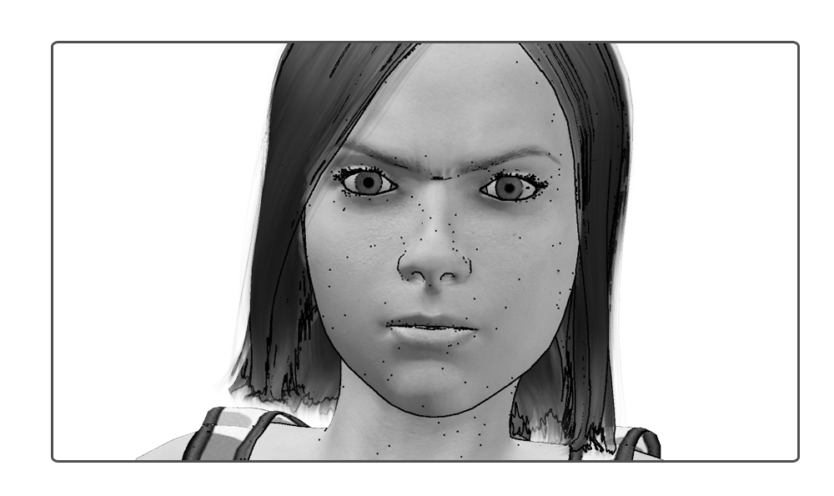
In the final shot of this character, we’re going to reframe the shot so that we capture a close up of her as she sighs, rolls her eyes and says, “You’re so full of crap.” Keep rolling as she stands up and you’ll be able to perform a nice match on action as we cut to the full shot.
SHOT 3.7 | FS
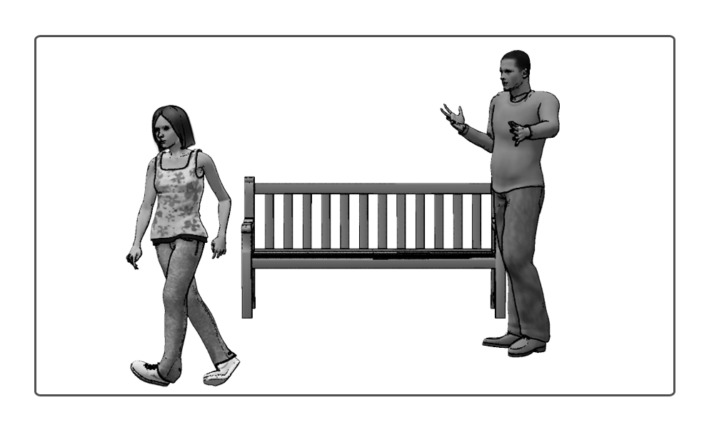
“You’re so full of crap,” our character says, before standing and storming off. Her friend is left standing in frame bewildered. He can walk out frame right. Keep rolling so you’ve got a few seconds to fade to black.

