Year 10 Photography Exercise 4

Students are reminded to take extreme care with the cameras. Remove the lens cap and leave it in the camera box: Do not touch the lens with your fingers, as this will affect your photographs.
Students must wear the camera strap around their neck at all times –failure to do so will forfeit your participation in this activity .If the camera is dropped or damaged students must report this immediately to the teacher. Students must ensure they return to class 10 minutes before the bell to enable them to upload their photos to the computer and store the camera back in its box and place the battery in the battery charger in the box

The Portrait

In todays exercise students will use extreme close ups in portraiture. For purposes of this creativity exercise, we will be producing images in which the subject’s head/face (or part of the face) fills the entire frame; the head itself should be touching or nearly touching at least two of the four edges of the frame

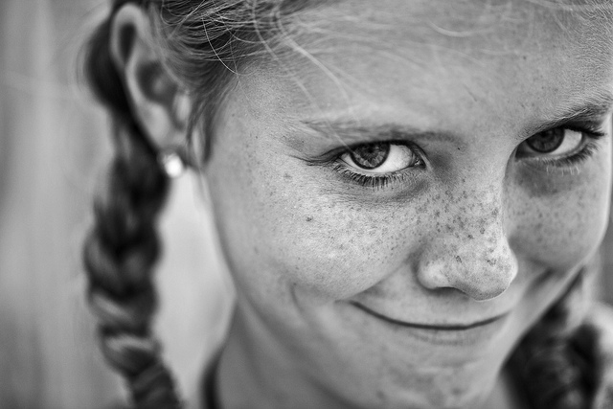
While a portrait need not be close-up to be intimate, it’s almost impossible to avoid intimacy in an extreme close-up of this nature. Depending on your chosen focal length and how close (from full face to even closer — partial face, some detail of the face) you’re framing, you may literally be getting “right in the face” of your subject. From this very close perspective, the viewer is much more likely to notice details about the face that is unlikely to be as apparent in a wider shot; use that to your advantage. Perhaps you’ll focus on the eyelashes, the texture of the skin, a scar, a birthmark, a chipped tooth, laugh lines, freckles, a cowlick, the language of human expression. What can you convey about the subject’s personality, mood, or even his/her life experiences? What kind of story can you tell even when you’ve stripped out most or all of the surrounding environment and the contextual clues it provides?
: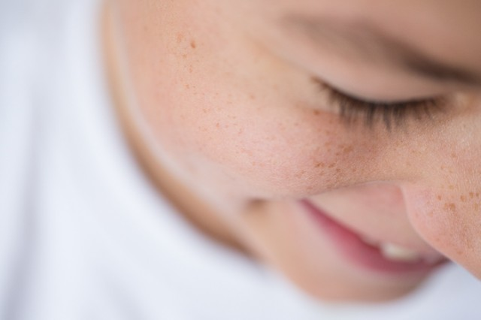 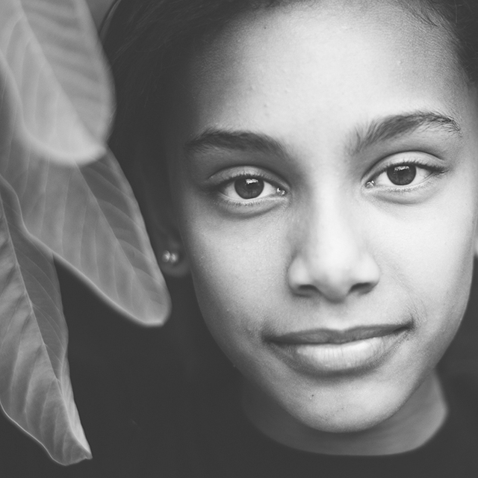
1) Close down! Remember that the tighter you frame, the more shallow your depth of field. If you want to get everything from the tip of the nose to the tips of the ears in focus, you certainly don’t want to shoot wide open in these circumstances. I’d suggest closing down to somewhere between f/5.6 and f/8.0, and taking it from there.
2) Consider bringing in some additional visual interest. Although you are shooting very tight, there’s stillroom to incorporate texture, color, framing, and more. Consider incorporating a scarf, jacket hood, hair or jewelry accessories, working with the hair itself, etc. Also remember that the array of light and shadow can completely change the emphasis of particular features or details.
3) Try some creative cropping. Just because you’ve filled the frame with the head/face doesn’t mean the entire head or face need be present. Play with different crops — crop below the eyes, above the mouth, left side of the face only, hair curving around the jawline, etc. How does your crop change the image and the most attractive point of focus for the viewer?
Change your perspective
Now alter your position from your subject and take the following Portrait shots
- The tilt up shot of your Subject- to do this – get down low and have the camera looking up at your portrait
- Tilt down shot- get up somewhere higher than your subject and take a portrait shot where the camera is positioned facing down at your subject
- Waist up – Compose the portrait from the waist up- ensure you have an interesting or complementary background to add interest to the composition
- Full Body shot – Take some portraits that reveal the entirety of your subject – again look for a commentary background which may add further to your composition

