Media PDP Tutorial 6
“Location & Setting”

The location or setting of a production is very important for both film and photography products, but not so much for print, animation or radio. This section should specifically detail all locations which you will be shooting in both written and visually. It only needs a short paragraph per location to accompany the visuals.

Visual additions can include location shoots, google maps or sketches. The written information can support this by explaining what shots will be taken at each place.

EXAMPLE

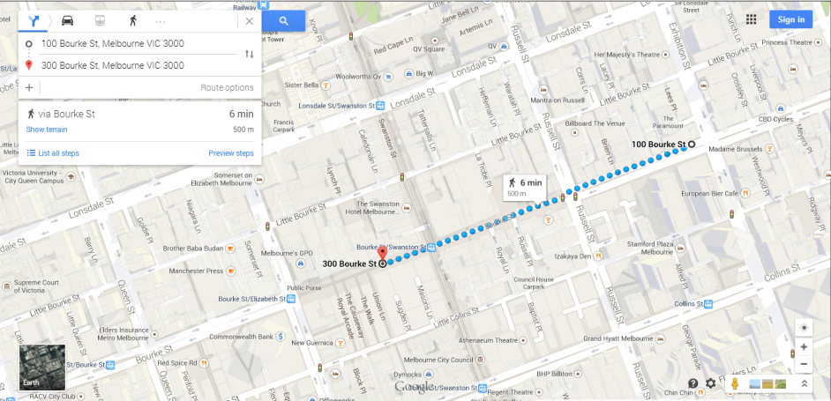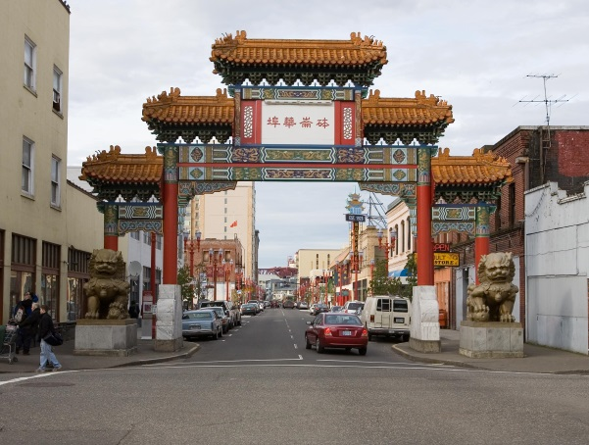

“I will be shooting my urban environment shots in the Melbourne CBD. I will be capturing various architectural developments down bourke street through Chinatown. While shooting, I will have the sun behind me in the east so that the buildings are well lit (around 11am.)”

