Why illegal streaming in Australia is about to get a lot harder
THOUSANDS of Australians have been using this sneaky new method to watch pay TV for free — but the crackdown is coming.
https://www.news.com.au/technology/home-entertainment/tv/why-illegal-streaming-in-australia-is-about-to-get-a-lot-harder/new story/1f479f5f517701088a3f03dc0e304032

THOUSANDS of Australians have been using a sneaky new method to illegally watch pay TV for free.

Whether it’s Suits, Game of Thrones or the English Premier League football channels, tech-savvy Aussies have been installing third-party applications onto their set-top boxes to get in on free viewing with the push of a button.
But don’t get too excited, because the powers that be are finally cracking down on it.

HOW WE’RE GETTING AWAY WITH STEALING TV
Sites like The Pirate Bay and 123 Movies have long allowed users to illegally download their favourite films and shows for free.
But today, users have a much simpler avenue for illegitimate viewing: the plug-and-play set-top box.
Users are now using open-source media players connected to their televisions to stream an array of subscription channels using third-party applications — at a fraction of the price.
The device can basically mimic a TV subscription service by stealing a signal being delivered to a legitimate subscriber and copying it over.
“With these devices, users can install a range of third-party add-ons … to access copyright-protected media from across the globe for free,” said Lori Flekser, executive director of Creative Content Australia. “Each app looks perfectly legal, like a Netflix platform where you’ve got a range of content options for everything from TV to movies to sports … and it does look legitimate.”

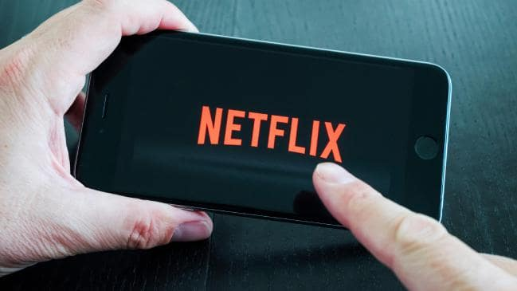
The third-party apps might look perfectly legal, but they’re not.

Only it’s not. While set-top boxes themselves are perfectly legal, the streamed content works by duplicating legitimate subscription TV services almost to the second, and selling them at reduced prices to consumers.
According to the company’s research, more than one-in-five Australians are using an illegal pirated app on their media players.
Unsurprisingly, perhaps, younger Australians are the main culprits. “About a third of teenagers are watching TV through a set-top box device, and about a quarter are using an infringing app,” Ms Flekser said.

But whether they’re aware of the legal issues is another question.
“There seems to be this idea that because they’re still paying for the service, it’s not illegal,” she said.

What’s the big deal with illegal streaming? It’s more harmful than you may think.

You might be wondering what the big deal is. If you stream or download content from somebody else’s server, you can both watch Game of Thrones hassle-free. Isn’t it a win-win? And aren’t the only people who lose out the multi-billion dollar film companies who keep us purchasing overpriced movie tickets?
Not so.

“While people are not aware they’re stealing anything physical, when they stream or download, they essentially reduce the value of the work to zero by paying nothing for it,” Ms Flekser said. “The value is not in the download itself. People compare it to stealing a bike, and say, ‘I’m just copying your bike, so we both get one!’ But the value is in the years of creative efforts.
“Whether it’s made in Hollywood or Hobart, less money goes into new projects diminished by piracy, and the impact is on the thousands of jobs in the screen industry.”

This view was echoed by Screen Producers Australia CEO Matthew Deaner, who told news.com.au piracy is harmful to anyone who works in the creative industry.
“Piracy … jeopardises creative jobs,” he said. “Ultimately this threatens the viability of the output of our industry to produce Australian content that Australian audiences enjoy.”

THE FEDERAL COURT IS TAKING ACTION
In late April, a ruling in the Federal Court granted Village Roadshow and six Hollywood studios an injunction to block 16 internet addresses that provided this service.
It used the 2016 blocking laws applied to illegal torrent services by testing the wording of the legislation on “online locations”, the Australian Financial Review reported.
The internet addresses could stream a range of paid channels including Disney, Fox HD, NatGeo Wild HD and three English Premier League football channels.
Ms Flekser says the move to stop this marks a significant step forward for the screen industry.

“The Federal Court is realising piracy is more than just the Pirate Bay and 123FreeMovies,” she said. “There are now more tech-savvy ways to access illegal material, and set-top boxes are a way in. It’s great the court has recognised that this goes beyond just websites.

“I think it will be interesting for consumers subscribed to soon-to-be blocked services. It’s an expensive paperweight, because it doesn’t provide them what they paid for, and forces them into this ‘buyer beware’ situation. Legal services can’t just cut you off, but illegal services can.”

When Australia cracked down on torrent sites in 2016, new ones kept propping up as predicted, which begs the question: Will a crackdown on illegal streaming channels prove sustainable?

“At the end of the day, people are always going to find ways to avoid paying for content if they can,” Ms Flekser said. “But these court initiatives are at least a reminder of the need to generate legal content that actually returns money to those who spent their money and labour to create it.

“We know from our research that if we make it harder for people to find content legally, they’ll go straight to the Pirate Bay. Addressing that is the next step.”

