Australian media wins relaxed ownership laws, but online rivals' threat to stay

SYDNEY (Reuters) - Australia’s big media players have won long-sought reforms that will allow them to boost market share by facilitating consolidation, although doubts remain on whether the changes can stem the declines at the moguls’ ageing empires.

Billed as a means to compete with online giants such as Netflix (NFLX.O) and Alphabet Inc’s Google (GOOGL.O), the loosening of ownership restrictions was approved by Australia’s parliament on Thursday after the country’s center-right government won support for the reforms from independent politicians.

The changes, supported by Rupert Murdoch’s News Corp (NWSA.O), Fairfax Media (FXJ.AX) and Kerry Stokes-chaired Seven West Media, remove the so-called “two out of three” rule prohibiting one organization from owning all three media - television, newspaper and radio - in any given city.

Television networks will also be allowed to extend their reach beyond the previously allowed 75 percent of the population.

The changes are expected to unleash a wave of consolidation locally, allowing long-established media players, including the Murdoch family, to increase their already vast interests.

It could clear the path for News Corp’s co-chairman Lachlan Murdoch and television entrepreneur Bruce Gordon to launch a rival bid to CBS Corp’s (CBS.N) proposed buyout of broadcaster Ten Network Holdings TEN.AX. The duo have mounted a joint legal challenge to CBS’s A$201 million deal to acquire ailing Ten.
News Corp Australia and Fairfax welcomed the government’s media reform legislation.

“This finally addresses the restrictions that have held back the competitiveness of media companies in Australia for far too long,” News Corp said in a statement.
But analysts said the reforms package was no panacea.

“I don’t think this helps at all,” said independent media analyst Peter Cox.

“For their long term survivability they have to come up with a way to counter the loss of revenue that’s going to Facebook and Google.”

Like their rivals globally, Australia’s traditional media companies have been squeezed by online rivals.

Australian advertising spending is increasing more than 6 percent a year, twice as fast as the economy, and is forecast to reach $12 billion this year. Yet most of the growth is seen going into online advertising, while print, radio and television advertising is either flat or down.
“I’m not sure it really makes any difference now as the horse has bolted,” Brian Han, senior equity analyst at Morningstar, said of the reforms.

“But it does remove some of the shackles of consolidation against the might of Google and Facebook.”
Australian media owners had been calling for a relaxation of ownership restrictions since the 1990s.

“We are relieved at the prospect of saying goodbye to the world’s highest licence fees and the antiquated ownership laws,” Ten Network Chief Executive Officer, Paul Anderson, said.

Seven West also issued a statement, welcoming the move.
Netflix Inc
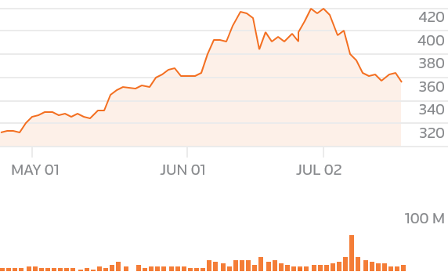
- NFLX.OGOOGL.ONWSA.OFXJ.AXCBS.N

NEXT WAVE
An anticipated wave of mergers, acquisitions and tie-ups has already started in Australia. Besides the Ten deal, private equity firms TPG Capital Management LP [TPG.UL] and Hellman & Friedman made competing buyout approaches for Fairfax earlier this year, although the deals weren’t concluded.

Senator David Leyonhjelm, of the minor Liberal Democratic Party, said he was not concerned about a consolidation in Australian media so long as there was international interest.

“It is not good policy to tie-up Australian media companies with rules and regulations that do not apply to Facebook and Google, which are not subject to restrictions such as two out of three,” said Leyonhjelm, who supports the reforms.
“It can’t shrink to a monopoly as long as you have international competition.”

