Photography as Narrative

As an introduction to the Photography unit students are required to take photographic compositions using any recording device such as their phone , ipad or digital camera
Students are challenged to use their imagination to interpret and take an individual image of the following themes. Try to avoid obvious or explicit images or take the same photo of your classmate. You should then return to class and present your work with text
Tired
Heavy
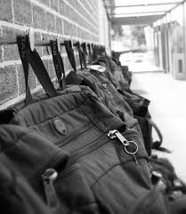

Round
repetitive
Express
Creative
Shabby
Open
Loud
Scary
Perfect
Hungry
Risky
Big
Dinosaur
Times Up

