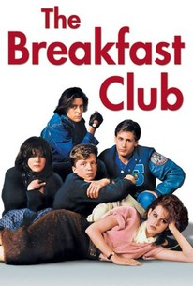

The Breakfast Club is a 1985 teen film widely considered as the definitive work in the genre. Written and directed by John Hughes, the storyline follows five teenagers (each representing a different clique in high school) as they spend a Saturday in detention together and come to realize that they are all deeper than their respective stereotypes. The film has become a cult classic and has had a tremendous influence on many coming of age films since then. The film was shot entirely in sequence. Shooting began on March 28, 1984, and ended in May of 1984.

Film Synopsis

Set in1984 suburban Chicago, the film, opens with a quote from the rock singer David Bowie about the adversarial nature of the relations between adolescent sand adults. This is quickly followed by the narrator (Brian, the Brain) further setting the stage and basic premise of the movie. He informs the viewers that while the five adolescents serve out their detention in the library of their school, they have been instructed to write an essay on the topic "Who Do You Think You Are?" by their nemesis, a teacher named Mr Vernon. Vernon then enters the library and establishes the outside authority that can only serve to galvanize the disparate students. Vernon then leaves for his guard-post position in the office across the hall. The next sections of the film portray the students 'initial defensive posturing while they feel each other out .The wise-guy Bender (the Criminal) forces much of the action and, in a pivotal scene, vandalizes the library door so that it must remain closed, effectively forging the group. Bender insistently pushes much of the interaction, pressing toward greater honesty with each other and a consequent deconstruction of their roles. Through fits and starts, they begin to trust each other.

These scenes are punctuated by a brief appearance by the janitor, Carl, who, after being insulted by Bender, responds genuinely and holds his ground, which establishes him as the only legitimate authority figure in the film. After this scene, the protagonists all whistle together "Bridge Over the River Kwai." This leads to further exploration of their relationships with their families and their pressing sexuality. Then, in a telling scene, they have lunch, each capturing the essence of their relationships with their parents. Bender then explodes, telling his story of growing up with alcoholic, abusive parents. When Andrew (the Athlete) challenges his veracity, Bender starkly shows the group a cigarette burn on his forearm. When Vernon leaves his office, the group, again led by Bender, pushes the envelope. After some reticence, the group as a whole leaves the library to retrieve marijuana from Bender's locker. On their return to the library they discover that they are trapped and will be caught by Vernon. Sacrificing himself for the group, Bender "falls on his sword" by drawing the attention of Vernon so the others can safely return to the library. Once caught, Bender is put by Vernon into solitary confinement in a storage room. He finds an escape route through the ceiling but then falls (without hurting himself, of course) through the ceiling panels, back into the library. Vernon comes rushing in to find out what's going on, and the group closes rank beautifully, returning the favour of protecting Bender. After Vernon leaves they have another bonding experience, smoking Bender's marijuana. More talk about sex, authority, and families ensues.
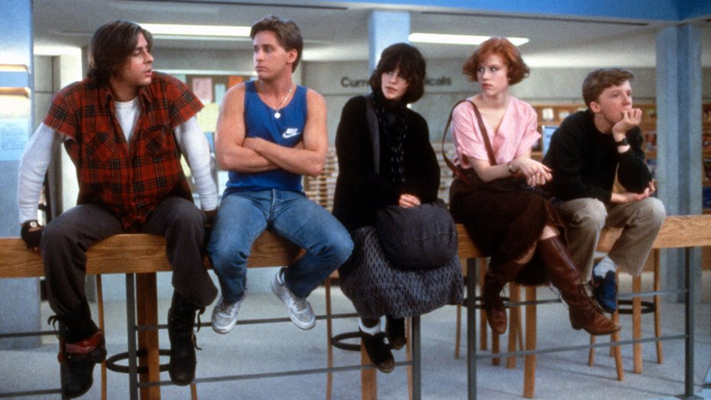

The action then moves to a telling conversation between Vernon and Carl about their own midlife issues. Cutting back, the group talks (more) about sex and why they are in detention. In a particularly moving scene, Andrew tearfully describes his humiliation of another student as the reason for his detention. As they continue to deconstruct their roles, Brian plaintively asks, "Are we going to be like our parents?" and, more pointedly, "What's going to happen on Monday? Are we still friends?" Wondering if they can also reconstruct themselves, they have intense discussions of these questions. As the movie comes to a close, Andrew and Allison (The Basket Case) pair up, as do Claire (The Princess) and Bender. In the final scene, they all say goodbye and return to their families. A song, "Don't You Forget About Me," plays in the background, and the narrator has the last word, reading his essay aloud.

The Breakfast Club provides a stereotypical representation of teenagers in the 1980’s. The Breakfast Club was ranked No. 1 on Entertainment Weekly's list of the 50 Best High School Movies. [6] and has had a tremendous impact on both the teen film genre and on popular culture since the 1980s.

ASSESSMENT TASK:

To be answered in your Media exercise book

1. Identify each character and what he/she did to receive detention.

2. Discuss the way each character in the film is introduced and represented in the film. (Stereotype) What media codes and conventions are evident in their representation?

3 What are some of the themes /issues raised that concern teenagers through the film

4. Whom if any character or characters do you most identify with?

4. What are the expectations the audience may have as to the outcome of the Saturday?
Detention

5 Write a critics review of the film “The Breakfast Club” 300 - 400 words

Design a Poster to promote the film using one character you identify with and

