Agency and Control : Australian Media Institutions in the Digital Age

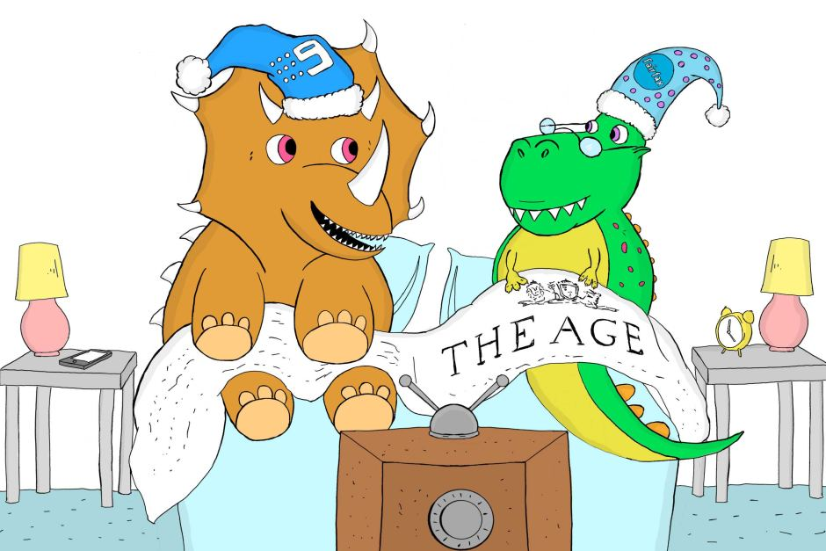

- Media diversity has been sacrificed for survival. Nine's takeover of Fairfax Media is the inevitable outcome of legal changes that bowed to the reality domestic media companies' advertising revenues have collapsed.

In the era before the internet, Fairfax and Nine were the kings of their respective media spaces.

The "rivers of gold" from classified advertising flowed for Fairfax, and the substantial revenues they created cross-subsidised well-resourced newspapers and journalism.

Nine enjoyed its own golden age of advertising revenue during the long era when free-to-air broadcasting was a primary source of news, sport and entertainment, while web-based alternatives such as Netflix did not exist.

Crucially, nearly all of Australia's advertising spend was captured by domestic media players.

The rise of digital media turned that on its head.

Now much of the revenue flows offshore, to Google and Facebook, which increasingly dominate the advertising market.
Digital advertising is predicted to reach $8.2 billion in the coming year — half of the nation's total advertising spend of more than $16 billion, according to a recent analysis.

Television advertising is set to fall to just half of that — $3.8 billion — and haemorrhage further in coming years, with newspapers commanding just $1.5 billion.
It may well be that these forecasts of digital advertising's rise will prove conservative, as they have in the past.

The future is digital

Most people understand Google makes money from the billions of people who use its search engine and then click on the links of businesses that have won a bidding war to have their content at the top of the search list.
Fewer people realise Google and Facebook now largely control the markets for display advertising and video advertising through their ownership of platforms that "programmatically" place adverts across different media.

- The Federal Government made some big changes to Australia's media ownership laws late last year, which have allowed this merger to go ahead.

- When the federal government changed the laws in September last year to allow once again cross-media ownership between newspapers, radio, television and online, speculation about a merger between Nine and Fairfax grew stronger.

- Companies such as Fairfax and Nine, which report the news and investigate issues, are losing the revenues that subsidise this endeavour.

- The repeal of laws safeguarding diversity — that stopped one company owning television, radio and newspapers — was a defensive move to try to rescue Australia's commercial media.

- The Media Entertainment and Arts Alliance journalists' union urged the ACCC to reject the merger proposal.

- Communications Minister Mitch Fifield has expressed his hope the merger will allow the combined Nine-Fairfax to compete with the global media behemoths.

- That's ambitious; it might merely be a case of slowing the decline.

- Either way, it may come at a cost.

- The changes effectively removed the restrictions that previously prevented
companies owning newspapers, television and radio stations in the same city.

- They also abolished the "reach rule" which prevented a single TV broadcaster from reaching more than 75 per cent of the population.

- Nine and Fairfax are positioning themselves to remain profitable in a world increasingly dominated by digital media. The merger will allow them to pool assets, reduce costs and streamline management, to adapt to the changing environment.

- Fairfax journalists will inevitably fear for their future, given the company's form in retrenching thousands of journalists in recent years and increasing competition from other digital media.Even if Fairfax's newspapers continue, for the foreseeable future, many will rightly fear that a pooling of journalists and other staff with Nine will inevitably lead to more job losses.

- It means the death of Fairfax and is the most consequential change in Australian media ownership in 31 years.

- It also means that three of Australia’s best and biggest newspapers – The Age, The Sydney Morning Herald and The Australian Financial Review – are now subsumed into a media conglomerate whose editorial culture is characterised by mediocre journalism.
- The takeover also means a further loss of diversity in an already highly concentrated media-ownership landscape. The big players are now down to four: News Corp, Nine, Seven West Media and the ABC.

- There is also a question about editorial independence.

- Fairfax has a charter of editorial independence, which all owners since 1990 have signed up to. Will Nine sign up to it? Will the charter have any meaning when the newspapers are owned by a company whose chairman, Peter Costello, was treasurer in the Liberal-National Coalition government of former Prime Minister
John Howard?
- The answers to these questions will not be known for some time. They will depend largely on who is given editorial control of the combined operation. Since the Nine CEO, Hugh Marks, is to be CEO of the combined operation, it seems more likely than not that it will be a Nine executive who calls the editorial shots, too.

- Decades ago, Fairfax journalists fought for, and won, a formal charter of editorial independence that was meant to ensure journalists could report free from commercial pressure to appease advertisers.

- Nine, which will have a 51 per cent share of the merged entity and is effectively taking over Fairfax, does not share that tradition, although chief executive Hugh Marks has indicated the Nine board would be happy to adopt the charter.

- But former prime minister Paul Keating was scathing about the implications for quality journalism.

- "Channel Nine, for over half a century has never other than displayed the opportunism and ethics of an alley cat," he wrote in an op-ed penned on Thursday.

- "Through various changes of ownership, no one has lanced the carbuncle at the centre of Nine's approach to news management.

- "And, as sure as night follows day, that puss will inevitably leak into Fairfax."
- Across the world, as traditional media companies fight to survive, many fine principles of diversity and independence once held dear in media policy are being jettisoned or compromised.

- A loss of journalists will mean fewer people reporting on the important issues facing Australia each day, and many fear will mean a loss of diversity in media coverage.

- A successful merger between Nine and Fairfax is tipped to open the door to other such deals, particularly now that Australian media laws have been changed to remove restrictions on cross media ownership.

- The merger of Australia's second biggest free-to-air TV network with the second biggest newspaper publisher will result in a $4 billion-company that is second only to News Corp in size and impact.

- That will put pressure on its media rivals, particularly the other commercial free-to-air networks, Seven and Ten.

- Already there is speculation that they will be forced to merge with other media to remain profitable.

- The merger could change Fairfax operations, and may well bring an end to its investigative co-productions with the ABC.

- Marketing lecturer David Waller from the University of Technology, Sydney, says the merger would open up opportunities for cross promotion between television programs and Fairfax assets, such as Nine's The Block and the real estate website Domain.It's no secret the advertising revenues the Domain portal brings in were a major selling point for Nine when considering the merger.

- "By combining different media — TV, print and online — they've got a greater scope to get more people to see the message."And if you have an extremely popular online site like Domain, they're going to use that to expand their promotional activities (for) TV programs like the Block."Such "cross-fertilisation" is likely across other programs and Fairfax assets.

- Both media companies have major motoring outlets for example, which could be used to cross-promote each other or expand television and online content.

- And it is almost certain to mean the loss of yet more journalists’ jobs.
- Since 2012, more than 3,000 jobs have been lost across Australian journalism. Yet, if the takeover is really going to represent “compelling value” for shareholders, as Fairfax chairman Nick Falloon says, then newsroom “synergies” – to borrow the corporate jargon – are likely to be essential.

- The Fairfax company’s death throes have been painful and prolonged.
- They began in 1987, when the younger son of Sir Warwick Fairfax, “young Warwick”, privatised it. That meant buying out all the public shareholders, for which purpose “young Warwick” borrowed AU$1.6 billion from the National Australia Bank.

- Even with the revenue from the “rivers of gold” then flowing in from the classified ads of The Age and The Sydney Morning Herald, “young Warwick” could not meet his debts to the bank, which promptly sold him up.
- The Fairfax story has all the elements of Greek tragedy: heroism in the creation of the company, then a combination of comedy, pride, stupidity, greed, arrogance and hubris to bring it down.

Fairfax and Nine are merging. Here's what the deal involves and what it will mean for you
By Anne Barker

Thu 26 Jul 2018,
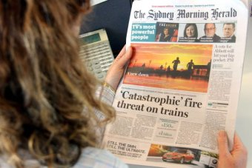
PHOTO: Both Fairfax and Nine will benefit from their merger, but there will likely be some losses..

Fairfax and Nine have announced they will be merging to create a new media giant.

The Fairfax name will be ditched, and the two will combine under the Nine name to create and broadcast content across television, radio and online.
Here's what you need to know about the deal and what it means for the newspapers, TV shows and radio stations you love.

Why are Nine and Fairfax merging?
Nine and Fairfax are positioning themselves to remain profitable in a world increasingly dominated by digital media.
The merger will allow them to pool assets, reduce costs and streamline management, to adapt to the changing environment.
Both companies are profitable enterprises in their own right, so this merger is about ensuring their future profitability as a merged company.

What's in it for Nine?
The new combined company will be called Nine, and at a management level Nine will become the majority owner and run the company.
Both it and its shareholders will benefit from the effective takeover of Fairfax' most lucrative assets, including the real estate portal, Domain, and its Macquarie Media radio interests.

It will also benefit from access to Fairfax' journalistic assets, such as investigative reporters, which would boost its reputation in the industry.
You can expect more joint ventures will be on the way, like the now defunct Financial Review Sunday program, which Fairfax and Nine previously cooperated on.

What will it mean for Fairfax?
The merger means Fairfax will lose its name, which means it's the end of the road for a company which has been part of the Australian media landscape for more than a century.

Nine-Fairfax shotgun marriage

Google and Facebook are taking Australian ad revenue hand over fist, and Nine's tie-up with Fairfax is a last ditch survival tactic.

But its newspapers — including its main mastheads, the Sydney Morning Herald, The Age, and the Australian Financial Review — are expected to continue as usual in both their printed format and online, at least for the foreseeable future.

Fairfax recently struck a deal with News Corp to share printing presses, in a move designed to extend the life of its print editions for many more years.
That deal involves more than 100 job losses, but the savings of around $15 million a year will help to preserve Fairfax' newspaper operations and staff, and could stave off future job losses.

What about Domain?
Fairfax has already cast off its property portal Domain as a separate entity, although it retains 51 per cent ownership.
Its majority ownership of Domain as well as other assets including its radio stations will now be owned and controlled by Nine.

Is this a done deal?
Fairfax and Nine announced the merger to the Australian stock exchange this morning.
It still needs formal approval from the Australian Competition and Consumer Commission (ACCC) and agreement from shareholders.
But given that Nine is offering Fairfax shareholders a 22 per cent premium on the latest share price, the offer is generous and unlikely to be a problem.
Once the regulatory hurdles are passed, the merger is likely to be finalised by the end of the year.

How is this allowed?
The Federal Government made some big changes to Australia's media ownership laws late last year, which have allowed this merger to go ahead.

The changes effectively removed the restrictions that previously prevented companies owning newspapers, television and radio stations in the same city.

They also abolished the "reach rule" which prevented a single TV broadcaster from reaching more than 75 per cent of the population.

What does it mean for employees? Will there be job losses?
Most if not all mergers involve job losses at some stage.

Fairfax journalists react to takeover
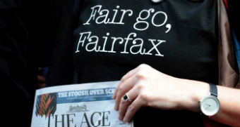

Fairfax's $4 billion merger with Nine divides journalists in its Sydney and Melbourne newsrooms, with some arguing the deal is nothing more than a takeover of one of Australia's strongest cultural institutions.

The most immediate changes, once the Fairfax-Nine merger takes effect, will be at management level.

Nine's current chief executive, Hugh Marks, and chairman, Peter Costello, will both retain their positions in the new merged company.
That raises questions about the future of Fairfax CEO Greg Hywood, amid speculation he may retire or would lose his job under the change.

Fairfax journalists will inevitably fear for their future, given the company's form in retrenching thousands of journalists in recent years and increasing competition from other digital media.
Even if Fairfax's newspapers continue, for the foreseeable future, many will rightly fear that a pooling of journalists and other staff with Nine will inevitably lead to more job losses.

A loss of journalists will mean fewer people reporting on the important issues facing Australia each day, and many fear will mean a loss of diversity in media coverage.

What does it mean for the rest of the media industry?

A successful merger between Nine and Fairfax is tipped to open the door to other such deals, particularly now that Australian media laws have been changed to remove restrictions on cross media ownership.

The merger of Australia's second biggest free-to-air TV network with the second biggest newspaper publisher will result in a $4 billion-company that is second only to News Corp in size and impact.

That will put pressure on its media rivals, particularly the other commercial free-to-air networks, Seven and Ten.

Already there is speculation that they will be forced to merge with other media to remain profitable.

The merger could change Fairfax operations, and may well bring an end to its investigative co-productions with the ABC.

How TV will change once Nine takes over Fairfax Media
By Anne Barker
Sat 28 Jul 2018, 5:11am

Karl Stefanovic as a radio jock. Alan Jones on Channel Nine. And some of the country's best investigative reporters switching their exposes from corrupt politicians to shonky plumbers.

They're some of the predictions of how a merger of Nine and Fairfax Media could change Australia's media landscape in the months and years ahead.

Marketing lecturer David Waller from the University of Technology, Sydney, says the merger would open up opportunities for cross promotion between television programs and Fairfax assets, such as Nine's The Block and the real estate website Domain.
It's no secret the advertising revenues the Domain portal brings in were a major selling point for Nine when considering the merger.

Nine-Fairfax shotgun marriage

Google and Facebook are taking Australian ad revenue hand over fist, and Nine's tie-up with Fairfax is a last ditch survival tactic.

At the least, we could expect to see Domain's property experts on The Block, and reality TV program promoted on Domain.

"It's a great way for companies to reduce costs and get more customers," David Waller says.
"By combining different media — TV, print and online — they've got a greater scope to get more people to see the message.
"And if you have an extremely popular online site like Domain, they're going to use that to expand their promotional activities (for) TV programs like the Block."
Such "cross-fertilisation" is likely across other programs and Fairfax assets.
Both media companies have major motoring outlets for example, which could be used to cross-promote each other or expand television and online content.

Old stars, new tricks
Dr Waller predicts the cross-fertilisation of Fairfax and Nine could see the rise of new celebrities, or existing stars branching out into new areas given that Nine will also acquire Fairfax's radio assets, including 2GB.

Karl Stefanovic expanding into radio, he suggests. Or Alan Jones presenting a program on Nine.

Or lesser-known journalists from Fairfax papers could produce work for Nine on high-profile shows like 60 Minutes.
Mr Waller points out that Chanel Seven's David Koch was once a cadet reporter on the business pages at the Australian newspaper, while Karl Stefanovic was a regional television reporter in Queensland.

It could also go the other way with Nine stars appearing in Fairfax papers. For example, last year Nine stars including Eddie McGuire and Sonia Kruger acted as "guest editors" for News Corp Sunday papers and a similar plan could be hatched with their new partnership.

Cuts and clicks

Despite some assurances that the planned merger would not involve job cuts, it seems inevitable that the new combined company — run and controlled by Nine — will rationalise its operations in areas where they now overlap to reduce costs.
That could mean a cut in television programs or — more likely — the redirection of specialist journalists at Fairfax to help boost flagging television ratings or expand online coverage.

Fairfax journalists react to takeover

Fairfax's $4 billion merger with Nine divides journalists in its Sydney and Melbourne newsrooms, with some arguing the deal is nothing more than a takeover of one of Australia's strongest cultural institutions.

Media analysts predict the merger could serve a real blow to investigative journalism in Australia.

"It could obviously go in two directions," says Stephen Harrington, an Associate Professor of Journalism at Queensland's University of Technology.
"For the most part we have seen a real evacuation of hard-hitting political journalism from TV in the last 20 years or so. And yet I think there's every possibility that this will see a little bit of that credibility come back to programs like 60 Minutes and so on.
"Or it could go in the other direction — that there is more of a push for clicks and eyeballs — more so than the underlying political value, or the social value of what journalists do.

"I'd hope it's at least a chance for Channel Nine to reinvest and take seriously the importance of serious investigation."

In that scenario the merger could allow Nine to reinstate a serious Sunday morning current affairs program to compete with the ABC's Insiders program.

'Fluff' is a concern
But Dr Waller warns there is a real risk it could simply result in some of Australia's best investigative journalists being asked to produce "fluff pieces" for programs like A Current Affair.

"If they're just looking at shareholders and an easy way out and not having controversy — and businesses usually hate controversy — they'll go for the fluff piece rather than the hard piece," he says.

He uses Fairfax investigative journalist Kate McClymont as an example.
"She's highly credible. But if she has ideas that Channel Nine doesn't like, and they want a fluff piece, then you're up against management.
"It will be interesting to see how they handle that."

A modern tragedy: Nine-Fairfax merger a disaster for quality media
https://theconversation.com/a-modern-tragedy-nine-fairfax-merger-a-disaster-for-quality-media-100584

All deaths are sudden, even if long expected.
Appropriately enough, this is the opening sentence of a book called Journalism in a Culture of Grief.
And if ever there was a time of grief for journalism in Australia, it is today, with the announcement that Nine Entertainment is taking over Fairfax Media.
It means the death of Fairfax and is the most consequential change in Australian media ownership in 31 years.
It also means that three of Australia’s best and biggest newspapers – The Age, The Sydney Morning Herald and The Australian Financial Review – are now subsumed into a media conglomerate whose editorial culture is characterised by mediocre journalism.
Nine’s news bulletins consist largely of police stories with a tincture of politics, and highlights of colourful or violent events overseas.

Read more: Australian media at a crossroads amid threats to diversity and survival

Its current affairs program, A Current Affair, is a formulaic procession of stories about consumer rorts and personal tragedies.
So there is a huge question mark over the future editorial quality of the newspapers.
A particularly pressing question is: what will happen to The Age’s investigative unit?
It is led by two of the best investigative reporters Australia has produced, Nick McKenzie and Richard Baker.
In addition to breaking an extraordinary range of major stories on subjects like organised crime and scandals in the banking industry, they have developed a highly successful collaboration with the ABC’s Four Corners team.
It seems very unlikely Nine would allow this collaboration to continue, since it involves a rival television channel.
There is also a question about editorial independence.
Fairfax has a charter of editorial independence, which all owners since 1990 have signed up to. Will Nine sign up to it? Will the charter have any meaning when the newspapers are owned by a company whose chairman, Peter Costello, was treasurer in the Liberal-National Coalition government of former Prime Minister John Howard?
The answers to these questions will not be known for some time. They will depend largely on who is given editorial control of the combined operation. Since the Nine CEO, Hugh Marks, is to be CEO of the combined operation, it seems more likely than not that it will be a Nine executive who calls the editorial shots, too.
The takeover also means a further loss of diversity in an already highly concentrated media-ownership landscape. The big players are now down to four: News Corp, Nine, Seven West Media and the ABC.
And it is almost certain to mean the loss of yet more journalists’ jobs.
Since 2012, more than 3,000 jobs have been lost across Australian journalism. Yet, if the takeover is really going to represent “compelling value” for shareholders, as Fairfax chairman Nick Falloon says, then newsroom “synergies” – to borrow the corporate jargon – are likely to be essential.
The Fairfax company’s death throes have been painful and prolonged.
They began in 1987, when the younger son of Sir Warwick Fairfax, “young Warwick”, privatised it. That meant buying out all the public shareholders, for which purpose “young Warwick” borrowed AU$1.6 billion from the National Australia Bank.
Even with the revenue from the “rivers of gold” then flowing in from the classified ads of The Age and The Sydney Morning Herald, “young Warwick” could not meet his debts to the bank, which promptly sold him up.

In a highly politicised auction, during which Paul Keating and the then-Labor prime minister, Bob Hawke, sought assurances from prospective buyers concerning political outlook, the company fell into the hands of a London-based Canadian, Conrad Black.
There followed a procession of ownership changes, board reshuffles and short-lived chief executives that left the company rudderless and vulnerable.
Shortly after the turn of the millennium, when the digital revolution began to engulf the media, a weakened and incompetently managed Fairfax was ill-equipped to respond.
A series of disastrous mistakes by successive boards resulted in Fairfax missing out on opportunities to buy into the new online advertising platforms in cars, jobs and real estate.
Hubris and arrogance led incumbent board members to believe that these markets could not function without the mountains of classified advertisements carried by The Age and Herald on Saturdays.

Read more: Mixed media: how Australia's newspapers became locked in a war of left versus right

By 2005, the shift in revenue to online platforms was discernible, and the trend has been accelerating ever since.
As a result, the company was increasingly unable to meet the demands of the share market for profit growth, and so became the object of sustained takeover speculation.
When the federal government changed the laws in September last year to allow once again cross-media ownership between newspapers, radio, television and online, speculation about a merger between Nine and Fairfax grew stronger.
Today that speculation became a reality.
The Fairfax story has all the elements of Greek tragedy: heroism in the creation of the company, then a combination of comedy, pride, stupidity, greed, arrogance and hubris to bring it down.

Nine's Fairfax takeover is a last-ditch bid for survival, but it comes at a cost
http://www.abc.net.au/news/2018-07-26/fairfax-nine-merger-comes-at-a-cost/10039040
By Stephen Long

Media diversity has been sacrificed for survival. Nine's takeover of Fairfax Media is the inevitable outcome of legal changes that bowed to the reality domestic media companies' advertising revenues have collapsed.

In the era before the internet, Fairfax and Nine were the kings of their respective media spaces.

The "rivers of gold" from classified advertising flowed for Fairfax, and the substantial revenues they created cross-subsidised well-resourced newspapers and journalism.
Nine enjoyed its own golden age of advertising revenue during the long era when free-to-air broadcasting was a primary source of news, sport and entertainment, while web-based alternatives such as Netflix did not exist.

Enter, the online behemoths
Crucially, nearly all of Australia's advertising spend was captured by domestic media players.

The rise of digital media turned that on its head.

Crushed: Digital giants vs Australian media

Within a couple of years the likes of Google and Facebook will devour more than half local ad revenues, leaving only crumbs for traditional media players.

Now much of the revenue flows offshore, to Google and Facebook, which increasingly dominate the advertising market.
Digital advertising is predicted to reach $8.2 billion in the coming year — half of the nation's total advertising spend of more than $16 billion, according to a recent analysis.
Television advertising is set to fall to just half of that — $3.8 billion — and haemorrhage further in coming years, with newspapers commanding just $1.5 billion.
It may well be that these forecasts of digital advertising's rise will prove conservative, as they have in the past.
The future is digital
Most people understand Google makes money from the billions of people who use its search engine and then click on the links of businesses that have won a bidding war to have their content at the top of the search list.
Fewer people realise Google and Facebook now largely control the markets for display advertising and video advertising through their ownership of platforms that "programmatically" place adverts across different media.

View image on Twitter
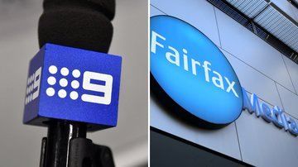

Nine’s takeover of Fairfax is a bad day for media diversity and quality journalism. It should be rejected by the ACCC. Read our full statement here:
https://
meaa.io/2v0hMJ0

This raises serious issues for the future of journalism.

Companies such as Fairfax and Nine, which report the news and investigate issues, are losing the revenues that subsidise this endeavour.
The repeal of laws safeguarding diversity — that stopped one company owning television, radio and newspapers — was a defensive move to try to rescue Australia's commercial media.

The Media Entertainment and Arts Alliance journalists' union urged the ACCC to reject the merger proposal.

Communications Minister Mitch Fifield has expressed his hope the merger will allow the combined Nine-Fairfax to compete with the global media behemoths.
That's ambitious; it might merely be a case of slowing the decline.
Either way, it may come at a cost.

Independence more than a tradition

The Fairfax culture has long prided itself on editorial independence.
Fairfax journalists react to takeover

Fairfax's $4 billion merger with Nine divides journalists in its Sydney and Melbourne newsrooms, with some arguing the deal is nothing more than a takeover of one of Australia's strongest cultural institutions.

Decades ago, Fairfax journalists fought for, and won, a formal charter of editorial independence that was meant to ensure journalists could report free from commercial pressure to appease advertisers.

Nine, which will have a 51 per cent share of the merged entity and is effectively taking over Fairfax, does not share that tradition, although chief executive Hugh Marks has indicated the Nine board would be happy to adopt the charter.

But former prime minister Paul Keating was scathing about the implications for quality journalism.

"Channel Nine, for over half a century has never other than displayed the opportunism and ethics of an alley cat," he wrote in an op-ed penned on Thursday.

"Through various changes of ownership, no one has lanced the carbuncle at the centre of Nine's approach to news management.

"And, as sure as night follows day, that puss will inevitably leak into Fairfax."
Across the world, as traditional media companies fight to survive, many fine principles of diversity and independence once held dear in media policy are being jettisoned or compromised.

Stephen Long is an ABC business reporter and a former Fairfax Media journalist.

