Year 9 Photography
The SLR Digital Camera
Students in pairs will practice using some functions of the SLR Digital Camera
Motion
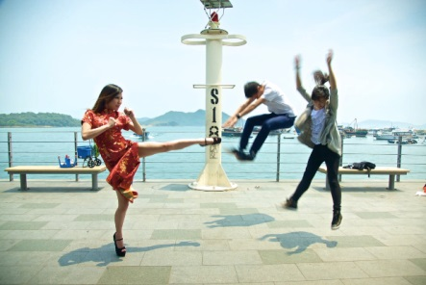
1. Select a fast shutter speed : On your camera you may have to turn the dial to TV -Shutter priority and adjust the shutter to 1/500 sec Have your partner run or jump in the air to determine if you can freeze motion . Try a range of action compositions using faster shutter speeds. E.g. 1/1000 sec

2. Now select a slow shutter speed e.g. 1/60 or 1/30 sec and take the same photographs to create motion blur.
3. Set your camera shutter at 1/60 sec: This time have your partner run and using the panning technique follow your partner in motion and press the shutter release button. By panning your subject should be sharp but the background will be blurred also giving a sense of motion
4. A variation on this is to try to take a shot of your partner with a shutter speed of 1/60 - but in the background have 1 or 2 other students run by. This should also create background blur
4. Try the following exercise. Using a long shutter speed of somewhere around a 1/4 second, take a picture of someone who is slowly waving her arm back and forth. Because the arm moves across the image, it does not stay in one place long enough to register on the film or sensor, and "disappears."
Depth of field
Aperture Priority Mode is a setting on your camera that allows you to choose a specific aperture value while the camera selects a shutter speed to match. So all you need to worry about is selecting the aperture setting
Find a subject, preferably a fixed subject (a subject that is not moving). For example a flower or your partner - anything you can at school. Make sure your subject is in the foreground and that there is background behind your subject
5 Set your aperture to its widest opening, or set it to the smallest f/stop number- which may be f2.8 or f5.6 Take a picture of your fixed subject.
Now, change your aperture setting to say, f/8 and take a picture of your subject again. Next, change your aperture setting to its smallest opening. In other words, set it to the highest f/stop number, for example, f/22. Take a photo of your subject again.
Return to class and either using Pic Collage or Power point to present your photographs

